**The Tygart Valley Trail**

**Pati Porter**

**Program Manager**

**(606) 286-5533**

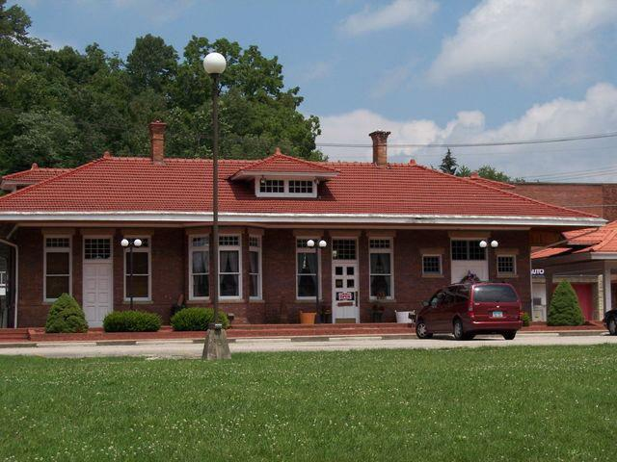

C & O Railway Depot at Olive Hill

Access Point for the Tygart Valley Trail

**The Tygart Valley Trail is a key link in the proposed**

**Lexington-Big Sandy Rails-to-Trails Project, a network of trails stretching from Lexington to Ashland.**



**The completed Tygart Valley Trail will follow the course of the old Lexington-Big Sandy (C&O) Railroad line from Lawton, east through Olive Hill and continue on to the town of Grahn. This trail will draw the visitor into many areas of unmatched natural beauty heretofore inaccessible to the residents of Carter County.**

**This will be a whole new way of experiencing our wonderful Appalachian Mountains, cool creek glens and our abundant birds, wild flowers and emerald forests. The trail will enhance the quality of life of Carter County citizens and visitors in countless ways. Young and old alike will use the trail network to meet their personal desire for fresh air, exercise and exploration.**

**Lawton, Olive Hill and other communities along the trail can all expect some degree of economic benefit from the hundreds of visitors to the trail system. The Trail will give residents of East Kentucky an excuse (and a good reason!) to come to Olive hill and other trail access points. Every year thousands of visitors pass through or make brief visits to Carter County. The Trail will give them an opportunity to experience our community in a new way, and encourage them to stop if they had not considered it before, and to stay longer if Carter County was their destination.**

**Short strolls or extended hiking will benefit the health and sense of well being of the users of our trail system. It will become a place where neighbors come together to renew friendships, share the trail experience and create stronger bonds of community. Trail walking is especially attractive to our seniors in that the trail will be level, well-cared for and convenient. For residents of Hydreco Village it will provide easy access to the Olive Hill commercial district including the Post office, banks, drug stores, hardware store and food vendors. As foot traffic increases, we would expect increased commercial investment in communities along the trail.**

**The old train depot will experience a new life as a major trail access point. At the Depot there will be plenty of parking, trail support (maps, brochures, nature guides, etc.) , as well as permanent and rotating exhibits relating to local history, arts and crafts and civic activities. Numerous special events will use the Depot as a focal or jumping-off point, including nature hikes, organized bike tours, fund raising walks, etc. Services and activities will evolve as use of the trail grows and its use stimulates new ideas.**

**What Will Our Trail Look Like?**

**We will soon have photos available of our trail as sections of it are completed. Until then, let’s take a look at similar trail systems.**

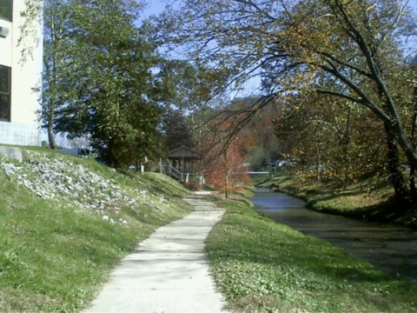

**Here’s a photo of a creek-side trail in Inez, Ky. Few trail systems across the country can match the beautiful water side views that we will be able to experience along the Tygart Valley Trail.**

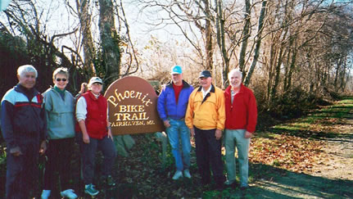

**Through experience with other trail systems we have learned that trails like ours are regularly used by young and older citizens, in all seasons of the year.**

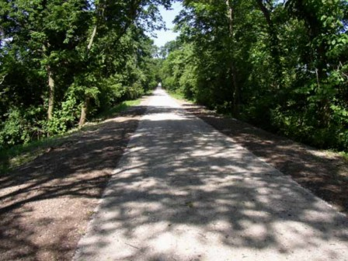

**Like the Miami Valley trail shown here, some portions of the Tygart Valley Trail will be straight and shaded. Other parts of the trail will meander along streams and through wooded glens.**

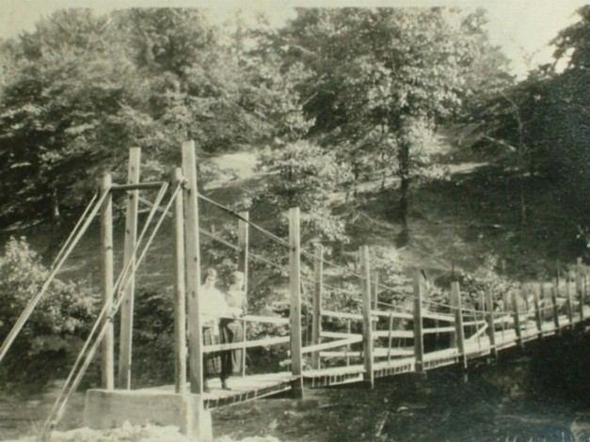

**One of the ideas that we are most excited about is the possibility of restoring the old Swinging Bridge that at one time spanned the Tygart Creek in the Hydreco-Woodside area of Olive Hill. We believe this would be a wonderful amenity for our Trail.**

**Progress on the Trail**

**The old C & O Train Depot in Olive Hill has been acquired. Trail easements have been acquired east of the Cross Street Bridge, and to the west of the Depot, a substantial open area adjacent to the creek has been purchased and preparation of this portion of the trail will soon begin.**

**Easements**

**Negotiations for easements for the trail to cross several properties to the west of the depot are in progress. Because this is very much a community trail, all of our Carter County neighbors will have input on the precise course and character of our trail. The property owners along the trail are important members of our community and their concerns and desires will determine to a large extent what the completed trail looks like. Those of us with trail experience know what a profound benefit a trail like this one can have on adjacent properties. Property owners will benefit from the easy access to the trail for themselves and their family. The trail will be carefully designed and well cared for, and will complement the natural beauty of areas through which it passes. Experience has demonstrated that trail-side land owners have found their properties more desirable and easier to market when it comes time to change ownership. Years into the future, our trailside property owners will be recognized for their contribution to this valued community resource.**

**Privacy is frequently mentioned as a concern by trail-side property owners. There are many ways in which privacy may be maintained: fencing; bushes and shrubs; earth berms. Each of these alternatives can be adapted to the particular concerns of each property owner. Experience with thousands of property owners has proven that trails are good neighbors and nearly every property owner comes to appreciate the value of an adjoining trail.**

**Security is the second greatest concern that property owners express. After many years of experience with walking trails we have found that the extension of a walking trail does not increase rates of anti-social behavior. They do provide an opportunity for young people to engage in a healthy, wholesome activities, and that just has to be good for any neighborhood or community.**

**We Support the Tygart Valley Trail**

**Danny Sparks, Olive Hill Mayor**

**Judge Executive Charles Wallace**

**Robin Webb (KRTC)**

**Pati Porter**

**Senator Charlie Borders**

**Mayor Danny Sparks**

**Judy Hazlet**

**Darlene Gee**

**100%**



**Recycled Paper**

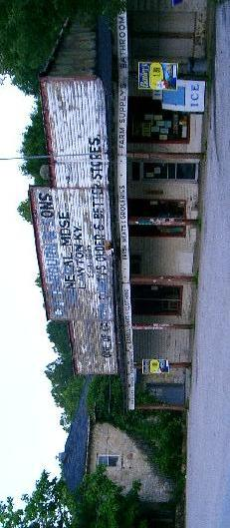**Lawton**

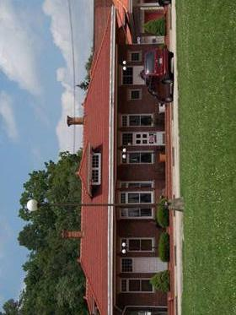**Olive Hill**

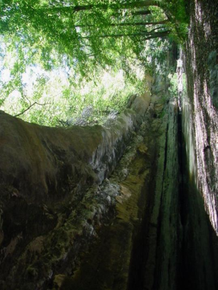

**Hanging Rock** 