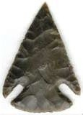

Little
Sandy
River
Trail

