Trail signs

(3) E. K. Railroad Trail
(10) "Little Sinking Creek Trail"
(4) "Tygart Creek Trail"
(5) “Little Sandy River Trail”
(3) "Cross bridge with caution. Watch for vehicles approaching from behind"
(3) "Caution. Watch for pedestrians on the bridge"
(3) "Speed limit 10 mph on the bridge - 5 mph when pedestrians are present"
(10) “Please yield the right-of-way to pedestrians, bike riders and horses”
(as needed) "Fultz 3 miles" "Fultz 2 miles" etc.
(3) "Be a good neighbor. Please do not leave the marked trail"
(as needed) "Be a good neighbor, please take refuse with you"
(5) "Become a trail volunteer: 286-5533 ext. 22"
(as needed) "Bicyclists, please alert pedestrians when passing from behind"
(as needed) "Walk to the right, ride to the left"
(3) "Cell phone access point"

Little Sandy River Trail



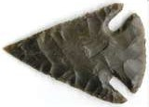



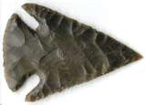

Caution
Little Sandy River Trail

This Trail is Under Construction
OUR BRIDGES HAVE NO GUARDRAILS

These Bridges are Unsafe

For Young Children

Caution

Little Sandy River Trail

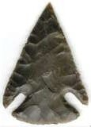

Little Sandy River Trail

Welcome to our
Little Sandy Creek Trail
A hiking, biking and equestrian trail
for the people of Carter County

This trail will eventually extend along the old CSX right-of-way from Hitchens to Fultz Fork. Our trail will have restroom facilities, benches, picnic areas, boat launching facilities and links to side trails throughout our wonderful
Carter County country-side.

This trail is made possible by:
Carter Co. Judge Executive Charles Wallace
County Maintenance Manager Larry McDavid
The Magistrates of the Carter County Fiscal Court:
Lovell Carper, Judy Roark, William Webb,
Millard Cordle and James Wilburn

We need your help!

Trail clearing
Rock spreading
Concrete forming
Telephone calling
Courthouse researching
Trail designing
Sign making

Contact: Pati Porter at 286-5533 ext 22

Little Sandy River Trail

