Descendents of Civil War Veteran Restore Cemetery

Carter County, Kentucky by Sherry Lowe

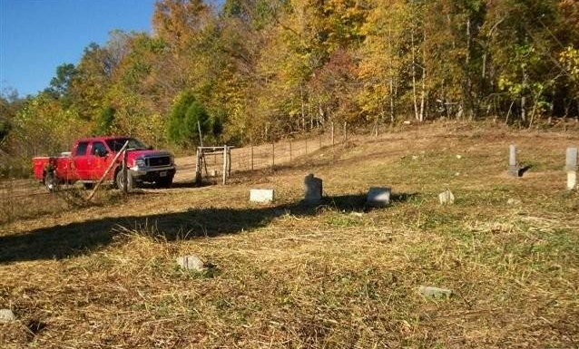

When the Civil War broke out, my gr gr gr gr grandfather, Reuben McGinnis was prepared to serve his country in the Union army, but his 18 year old son, William Jasper “Bill” McGinnis, wanted to join and persuaded his father to allow him to take his father’s place and instead Reuben joined the Carter County Home Guard on Tygarts Creek in Co. G of the 22nd Regiment, Ky. Union Volunteer Infantry.
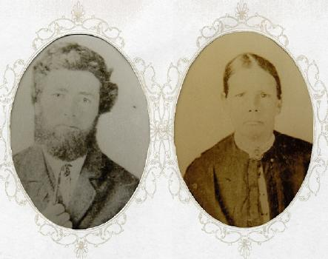
(Pictured are Reuben and Martha Patsy Black McGinnis – If you look closely you can see that Reuben is holding a pen. He was very proud of the fact that he could read and write.)
Bill was a sergeant in the 40th Kentucky Regiment, Company E of the Union army, at age 18. According to his military records Bill was 5' 7", of fair complexion, with gray eyes and black hair.

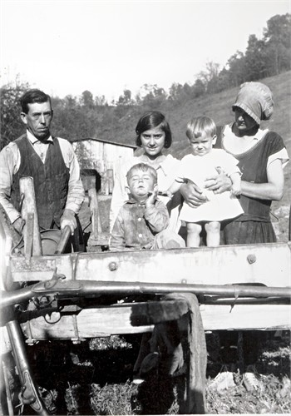
Pictured are William Jasper “Bill” McGinnis, Matilda McCleese McGinnis and
three of their young children.

On February 4, 1862, Bill found himself on a boat on the Tennessee River. In front of his boat were four ironclad gunboats known as “Ironsides” under the command of Commodore Andrew Hull Foote. They were coming in at night in a storm, so close to the shore that the limbs of a fallen tree hit the boat, as the boats were being shelled by the enemy. When daylight came, they were near Fort Henry and the gunboats went into action. Within an hour the Fort had surrendered, allowing a then little known brigadier general named Ulysses S. Grant, to get through overland with his 17,000 men. This was the first major victory for the Union armies. The boat Bill was on carried gunpowder packed in casks made out of plywood, that would hold exactly one-half bushel. Bill brought one of these cask home with him and stretched a skin across it to make a drum. Each morning when he started out to feed the animals, the first thing he would do is pick up that drum.

Bill was wounded in the thigh in one engagement, but the low point for him came when his cousin, whom he had enlisted with, was stricken with typhoid fever. Bill was assigned to take him home. But when they got as far as the home of the notorious Underwoods, the boy could go no further. The Underwoods took them in and did what they could, but the boy died. The Underwoods buried the boy in their cemetery. Bill always had a high regard for the Underwoods after that, in spite of their feudal reputation.

When Bill came home from the army there was no work to be found. The war would not end for another six months. But he heard about work at Jackson, Ohio in the iron furnaces making pig iron. One place said he could have a job since they had just signed a contract with Washington for the next two years however Washington would not be able to pay wages for a period of at least 2 years. Bill negotiated with them to get a provision for room and board and went to work. At the end of the two years, William received a bag of gold for his wages. For safety, he mailed the gold to himself at the Smith Creek post office and headed home. When he arrived back home he went to the post office and retrieved his bag of gold. He then used a portion of the gold to go into partners with his father, Reuben, to purchase 600 acres of farmland. William and Reuben split the land and each took approximately 300 acres.

Bill took the portion of land at Smith Creek and he and Matilda spent the rest of their lives farming that land. William built a nice home with a huge front porch that ran across the entire front of the house and always seemed to catch the cooling breezes in summer. There were 2 large gardens, one on either side of the house. In most of the garden space close to the house, Matilda grew such flowers in those 30' wide gardens that each Sunday, after Church, people were always stopping by to roam the paths of her gardens and admire the yield of her green thumb.
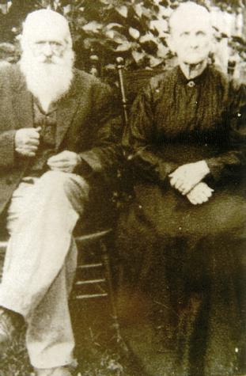
{Pictured are William Jasper “Bill” and Matilda McCleese McGinnis}

By the standards of the late 1800's, in Carter County, Kentucky, Bill was a rich man at the age of 38. He kept the remainder of his gold in a wooden box in the attic and guarded it well.

Upon his death, as was the practice of the time, Bill was buried at the top of a ridge on the farm and after him so were many other members of the McGinnis family. Today this cemetery is listed as McGinnis Cemetery #2 by the Carter County cemetery board.

For years it has been nearly impossible to get to the cemetery to care for the graves that are there. Recently some of Bill’s descendents, William, Vinton, Oscar, Paul and Doug McGinnis took it upon themselves to build a road and restore the cemetery, in honor of Bill’s memory. It was a lot of hard work but they built a new road, cleared the cemetery which was terribly overgrown, and made repairs to the stones. In years gone by, according to older family members, the hill was so steep that when someone was buried in the cemetery, the body was carried to the cemetery by a sled.

Bill would be proud of the efforts his descendents have put into restoring the cemetery, in honor of his memory and the memory of his family members.

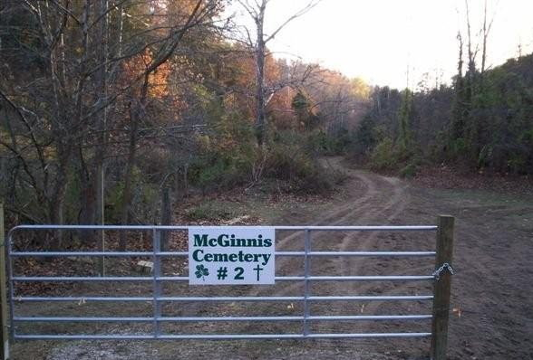

The cemetery entrance is located at Smith Creek, 3 miles west of Carter City on state route 474 {38 degrees 26 minutes 49.31 seconds N by 83 degrees 10 minutes 18.19 seconds W).

