Descendents of Benjamin Burnett

Contributed by Sherry Lowe

Generation One

1. Benjamin¹ Burnett, born 1816.

He married Nellie Elizabeth Gould Burnett, born 1815.
The children of Benjamin and Nellie are listed per the 1860 Ripley Township, Brown Co., Ohio census records.

Children:
i. Nancy² Burnett, born 1837.
ii. George O. Burnett, born 1838.
2. iii. James Wesley Burnett born 26 May 1840.
iv. Mary A. Burnett, born 1843.
v. P. J. Burnett, born 1844.
vi. Matilda Burnett, born 1848.
vii. Louisa Burnett, born 1851 in Ohio.

Generation Two

2. James Wesley² Burnett, (Benjamin¹) born 26 May 1840 near West Union, Ohio, died 8 Aug 1897 in Carter County, Kentucky, buried in Old Grayson Cemetery, Grayson, Carter County, Kentucky, occupation Carpenter.

James was born near West Union, Ohio. He came to Iron Hills Furnace after service in Union Army which included imprisonment at Andersonville. He was a republican.

He resided in Adams County, Ohio, prior to coming to Carter Co., Ky. He married Nannie Mariah Botts Burnett, born Feb 1855 in Kentucky, (daughter of Judge James R. Botts and Mary Matilda Everman Botts) died Dec 1924 in Grayson, Carter County, Kentucky.

Nannie:
Dec 24, 1924
Huntington Herald -Dispatch
Mrs. J. W. Burnett

Mrs. J. W. Burnett, mother of A. D. Burnett, 1911 Adams Avenue, this city, died Tuesday at the home of her daughter, Mrs. Nellie B. Keffer at Grayson, Kentucky.

Funeral services were held Wednesday morning at 10 o'clock at Grayson and burial was made there.

Mrs. Burnett was a daughter of the late Judge Botts, of Grayson. She is survived by her five children, Mrs. Burnett, of Huntington; B. W. Burnett, of Phoenix, Arizona; Gene B. Burnett, Ashland, Kentucky; Edward Burnett of Grayson, and Mrs. Keffer of Grayson. Three brothers and one sister also survive.

Note: There were 8 children total, 3 died as infants and were not counted since they did not survive to adulthood.

Children:
3. i. Imel Eugene³ Burnett born 8 Jun 1879.
4. ii. Ben W. Burnett born Aug 1882.
5. iii. Edwin Russell "Ned" Burnett born 8 Sep 1884.
6. iv. Carrie Nell "Nellie" Burnett Keffer born 1886.
7. v. A. D. Burnett born Oct 1888.
vi. Olive B. Burnett, born 1889 in Carter County, Kentucky.
vii. Jimmie Burnett, born 31 Oct 1889 in Carter County, Kentucky, died 6 Mar 1891 in Carter County, Kentucky, buried in Old Grayson Cemetery, Grayson, Carter County, Kentucky.
viii. M. B. Burnett, born Dec 1891 in Carter County, Kentucky.

Generation Three

3. Imel Eugene³ Burnett, (James Wesley², Benjamin¹) born 8 Jun 1879, died 13 Dec 1916 in West Liberty, Morgan County, Kentucky, buried in East Carter Memory Gardens, U.S. 60, Grayson, Carter County, Kentucky.

He married Katherine "Kate" Elliott Burnett, born 1884, buried in East Carter Memory Gardens, U.S. 60, Grayson, Carter County, Kentucky.

Children:
i. Dortha⁴ Burnett, born 1907 in Carter County, Kentucky.
8. ii. Margaret Nannie Burnett Cooper born 1908.
iii. Wesley Burnett, born 1911 in Carter County, Kentucky.
iv. Pearl Burnett, born 1915 in Carter County, Kentucky.
v. Catherine Burnett, born 16 Aug 1919 in Carter County, Kentucky.
vi. A. Burnett, born 16 Aug 1919 in Carter County, Kentucky.
vii. Edith M. Burnett, born 12 Nov 1922 in Carter County, Kentucky.

4. Ben W.³ Burnett, (James Wesley², Benjamin¹) born Aug 1882, resided in Phoenix, Arizona.

He married 24 Dec 1915, Lucy Womack Burnett, born 5 Jun 1881, (daughter of Samuel Womack and Susan Ferries Womack).
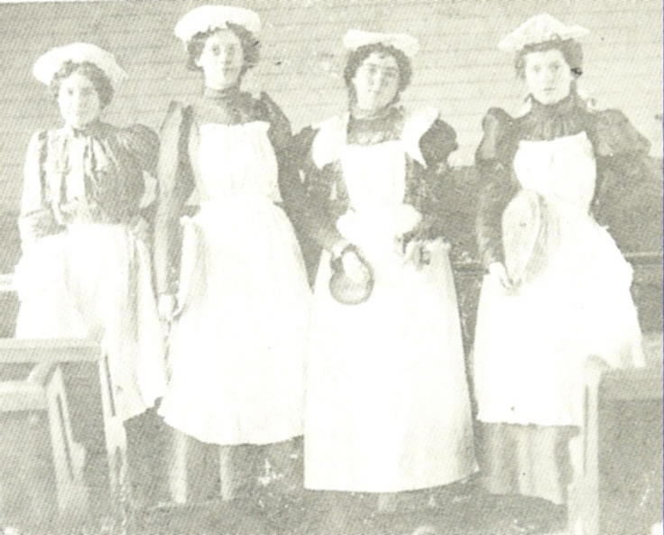

Lucy: Pictured are (l to r) Emma Seaton Jones, Lucy Womack Burnett, Lizzie Porter and Hattie MacMullen. early in the century featured these Grayson area girls in the Lindsey Chapel Church Service.

Children:
i. Homer⁴ Burnett, born 5 Oct 1916 in Carter County, Kentucky.

5. Edwin Russell "Ned"³ Burnett, (James Wesley², Benjamin¹) born 8 Sep 1884, died 17 May 1970, occupation Merchant/Farmer.

Ned and Ella both were educated at Morehead Normal School before a store business at Shady Valley. Later Ned, Homer Womack and Bill Gosney worked at Ensign Car Shop in Huntington, WV for a while. Later, they returned, Ned to the farm, but Homer with his father Andrew and brother Leslie started "Farmers Hardware Co."

He married 1915, Linella "Ella" Alexander Burnett, occupation Greenup County, Ky. School Teacher.

Children:
9. i. Clayton Alexander⁴ Burnett born 18 Mar 1918.
ii. Edwin "Eddie" Aubrey Burnett.
iii. Alma Burnett Jackson.

She married Elwood Jackson.

6. Carrie Nell "Nellie" Burnett³ Keffer, (James Wesley² Burnett, Benjamin¹) born 1886.

She married Homer Hudson Keffer, born 1880 in Carter County, Kentucky, (son of Robert "R. Q." Quincy Keffer and Elizabeth P. Montgomery Keffer) died 1964 in VA Hospital, Huntington, Wayne Co., WV, buried in Carter Co. Memorial Gardens, Grayson, KY.

Homer:
"H. H. Keffer Claimed After Long Illness"

Funeral services were conducted at 1:30 p.m. Tuesday, for Homer Hudson Keffer, 84, well known Grayson resident, who died at 10 a.m., Sunday in Veterans' Hospital, Huntington, following a long illness.

Mr. Keffer was born in Carter County, a son of the late Robert Quincy and Elizabeth Montgomery Keffer.

A member of the First Church of Christ, Grayson, Mr. Keffer maintained a consistent Bible School attendance record. He was a veteran of World War I.

Services were held at the Malone Funeral Home with Jay Cooper officiating. Burial was in the Carter County memory Gardens.

Surviving are his wife, Mrs. Nell Burnett Keffer; two sons, Wesley H. and Charles G. Keffer; a sister, Mrs. Mary Pelfrey, and five grandchildren, all of Grayson.

Children:
10. i. Wesley⁴ Keffer.
ii. Charles G. Keffer.

7. A. D.³ Burnett, (James Wesley², Benjamin¹) born Oct 1888 in Carter County, Kentucky, resided in Huntington, Cabell County, West Virginia.

He married Maude Burnett, born 1889.

Children:
i. Robert⁴ Burnett, born 1913 in Huntington, Cabell County, West Virginia.
ii. James Burnett, born 1917 in Huntington, Cabell County, West Virginia.
iii. Mary Burnett, born Apr 1919 in Huntington, Cabell County, West Virginia.

Generation Four

8. Margaret Nannie Burnett⁴ Cooper, (Imel Eugene³ Burnett, James Wesley², Benjamin¹) born 1908 in Grayson, Carter County, Kentucky, died 17 Nov 1937, buried in Mt. Tabor Cemetery, Chillicothe, Ross County, Ohio.

She married Hommie Lea Cooper, born 28 Jun 1910 in Magoffin County, Kentucky, (son of William Hamilton Cooper and Alice Vada Montgomery Cooper) buried in Mt. Tabor Cemetery, Chillicothe, Ross County, Ohio.

Children:
11. i. Hommie Lee⁵ Cooper born 13 Sep 1932.
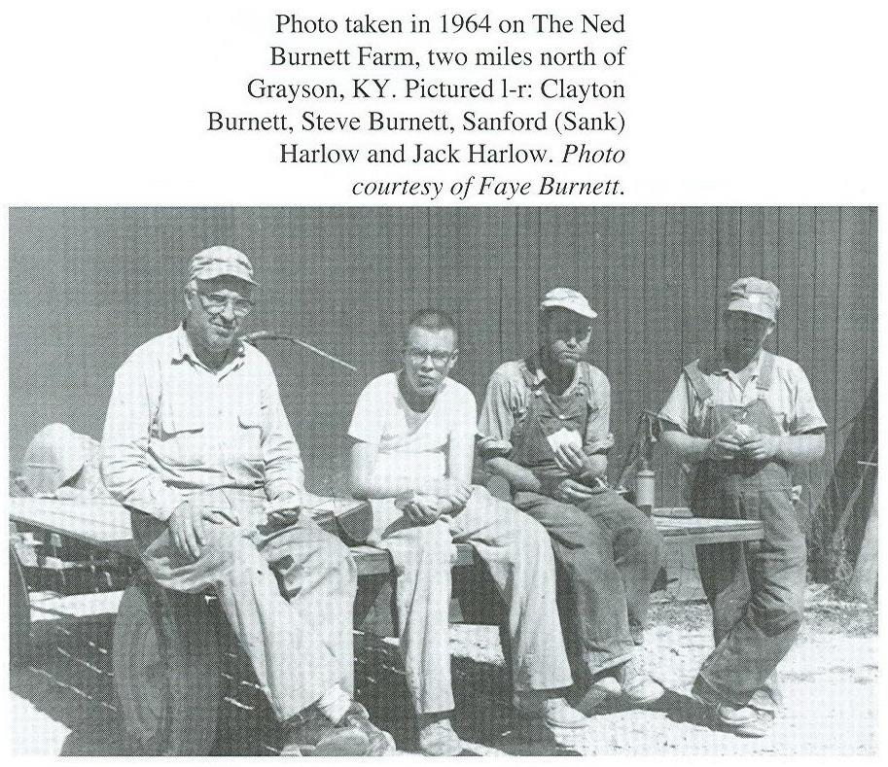

9. Clayton Alexander⁴ Burnett, (Edwin Russell "Ned"³, James Wesley², Benjamin¹) born 18 Mar 1918 in Grayson, Carter County, Kentucky.

He married (1) Mary Louisa James Burnett, born 28 Nov 1921 in Hitchins, Carter Co., Ky., (daughter of Lula James and Bertha Kitchen James) died 1980.

Children:
i. Clayton Stephen⁵ Burnett, born 11 May 1950 in Charleston, Kanawha County, WV.

He married (2) Faye Littleton Pope Burnett, born 1920.
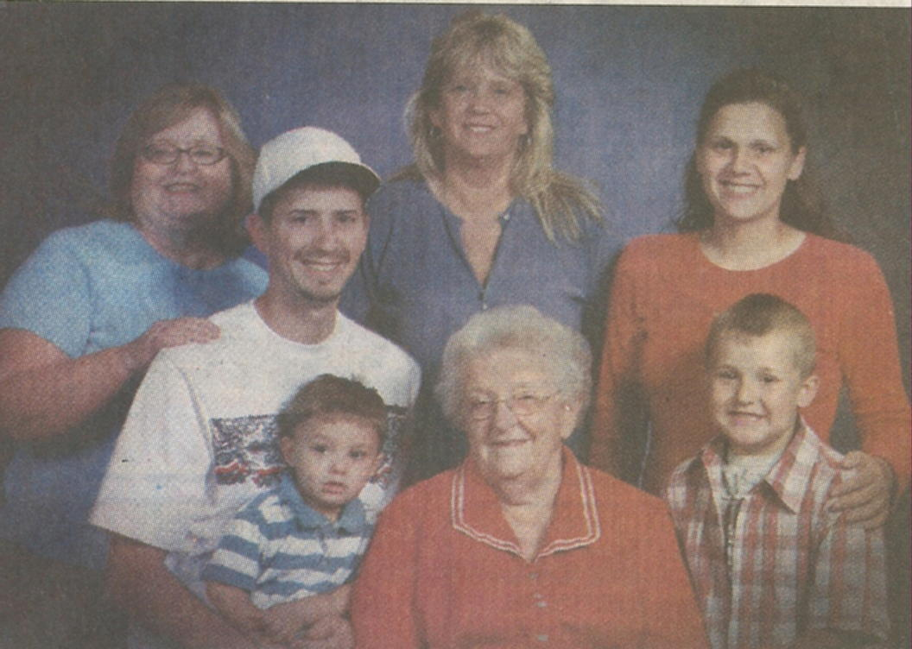

Faye: Pictured circa 2007: Back row (l to r), Sue Wellman, Nathan Gallion, Erica Gallion and Ashley Gallion. Front row (l to r), Kyler Gallion, Faye Pope Burnett and Kobi Rice Gallion.

Faye is the mother of Sue Wellman, Sue is the mother of Erica Galliion. Erica is the mother of Nathan and Ashley Gallion. Nathan is the father of Kyler Gallion. Ashley is the mother of Kobi Rice Gallion.

10. Wesley⁴ Keffer, (Carrie Nell "Nellie" Burnett³, James Wesley² Burnett, Benjamin¹).
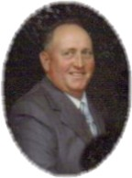

Wesley Keffer (1924-2007)

Wesley Keffer, 83, of Grayson, Ky., passed away Wednesday, Sept. 19, 2007, at his residence.

He was born July 12, 1924, in Huntington, W.Va., a son of the late Homer Hudson and Carrie Nell Burnett Keffer.

He was a lifelong farmer and of the Christian faith.

Preceding him in death were a daughter, Linda Calloway, and a son, John William Keffer.

His survivors include his wife, Eula Vanhorn Keffer of Grayson; three daughters, Martha Jane and Charles Kouns of Hitchins, Ky., Josie and Randy McGlone of Grayson and Sally and Elwood Ebert of Grayson; two sons, Bruce and Anna Keffer of Grayson and Steven Wesley and Karen Keffer of Huntington; a brother, Charles Botts Keffer of Grayson; 15 grandchildren; and 25 great-grandchildren.

Funeral services will be at 11 a.m. Saturday, Sept. 22, 2007, at Malone Funeral Home in Grayson with Steven Keyes, minister. Burial will be in Keffer Family Cemetery.

He married Eula Vanhorn Keffer.

Children:
i. Martha Jane Keffer⁵ Kouns.

She married Charles Kouns.

ii. Josie Keffer McGlone.

She married Randy McGlone.

iii. Sally Keffer Ebert.

She married Elwood Ebert.

iv. Steven Wesley Keffer.

He married Karen Keffer.

v. Charles Botts Keffer.
- John William Keffer.
John W. Keffer

1965 - 2005

John William Keffer, age 39, of Grayson, KY, passed away Wednesday, February 2nd, 2005 at his residence.

He was born September 9th, 1965, at Greenup County, KY a son of Wesley and Eula Marie Vanhorn Keffer of Grayson.

He was a self employed dry waller.

Preceding him in death was a sister, Linda Calloway in 2004

In addition to his parents, he is survived by:

1 daughter: Lindsey Keffer of Grayson
3 sisters: Josie and Randy McGlone of Grayson; Martha Jane and Charles Kouns of Hitchins, KY ; Sally Keffer and Elwood Ebert of Upper Sandusky, OH
2 brothers: Steven and Karen Keffer of Huntington, WV
Bruce and Anna Keffer of Grayson Funeral services will be conducted Saturday, February 5th, 2005 at 2:00pm at the Malone Funeral Home with Phil LeMaster, minister.
Burial will be in the Keffer Family Cemetery. Friends may call Saturday after 1:00pm until service time at the funeral home.

12. vii. Linda Keffer Calloway.

Generation Five

11. Hommie Lee⁵ Cooper, (Margaret Nannie Burnett⁴, Imel Eugene³ Burnett, James Wesley², Benjamin¹) born 13 Sep 1932 in Chillicothe, Ross County, Ohio, died 9 Mar 2001 in Springfield, Ohio.

He married Ruth Evelyn Haney Cooper, born 12 May 1929 in Carter County, Kentucky, (daughter of Paris Haney and Rebecca McGlone Haney) died 27 Mar 1982 in Springfield, Ohio.

Children:
i. Rita⁶ Cooper.

12. Linda Keffer⁵ Calloway, (Wesley⁴ Keffer, Carrie Nell "Nellie" Burnett³, James Wesley² Burnett, Benjamin¹).

Linda Calloway
1956 - 2004

Linda Ann Keffer Calloway, age 48, of Harrisville, WV, formerly of Grayson, KY, passed away Sunday, October 10th, 2004.
She was born December 10th, 1956 a daughter of Wes and Eula VanHorn Keffer of Grayson, KY.

In addition to her parents, she is survived by her husband, Norman Calloway of Harrisburg, WV; one daughter, Kerry and Scott Wilkerson of Tifin, OH;
3 sisters, Jane and Charles Kouns of Grayson, Sally Keffer and Elwood Ebert of Upper Sandusky, OH and Josie and Randy McGlone of Grayson;
3 brothers, Bruce and Anna Keffer of Grayson, Steven and Karen Keffer of Huntington, WV, John Keffer of Grayson and 4 grandchildren.

Memorial services were conducted Saturday, October 16th, 2004 at 2:00pm at the Malone Funeral Home.

She married Norman Calloway.

Children:
i. Kerry Calloway⁶ Wilkerson.

She married Scott Wilkerson.

