Descendants of John Everman
(Please note that this only meant to be a guide, not a completed work)

Generation One

1. John¹ Everman. was born 10 Aug 1776 at Barrett Creek, Potomac, Virginia (son of William and Margaret French Everman) died 11 Mar 1855 in Carter, Kentucky, USA, Burial in Everman Cemetery at Grassy Creek, Carter, Kentucky, USA.

He married Sarah Clark Everman, born 1787 in Potomac, King George County, Virginia, (daughter of General George Clark and Jane Mercer Clark) died 1857 at Barretts Creek, County, Kentucky.

Children:
2. i. Samuel² Everman born 16 Mar 1803.
3. ii. Malinda Everman Kibbey born 26 Aug 1806.
iii. John Everman, Jr.. was born 13 Feb 1831 on Barretts Creek, Greenup, Kentucky, USA, died 10 Aug 1863 at Vicksburg, Warren, Mississippi, USA. He married Nancy Biggs in 1853, daughter of Jeremiah Biggs and Louisa Barrett. She was born in 1827 in Greenup, Kentucky, USA and died between 1881-1899 in Carter, Kentucky, USA.
iv. William Everman, born 26 Aug 1808 in Greenup County, Kentucky, died 12 Dec 1889 in Carter County, Kentucky, resided 1850 in District 2, Carter County, Kentucky, resided 1870 in Precinct 1, Carter County, Kentucky, resided 1880 in Precinct 4, Carter County, Kentucky.
v. Martha "Patsy" Everman Offill. born 06 Apr 1810 on Barretts Creek, Carter, Kentucky, USA, died between 1861-1869 in Carter, Kentucky, USA. She married Elzaphan Offill on 26 Sep 1829 in Greenup, Kentucky, USA. He was born 04 Sep 1804 in Montgomery, Kentucky, USA, died 23 Sep 1863 in Carter, Kentucky, USA.

Generation Two

2. Samuel² Everman, (John¹) born 16 Mar 1803 in the area of Harrodsburg, Kentucky.

He married (1) Margaret Barnes Everman.

Children:
i. Anne³ Everman.

He married (2) 12 Dec 1828, Phoebe Skidmore Everman, born 22 May 1809 in Virginia, USA died 20 Jul 1892 at Smiths Branch, Carter, Kentucky, USA

Children:
4. ii. John Thomas Everman born 02 Oct 1829 at Smiths Branch, Greenup, Kentucky, USA, died 10 Aug 1863 at Vicksburg, Warren, Mississippi, USA.
iii. Harriett Eliza Brunetta. Everman. born 1831 married James F. McFerrin
iv. William Everman. born 1832 at Smiths Branch, Greenup, Kentucky, USA
v. Joseph S. Everman. born 1838 at Smiths Branch, Greenup, Kentucky, USA, married Miranda James Everman 10 Aug 1859 in Carter, Kentucky, USA
vi. Samuel Everman, Jr..
vii. George Everman.
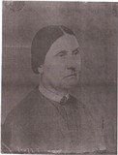

viii. Martha Everman.

3. Malinda Everman² Kibbey, (John¹ Everman) born 26 Aug 1806, died 13 Dec 1872. Burial in Fitch Cemetery; Salem, Carter, Kentucky, USA

Pictured is Malinda Everman Kibbey.

She married Jacob Kibbey, (son of Moses Kibbey and Sarah Everman Kibbey). born 01 Mar 1803, Greenup, Kentucky, USA, died 20 Mar 1870, Carter, Kentucky, USA. Burial in Fitch Cemetery; Salem, Carter, Kentucky, USA

Jacob: Pictured is Jacob Kibbey.
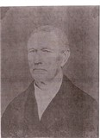

Children:
5. i. Martha Ann Kibbey³ Everman born 1829.
6. ii. John E. Kibbey born Nov 1835. at Evermans Creek, Greenup, Kentucky, USA

Generation Three

4. John Thomas³ Everman, (Samuel², John¹) died 10 Aug 1863, occupation 2nd Lt Co. H, 22nd KVI, born 1829.

John's ancestors came from Germany and first settled in Virginia. His father left Virginia and came to Kentucky. John fought on the side of the North during the Civil War.

John, a second lieutenant in Co. H, 22nd KVI, wrote the following letter to his wife Martha on April 5, 1863 (spelling per letter):
Rec'd a letter from cousin Sam, also Jeremiah Biggs, Joseph Stuart is well, John Littleton complaining little...We are 25 miles from Vicksburg, in hopes we will not be in the fight.
Well, Martha, you said I must resign and come home. I would like to come...but I cannot resign now. The boys who have deerted are bound to be brought back to the army. Get word to Sam Everman to return.
It has got so a man can't resign without he ahs got something the matter with him. I will come the first change there is for me. I hate to disgrace myself by running off, for I could not stay at home in peace. I want t ocome honorably when I come home.
Old Abe's proculation (sic) is worth no more than if I had issued it. I am still a Union man, but I do not justify all that Lincoln has done, but it gave great room for Nigro stealing. I could fetch home as many blacks as I wanted but I don't like to take them that way.
I was glad to you was making sugar. I would like to get into the big jug of molasses.

John was due home in twenty days after being mustered out, but before being permitted to start home, he contracted yellow fever and died on August 10, 1863.

He married 28 Dec 1845, Martha Ann Kibbey Everman, born 1829 in Kentucky, (daughter of Jacob Kibbey and Malinda Everman Kibbey).

Children:
7. i. William Riley⁴ Everman born 20 Nov 1851.
8. ii. James Lee Everman born 6 May 1859.
iii. Sarah Everman Fox.

5. Martha Ann Kibbey³ Everman, (Malinda Everman² Kibbey, John¹ Everman) born 07 Nov 1828 at Evermans Creek, Greenup, Kentucky, USA.

She married (1) 28 Dec 1845, John Thomas Everman, (See marriage to number 4).

John: John's ancestors came from Ireland and first settled in Indiana. He father left Indiana and came to Kentucky. John fought on the side of the North during the Civil War.

John, a second lieutenant in Co. H, 22nd KVI, wrote the following letter to his wife Martha on April 5, 1863:
Rec'd a letter from cousin Sam, also Jeremiah Biggs, Joseph Stuart is well, John Littleton complaining little...We are 25 miles from Vicksburg, in hopes we will not be in the fight.
Well, Martha, you said I must resign and come home. I would like to come...but I cannot resign now. The boys who have deerted are bound to be brought back to the army. Get word to Sam Everman to return.
It has got so a man can't resign without he ahs got something the matter with him. I will come the first change there is for me. I hate to disgrace myself by running off, for I could not stay at home in peace. I want t ocome honorably when I come home.
Old Abe's proculation (sic) is worth no more than if I had issued it. I am still a Union man, but I do not justify all that Lincoln has done, but it gave great room for Nigro stealing. I could fetch home as many blacks as I wanted but I don't like to take them that way.
I was glad to you was making sugar. I would like to get into the big jug of molasses.

John was due home in twenty days after being mustered out, but before being permitted to start home, he contracted yellow fever and died on August 10, 1863.
.

Children:
(See marriage to number 4)

She married (2) George W. Patton, born 1824 in Kentucky, occupation Farmer.

Children:
iv. William G. Patton, born 1864 in Carter County, Kentucky.
v. Samuel Patton, born 1870 in Carter County, Kentucky.

6. John E.³ Kibbey, (Malinda Everman², John¹ Everman) born Nov 1835 in Evermans Creek, Greenup County, Kentucky, died 15 May 1883 in Charlotte Furnace, Carter County, Kentucky.
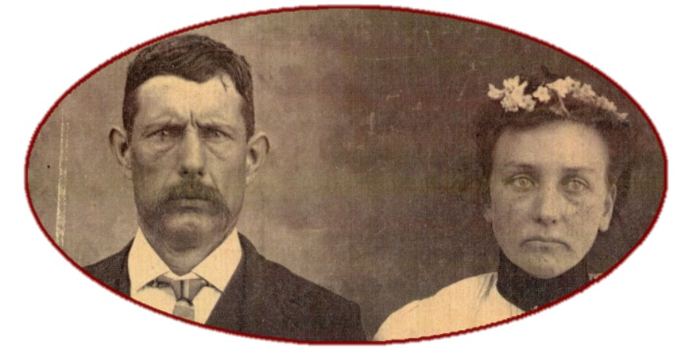

Pictured are John and Lucy, possibly on their wedding day. John & Lucy Kibbey are buried in the Kibbey cemetery on a hill just above their old home place at Charlotte Furnace, Carter Co., Ky.

He married 4 Nov 1858 in Carter County, Kentucky, Mary Lucy Morris Kibbey, born 2 May 1844 in Floyd County, Kentucky, (daughter of John G. Morris and Rebecca Coburn Morris) died 17 Apr 1935 in Charlotte Furnace, Carter County, Kentucky.
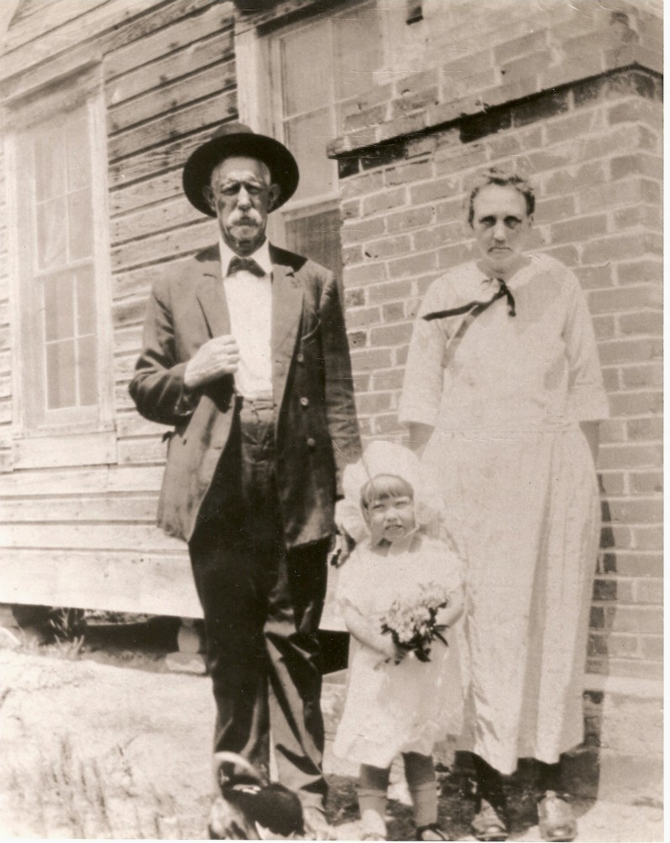

Mary: Pictured are John and Mary Lucy Morris Kibbey. It is believed that they are standing in front of the Kibbey home place at on Tygart Creek Road at Charlotte Furnace, Grayson, Ky.

Children:
9. i. James Thomas "Jim"⁴ Kibbey born 5 Oct 1860.
ii. Francis Lawson Kibbey, born 4 Jul 1861 in Carter County, Kentucky.
10. iii. Laura Jane "Jennie" Kibbey McGlone born 22 Aug 1877.

Generation Four

7. William Riley⁴ Everman, (John Thomas³, Samuel², John¹) born 20 Nov 1851 in Carter County, Kentucky, died 22 Sep 1932, buried in Everman Creek Cemetery, Carter Co., Ky.
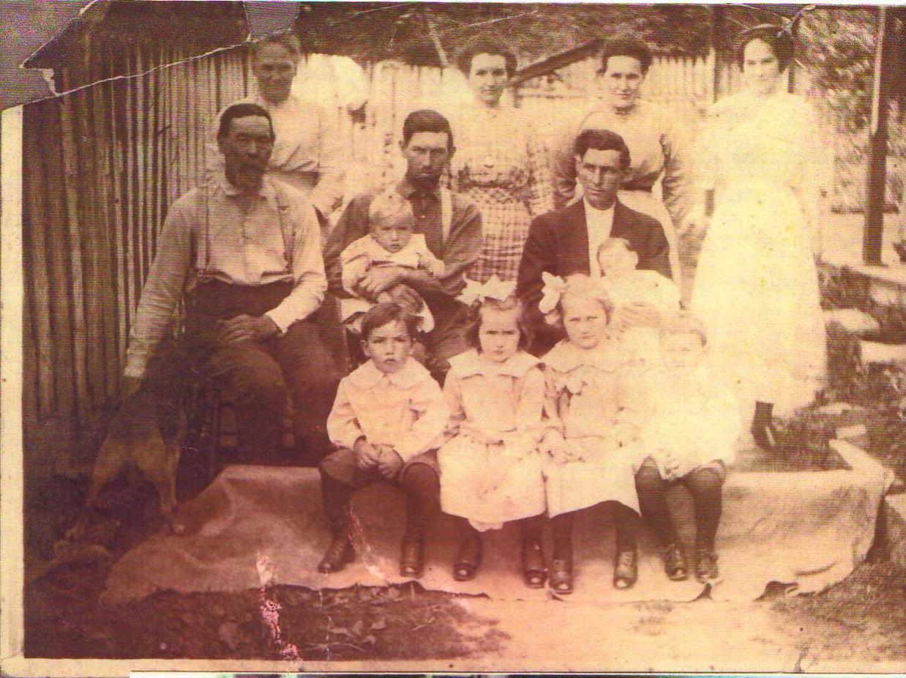

Front row, left to right:
Russell and Mabel Everman, Hazel and Bill Harris
Row 2:
William R. Everman, Willis Everman (baby), John D. Everman, C. G. Harris, (unk) baby
Back row:
Alpha (McGinnis) Everman, Laura (Ramey) Everman, Mollie (Everman) Harris, Pearl Everman.

He married 14 Jan 1881 in Carter County, Kentucky, wedding official William A Kibby at the home of David McGinnis, Greenup County, Kentucky, Alphamenta "Alpha" Nevada McGinnis Everman, born 12 Aug 1859 in Greenup County, Kentucky, (daughter of George David McGinnis and Sarah Ann Dysard McGinnis) died 10 Feb 1949, buried in Everman Creek Cemetery, Carter Co., Ky.

Alphamenta: Pictured are Alpha and William. They were married in the presence of George A. Baker and Harvy McGinnis.
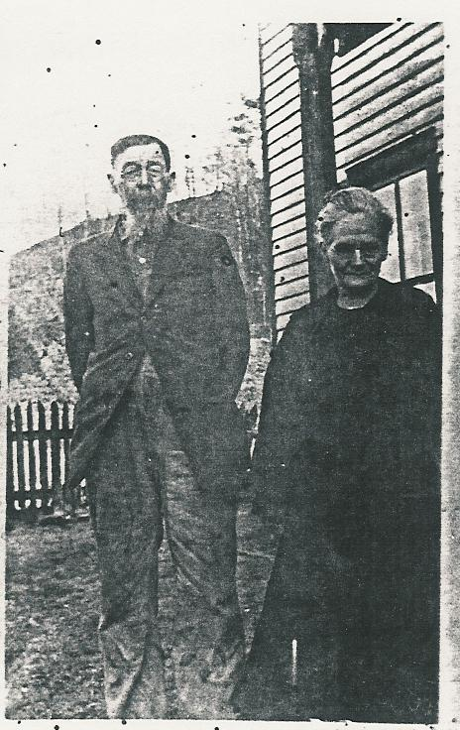

Alpha and her daughter, Pearl were nicknamed Mutt and Jeff after the comic characters. Pearl was tall and slim and Alpha was short and plump.

Alpha's funeral was officiated by the Rev. A. C. Jarvis under the direction of the Satterly-Phillips Funeral Home of Grayson. Alpha had been ill for several month. At the time of her death Alpha had 18 grandchildren and 27 great-grandchildren.

Children:
11. i. Edgar T.⁵ Everman born 26 Jun 1883.
12. ii. Molly Everman Harris born 21 Oct 1884.
13. iii. John David Lee Everman born 18 Dec 1888.
14. iv. Pearl Annis Everman Harris born 13 Mar 1894.

v. Clyde Everman, .
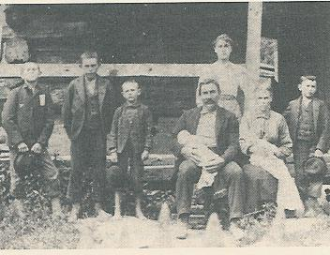

Pictured are members of the Everman Family: L to R and Back to Front-John-Roy-Edgar-Bill-Pearl-Laura-Ethel and Mandy.

8. James Lee⁴ Everman, (John Thomas³, Samuel², John¹) born 6 May 1859 in Tygart Creek, Carter Co., Ky., died 4 Jul 1920.

James was a twin. The other twin died at birth. Pictured here are the James and Sarah Everman Family in front of their home at Iron Hill about 1882. L to R: Willie, George, Oscar, James holding Ora, Sarah holding Orra, Tom. Girl in back is Dollie Huffman, Sarah's niece.
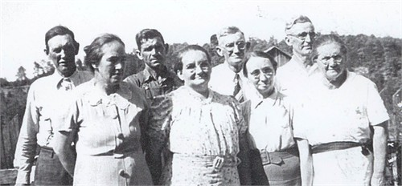

He married 31 Oct 1882, Sarah Allen Huffman Everman, born 10 Jul 1856, died 1944, buried in Patton Cemetery., Carter Co., Ky.

Children:
i. George⁵ Everman, born 22 Feb 1883.
ii. William Ellis Everman, born 20 Apr 1884.
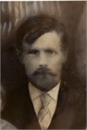

iii. Oscar Everman.
iv. Eva Lee Everman.
15. v. Ora Everman born 13 Jul 1895.
vi. Tom Everman.
vii. Orra Everman, born 13 Jul 1895.

Orra and Ora were twin brothers.

9. James Thomas "Jim"⁴ Kibbey, (John E.³, Malinda Everman², John¹ Everman) pictured here was born 5 Oct 1860 at Charlotte Furnace, Carter County, Kentucky, died 13 Mar 1931 at Charlotte Furnace, Carter County, Kentucky, buried in Kiser-McGinnis Cemetery, Tygarts Creek Road, Carter County, Kentucky.
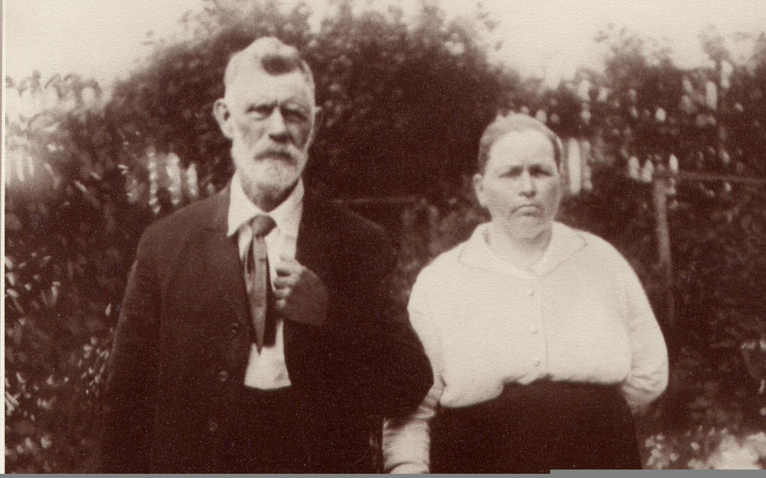

He married Ellen Martha Grubb Kibbey, born 10 Mar 1871 in Greenup County, Kentucky, (daughter of Andrew Grubb and Elizabeth Burchett Grubb) died 13 May 1925 at Iron Hill, Carter County, Kentucky.

Children:
16. i. James Luther⁵ Kibbey born 8 Apr 1891.
ii. Orville E. Kibbey, born 1895.
17. iii. Leonard H. Kibbey born 12 Oct 1900.
iv. Robert E. Kibbey, born 1902.
v. Walter C. Kibbey, born 1904.
vi. Ethel L. Kibbey, born 1906.
vii. Samuel E. Kibbey, born 1908 in Carter County, Kentucky, occupation Farmer.

He married 12 Sep 1928 in Carter County, Kentucky, wedding official Clark O'Banion at the home of Clark O'Banion, Hazel Pence Kibbey, born 1910 in Carter County, Kentucky, (daughter of Lewis Pence and Jossie Ash Pence).

Hazel: Hazel and Samuel were married in the presence of Robert Kibbey and John Frank Davis.

viii. Herbert P. Kibbey, born 1910.

10. Laura Jane "Jennie" Kibbey⁴ McGlone, (John E.³ Kibbey, Malinda Everman², John¹ Everman) born 22 Aug 1877, died 3 May 1937.

She married Benjamin Franklin "Frank" McGlone, born 11 Nov 1869, (son of Joseph Harvey McGlone and Frances Ann McCleese McGlone) died 6 Dec 1950.

Children:
18. i. Edgar Allen "Jake"⁵ McGlone born 19 Sep 1897.
ii. Alvis D. McGlone, born 5 Nov 1899, died 28 Feb 1988 in Carter County, Kentucky.
19. iii. Denver McGlone born 1 Mar 1901.
iv. Thelma McGlone England, born 11 Nov 1909 in Manchester, Ohio.

She married Manuel England, born 27 Feb 1853, (son of William Lee England and Elizabeth Yates England) died 3 Mar 1965.

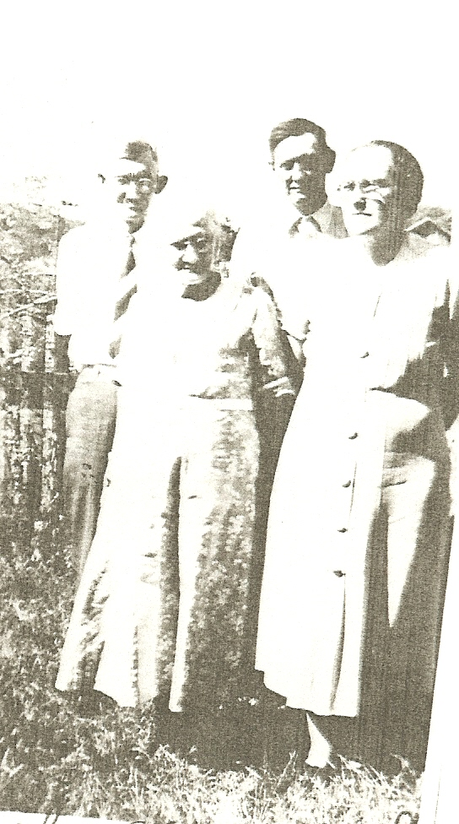

Generation Five

11. Edgar T.⁵ Everman, (William Riley⁴, John Thomas³, Samuel², John¹) born 26 Jun 1883 in Carter County, Kentucky, died 1969, buried in Everman Creek Cemetery, Carter Co., Ky., occupation Farmer.

Pictured are Edgar Everman, John Everman, Alpa Everman and Pearl Everman Harris, in the front yard of the home of Alpha McGinnis. Edger and Ethel were married in the presence of Alvis Zornes and Charles Zornes.

He was married 1 Apr 1908 in Carter County, Kentucky, by wedding official Rev. George W. Staggs in the home of Jarett Zornes, Ethel May Zornes Everman, born 1890 in Carter County, Kentucky, (daughter of Jarrette Zornes and Mary Smith Zornes) buried in Everman Creek Cemetery, Carter Co., Ky. Pictured is Ethel Everman.
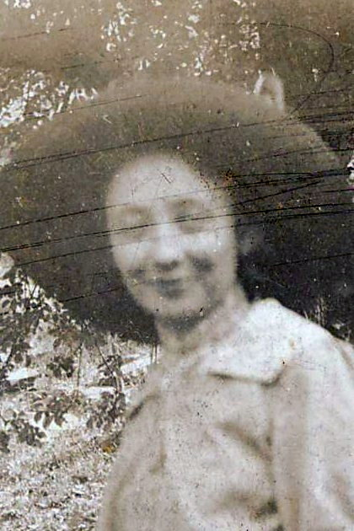

Children:
20. i. Elwood W.⁶ Everman born 2 Feb 1909.

12. Molly Everman⁵ Harris, (William Riley⁴ Everman, John Thomas³, Samuel², John¹) born 21 Oct 1884, died 4 Sep 1916.

Pictured are Pearl Everman Harris (standing) and her sister Molly Everman Harris (seated). Molly and Pearl married brothers.
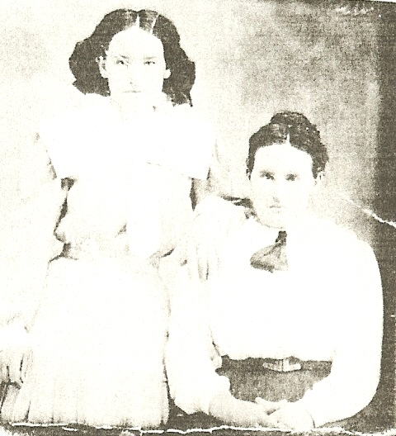

She married 17 Apr 1906, Cyrus Grimms "C. G." Harris, born 11 Mar 1882, (son of David R. Harris and Fanny Maddox Harris) died 16 Jan 1971.

Cyrus: Pictured back - Pearlie Everman. Seated - C. G. Harris and on his lap Hazel Harris and Molly Harris and on her lap Bill Harris. Photo taken in 1910.

Children:
21. i. Hazel Harris⁶ McGlone born 4 Mar 1907.
22. ii. William Edgar "Bill" Harris born 13 Jun 1908.
23. iii. Ruth Mae Harris Rupert born 9 Jan 1912.
iv. Anna Lee Harris McGlone, born 25 Aug 1913, died 30 Jun 1997 in Lemore, California.
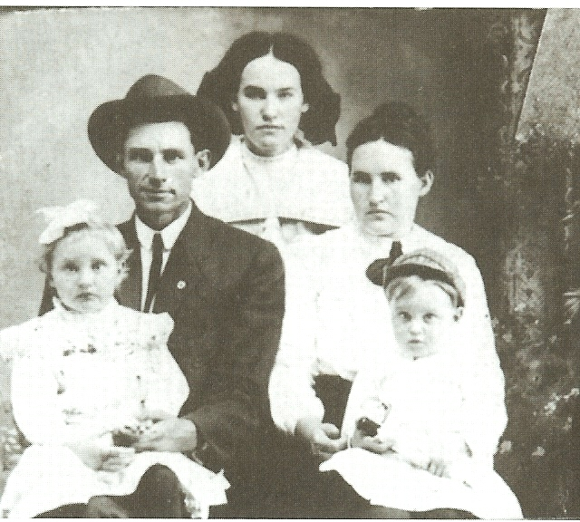

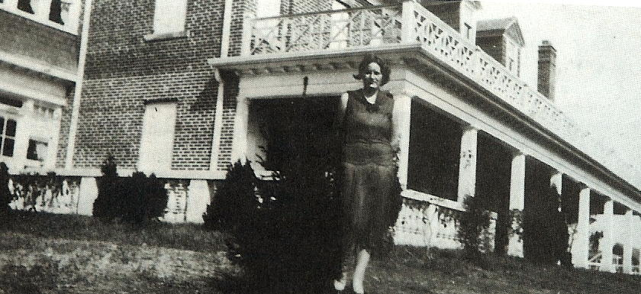

Pictured is Anna Lee Harris McGlone standing in back of the Bagby Mansion, now Grayson Rural Electric Corp., Grayson, Kentucky.

She married 25 Dec 1935, in Grayson, Carter County, Kentucky, Russell "Rags" McGlone, born 11 Sep 1913, (son of Noah "Cap" McGlone and Elizabeth Messer McGlone).

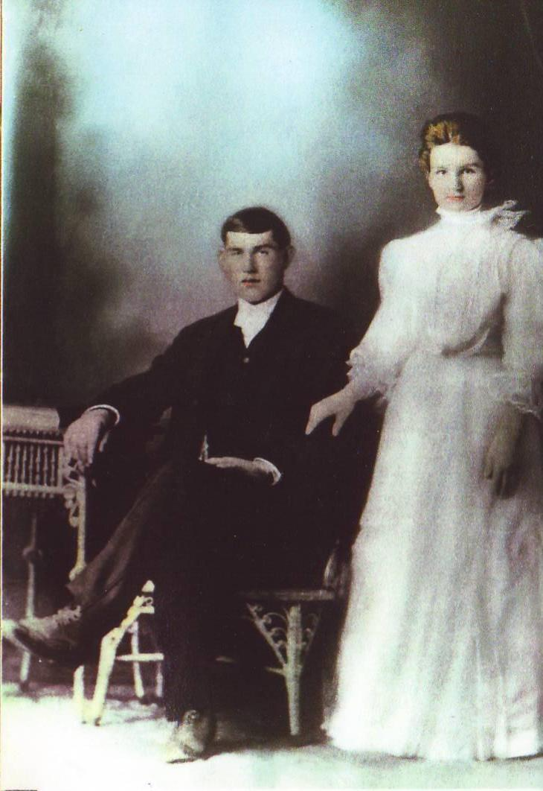

13. John David Lee⁵ Everman, (William Riley⁴, John Thomas³, Samuel², John¹) born 18 Dec 1888 in Carter County, Kentucky, died 1959, occupation Lumber dealer.

John and Laura were married in the presence of William R. Everman and Amanda Harris. According to a note made on their marriage license, permission for Laura to marry John was granted by James Ramey.

He married 17 Jan 1906 in Carter County, Kentucky, wedding official James S Everman in Home of James W. Ramey, Laura Gertrude Ramey Everman, born 1886 in Carter County, Kentucky, (daughter of James William Ramey and Alice Crowe Ramey) died 1958, occupation Teacher.
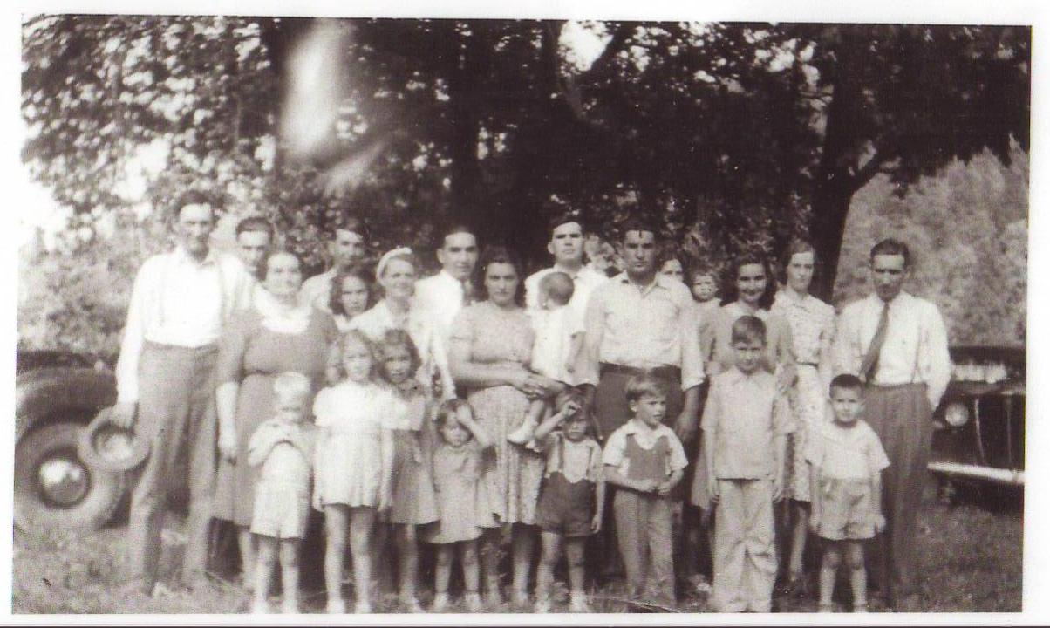

Laura: Pictured is the John and Laura Everman family, taken cira 1940.

Children:
24. i. Mabel Ramey Everman⁶ Underwood born 20 Mar 1907.
25. ii. William Russell Everman born 17 Oct 1908.
26. iii. Willis James Everman born 6 Sep 1910.
27. iv. Clyde Thomas Everman born 7 Mar 1913.
28. v. Woodrow Lee Everman born 18 Dec 1914.
29. vi. Pansy Everman Foster born 13 Dec 1916.
vii. Lilly M. Everman, born 23 Jun 1919, died 28 Jan 1922.
viii. John David Everman, born 12 Apr 1921, died 29 Sep 1921, buried in Everman Creek Cemetery, Carter Co., Ky.
30. ix. Arthur Everman born 22 Feb 1923.
31. x. Edgar Bruce Everman born 6 Dec 1924.
32. xi. Ruth Everman Connelly born 26 Nov 1927.

14. Pearl Annis Everman⁵ Harris, (William Riley⁴ Everman, John Thomas³, Samuel², John¹) born 13 Mar 1894, died 29 Dec 1972.
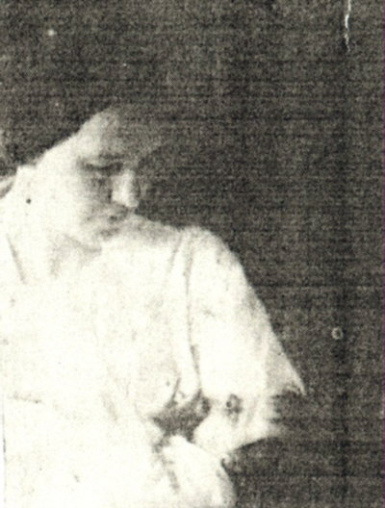

Pictured is Pearl Harris holding her daughter, Mary Tom Harris.

She married 21 Aug 1914, Roy Haven Harris, (son of David R. Harris and Fanny Maddox Harris) died 29 Jun 1966.

Roy: The Harris family Bible lists Roy's date of birth as 1/20/1888 and his obit list the date as 1/19/1889.

Children:
i. Alpha Bernice⁶ Harris, born 26 Jul 1915, died 27 Sep 1917, buried in Everman Creek Cemetery, Carter Co., Ky.
ii. William David Harris, born 26 Nov 1918, died 22 Feb 1944 in England.
William never married. He was killed during World War II.
33. iii. Clarence Edgar "Brownie" Harris born 26 Nov 1920.
iv. Mary Tom Harris Crum, born 15 Apr 1923.

She married 16 Feb 1944, Mat Crum.

v. Jack Lee Harris, born 9 Aug 1925, died 10 Jan 1994.

He married 19 Apr 1946, in Greenup County, Kentucky, Betty Ruth Lewis Harris.

vi. Russell Everman Harris, born 9 Dec 1927, died 21 Dec 1951.

Russell never married.
vii. Anna Fern Harris, born 25 May 1931.

Anna never married.

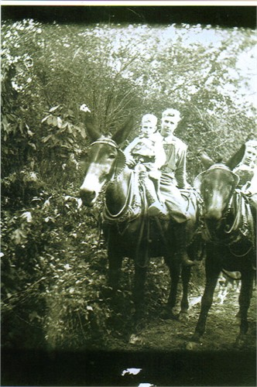

15. Ora⁵ Everman, (James Lee⁴, John Thomas³, Samuel², John¹) born 13 Jul 1895 in Carter County, Kentucky, died 30 Sep 1977 in Carter County, Kentucky.

Pictured is Ora riding mules with his sons Raymond and Virgil, riding mules.

He married 17 Oct 1919 in Carter County, Kentucky, wedding official R. H. Gee in DeEverett, Carter Co., Ky., Katherine "Katie" Forrest Everman, born 19 Apr 1895 in Carter County, Kentucky, (daughter of Samuel Hansford Forrest and Mary Lumpkies Forrest) died 25 Apr 1974 in King's Daughters' Medical Center, Ashland, Boyd County, Kentucky, religion Holiness.
Katherine: Pictured are Ora and Katie circa March 1956 at their home on Rock House Road. Katie and Ora were married in the presence of Betty Adams and Generva Gee.
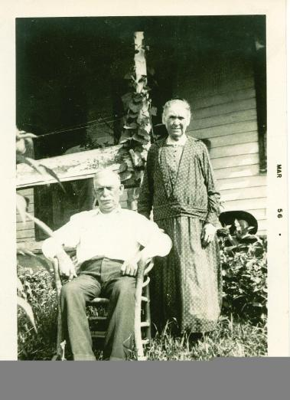

April 25, 1974
Mrs. Kate Everman
Mrs. Kate Everman, 78, Rt. 3 Grayson, died Wednesday, April 17, 1974 in King's Daughters' Hospital following an extended illness.
Mrs. Everman was born April 19, 1895, in Carter County, Kentucky, a daughter of the late Sam and Mary Lumpkins Forrest. She was a member of the Holiness Church.
Surviving are her husband, Ora Everman; two sons, Raymond R. Everman of Columbus; a daughter, Mrs. Judy L. Holbrook of Mansfield; a brother, Dan Forrest of Grandview, Washington; a sister, Mrs. Ann Adv Redmond of Argillite; six grandchildren, and two great-grandchildren.
Funeral services were conducted at 11 a.m. Saturday at the Ironhill Church of Christ by the Rev. John Maggard and the Rev. Allen Fox. Burial was in the Grayson Memorial Gardens.

Children:
i. Raymond R.⁶ Everman.
ii. Virgil H. Everman, born Nov 1925 in Carter County, Kentucky, died 5 Aug 1994 in Ohio.

Pictured are Virgil, Raymond and Myrtle.

He married (1) Bonnie Everman.
He married (2) Louise Southerland Everman.
He married (3) Karen Everman.

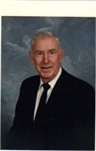

34. iii. Judy L. Everman Holbrook.
iv. Russell R. Everman, born 1924 in Grayson, Carter County, Kentucky.

Pictured is Russell R. Everman.

He married (1) Myrtle Burchett Everman, born 7 Apr 1932 in Olive Hill, Carter County, Kentucky, (daughter of Bruce Burchett and Stella Munia Lawhorn Burchett Gilliam) died 22 Mar 1906 in Morehead, Rowan County, Kentucky.
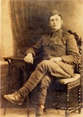

He married (2) Bea Pelfrey Everman.

16. James Luther⁵ Kibbey, (James Thomas "Jim"⁴, John E.³, Malinda Everman², John¹ Everman) born 8 Apr 1891 in Charlotte Furnace, Carter County, Kentucky, died 18 Apr 1965 in Veteran's Hospital Tucson, Pima County, Arizona, buried in Southlawn Cemetery, Tucson, Pima County, Arizona, religion Freewill Baptist, occupation Farmer/Minister/Soldier, ordination 2 Aug 1941 at Minister Of the Gospel of the Freewill Baptist Church, at Bethlehem, Logan, West Virginia, USA.

Pictured is James Luther Kibbey. James served as a Corporal, Service No. 12-010-615, in Company F, US Army 26th Infantry, during World War I. His name is on a Monument to World War I Veterans who served from Carter, Kentucky, USA, in front of the Carter, Kentucky, USA Courthouse, Kentucky. During the war James was gassed with chlorine gas which damaged his lungs. He died of terminal aspiration bronchopneumonia, Marked pulmonary emphysema & corpulmonale.
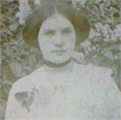

James was 5'7" tall, with brown hair and blue eyes.
. He married 9 Dec 1914 in Carter County, Kentucky, wedding official Rev. James Sanders E, Rosa Alice Bush Kibbey, born 29 Dec 1896 in Charlotte Furnace, Carter County, Kentucky, (daughter of Edward Clayton Bush and Arminta "Minta" Stephens Bush) died 13 Feb 1917 in Carter County, Kentucky.

Rosa: Pictured is Rosa Alice Bush Kibbey. Rosa and James were married in the presence of E. F. Keaton and Henry Kottcamp. Rosa was James' third wife.

Children:
35. i. Lillis Bessie Kibbey⁶ Burge born 29 Oct 1915.
ii. Bernie L. Kibbey, born 29 Oct 1915 in Carter County, Kentucky.

17. Leonard H.⁵ Kibbey, (James Thomas "Jim"⁴, John E.³, Malinda Everman², John¹ Everman) born 12 Oct 1900 in Charlotte Furnace, Carter County, Kentucky, died 21 Oct 1960 in Ortonville, Oakland County, Michigan, buried in Burnett Cemetery, Tygart's Creek Road, Iron Hill, Carter County, Kentucky, occupation Carpenter, Laborer at Rubber Plant, Farmer, resided 1920 in Akron, Summitt County, Ohio, resided 1930 in Pitt, Wyandott County, Ohio.
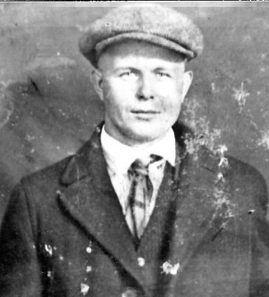

Pictured is Leonard H. Kibbey. World War I Draft Registration description: Medium height, Stout, Blue eyes, Brown hair. Age at Death: 60 years, 0 months, 9 days
.

He married 15 Mar 1926 in Carter County, Kentucky, wedding official Arthur Jarvis at Grayson, Carter County, Kentucky, Edna Bell Burnett Kibbey, born 27 Oct 1907, (daughter of Henry "Poppy" Newman Burnett and Lucy Jane Wicker Burnett) died 24 Jul 1943, buried in Burnett Cemetery, Tygart's Creek Road, Iron Hill, Carter County, Kentucky.
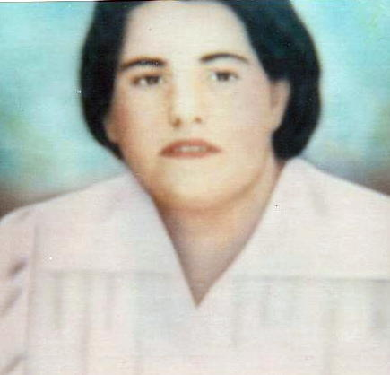

Edna: Edna and Leonard were married in the presence of Mrs. Arthur Jarvis, Mary James and Henry Burnett.

Children:
36. i. Lawrence Lee⁶ Kibbey born 1 Oct 1925.
37. ii. Linwood Kibbey.
iii. Norman Kibbey, born 20 Feb 1927 in Carter County, Kentucky, died 24 Mar 1927 in Iron Hill, Carter County, Kentucky.

Norman died from smallpox.

18. Edgar Allen "Jake"⁵ McGlone, (Laura Jane "Jennie" Kibbey⁴, John E.³ Kibbey, Malinda Everman², John¹ Everman) born 19 Sep 1897, died 29 Oct 1980 in Rowan County, Kentucky.

He married Bess McGlone.

Children:
i. Roberta⁶ McGlone.
ii. Phyllis McGlone.
iii. Henry F. McGlone.

19. Denver⁵ McGlone, (Laura Jane "Jennie" Kibbey⁴, John E.³ Kibbey, Malinda Everman², John¹ Everman) born 1 Mar 1901 in Carter County, Kentucky, died 2 Oct 1970 in Carter County, Kentucky, buried in Bethel Church Cemetery, Route 2, Carter County, Kentucky.

He married 1927, Goldie Fannin McGlone.

Children:
i. James D.⁶ McGlone.
ii. Charles E. McGlone.

Generation Six

20. Elwood W.⁶ Everman, (Edgar T.⁵, William Riley⁴, John Thomas³, Samuel², John¹) born 2 Feb 1909, died 21 Feb 1934, buried in Everman Creek Cemetery, Carter Co., Ky.

The Everman Cemetery is located near the home of Ray Harris on Buffalo. Kehoe, Rt. 7, Grassy Hill, turn right before crossing bridge, up holler 1/2 mile.

He married 5 Sep 1928, Ruby Javins Pretty Everman, born 26 Jan 1911, buried in Everman Creek Cemetery, Carter Co., Ky.

Children:
i. Betty Jean⁷ Everman, .
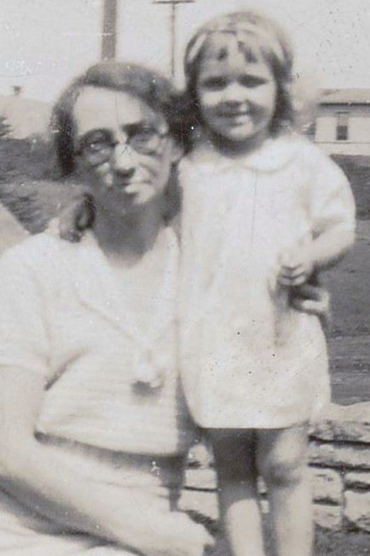

Pictured are Betty Jean and her grandmother Ethel.
ii. Woody Everman.

21. Hazel Harris⁶ McGlone, (Molly Everman⁵ Harris, William Riley⁴ Everman, John Thomas³, Samuel², John¹) born 4 Mar 1907, died 14 Nov 1991, buried in Everman Cemetery, Carter Co., Ky.

She married 25 Apr 1931, Oscar Epperson "Epp" McGlone, born 3 Feb 1906, (son of Noah "Cap" McGlone and Elizabeth Messer McGlone) died 31 Mar 1984, buried in Everman Cemetery, Carter Co., Ky.

Children:
i. Wilma Ann⁷ McGlone, born 11 Feb 1934, died 1 Nov 1935.
38. ii. Jackie Lee McGlone born 31 Oct 1936.

22. William Edgar "Bill"⁶ Harris, (Molly Everman⁵, William Riley⁴ Everman, John Thomas³, Samuel², John¹) born 13 Jun 1908 in Grayson, Carter County, Kentucky, died 1 Dec 1977.

He married 10 Mar 1934, in Greenup County, Kentucky, Eldeane Logan Harris, born 30 Oct 1912, (daughter of Marshall F. Logan and Amy Jesse Logan) died 20 May 1991.

Children:
i. Joan Frances⁷ Harris, born 2 Jan 1941 in Bucyrus, Ohio, died 2 Jan 1941 in Bucyrus, Ohio.
39. ii. Carolyn Sue Harris Pirschel born 21 Dec 1941.
40. iii. Patricia Ann Harris Arlington Tracy born 26 Nov 1943.

23. Ruth Mae Harris⁶ Rupert, (Molly Everman⁵ Harris, William Riley⁴ Everman, John Thomas³, Samuel², John¹) born 9 Jan 1912.

She married 12 Jun 1932, in Catlettsburg, Boyd County, Kentucky, Elton Christopher "Dick" Rupert, born 1 Nov 1903 in Carter County, Kentucky, (son of Christopher Rupert and Katharine "Kate" Everman Rupert) died 16 Jan 1971.

Children:
41. i. Mary Christine Rupert⁷ McGlone born 11 May 1933.

24. Mabel Ramey Everman⁶ Underwood, (John David Lee⁵ Everman, William Riley⁴, John Thomas³, Samuel², John¹) born 20 Mar 1907 in Carter County, Kentucky, died 19 Jun 1993 in Adams County, Ohio.
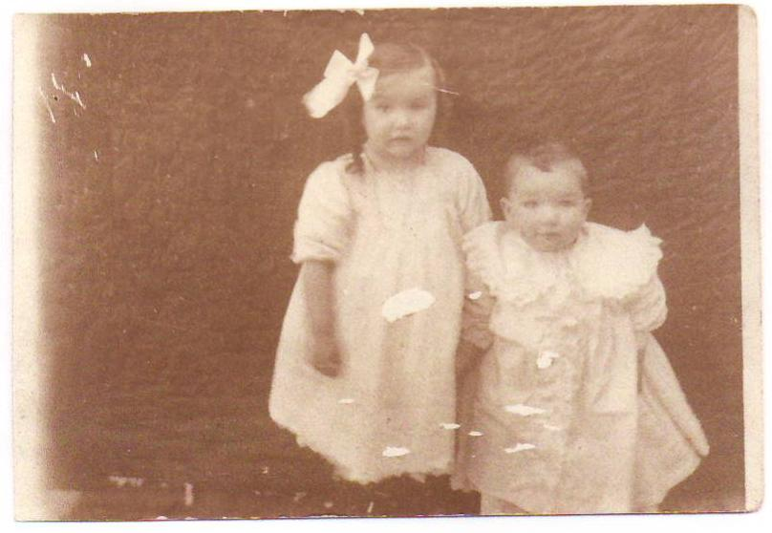

Pictured are Mabel and her little brother, Russell. Mabel and Tillman were married in the presence of Winnifred Crouch McCombe and John McCombe, Jr.

She married 14 May 1927 in Carter County, Kentucky, wedding official John H McCombe at Ashland, Boyd County, Kentucky, Tillman Underwood, born 30 Sep 1895 in Carter County, Kentucky, (son of Robert Daniel Underwood and Mary Elizabeth "Lizzie" Harris Underwood) died 18 Jun 1976 in Cincinnati, Hamilton County, Ohio, occupation Farmer.

Tillman: According to family folklore, Jesse James and his brother, Frank came to hide out at the Robert Daniel Underwood home place once. They had work clothes on over their more fancier clothes, but the children caught a glimpse of their guns. They worked for a time for Daniel in exchange for him offering them a place to hole up. They tried to pay him when they left but he refused to take money from them.

Children:
42. i. Richard Tillman⁷ Underwood born 18 Jul 1929.
43. ii. Faye Underwood Hardert born 9 Apr 1932.

25. William Russell⁶ Everman, (John David Lee⁵, William Riley⁴, John Thomas³, Samuel², John¹) born 17 Oct 1908 in Charlotte Furnace, Carter Co., Ky., died 11 May 1990 in Upland, San Bardino County, California.
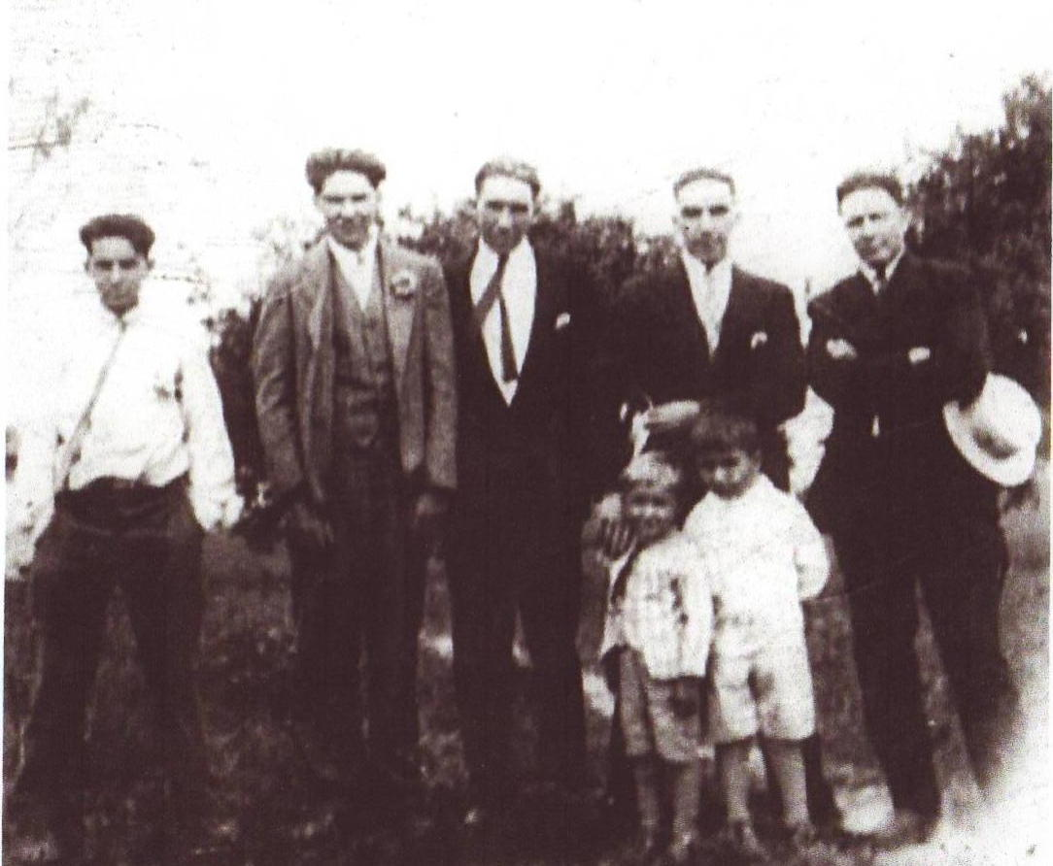

Pictured Left to right: Woodrow Everman, Clyde Everman, Willis Everman, Russell Everman, Tillman Underwood
Boys in front: Edgar Everman, Arthur Everman
.

He married 17 Sep 1932, Minnie Louise Bradford Everman, born 14 Sep 1909 in Kehoe, Greenup County, Kentucky.

Children:
44. i. Betty Lou Everman⁷ Jackson born 22 Jan 1934.
45. ii. Patricia Eleanor Everman Myers born 6 Feb 1939.
46. iii. John Robert Everman born 20 Aug 1945.

26. Willis James⁶ Everman, (John David Lee⁵, William Riley⁴, John Thomas³, Samuel², John¹) born 6 Sep 1910 at Charlotte Furnace, Carter County, Kentucky, died 18 Jan 1985 in VA Hospital, Huntington, Wayne Co., WV, buried 21 Jan 1985 in East Carter Memory Gardens, U.S. 60, Grayson, Carter County, Kentucky, occupation Surveyor.
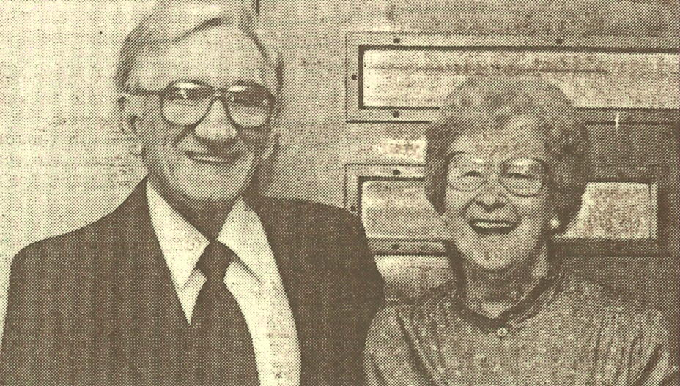

At the time of his death, Willis had 16 grandchildren and 12 great grandchildren. His funeral services were conducted at Malone Funeral Home by J.L. Craft and Charles Lybrook.

He married 15 Apr 1933 in Carter County, Kentucky, Myrtle Williams Everman, born 3 Sep 1913, (daughter of William Hugh "Hughy" Williams and Anna McCleese Williams).

Children:
47. i. William John "Bill"⁷ Everman born 15 May 1934.
48. ii. Anna Frances Everman Worthington born 21 Sep 1935.
49. iii. Hubert Wayne Everman born 6 Jan 1938.
50. iv. Donald Hugh Everman born 20 Jul 1942.

27. Clyde Thomas⁶ Everman, (John David Lee⁵, William Riley⁴, John Thomas³, Samuel², John¹) born 7 Mar 1913 in Carter County, Kentucky, died 7 Feb 1996 in Fort Mitchell, Ky., buried 10 Feb 1996 in Highland Cemetery, Fort Mitchell, Ky., religion Baptist, occupation Teacher.

Clyde was a vocational teacher, a World War II Navy veteran and a member and deacon at Calvary Baptist Church of Ashland. His funeral arrangements were handled by Chambers and Grubbs Funeral Home at Independence. Clyde and Mildred were married in the presence of Willis Everman and Mildred Hord.

He married 29 Jun 1935 in Carter County, Kentucky, wedding official Clark O'Banion in Grayson, Carter County, Kentucky, Mildred Opal Kiser Everman, born 22 Nov 1909 in Carter County, Kentucky, (daughter of Noah Kiser and Bettie Turner Kiser).

Children:
i. Betty Laura⁷ Everman, born 14 Jun 1940.
51. ii. Robert Clyde Everman born 26 May 1949.

28. Woodrow Lee⁶ Everman, (John David Lee⁵, William Riley⁴, John Thomas³, Samuel², John¹) born 18 Dec 1914 in Carter County, Kentucky, occupation Farmer/Sheriff, died 28 Nov 1998.

Pictured Left to right:
Woodrow Everman, Clyde Everman, Willis Everman, Russell Everman, Tillman Underwood
Boys in front:
Edgar Everman, Arthur Everman

Woodrow was a member of the Faith Baptist Church, Briary Road at Quincy. He was the retired owner and operator of Everman Lumber Company. He served as the Lewis County Sheriff from 1958 to 1961. At the time of his death Woodrow had 18 grandchildren and 34 great grandchildren. His funeral services were conducted at the Gaydos Funeral Home in Vanceburg, Kentucky by Rev. Tim Underwood and Rev. Roy Humble. Woodrow's epitaph reads "Together Forever".

He married 30 Nov 1935 in Carter County, Kentucky, wedding official Nelson Webb at Charlotte Furnace, Carter Co., Ky., Phoebe Isabelle McDaniel Everman, born 19 Dec 1918 in Greenup County, Kentucky, (daughter of Samuel Allen McDaniel and Arminta "Minnie" Felty McDaniel) died 4 Apr 2007 in Southern Ohio Medical Center, Scioto County, Ohio, buried 7 Apr 2007 in Everman Cemetery, Grassy, Carter County, Kentucky.
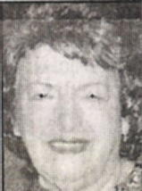

Phoebe: Phoebe and Woodrow were married in the presence of Pansy Everman and Anna Lee Harris. Phoebe passed away after a five day stay in the medical center. She had been lovingly cared for at her home for the past two years by her devoted daughter, Mary Alice.

Phoebe enjoyed quilting, music, shopping and truly had a green thumb that showed in her beautiful plants and flowers around her home. Phoebe's love for music endured to the end. Phoebe went to be with the Lord with the son, "What Friend We Have in Jesus" being whistled into her hear.

Phoebe was a devoted homemaker who regularly prepared lavish and bountiful meals. She served family, friends, and business associates with the hospitality that caused her to be praised by the many who had the pleasure to sit at her table. Phoebe was a tremendous blessing and inspiration to her family who loved her very much.

Phoebe's quick wit, humor and hospitable ways made her a unique individual who touched the lives of all who knew her. Phoebe will be sadly missed by her family, friends and church family of Faith Baptist Church on Briary Road in Quincy, Kentucky, where she was a member.
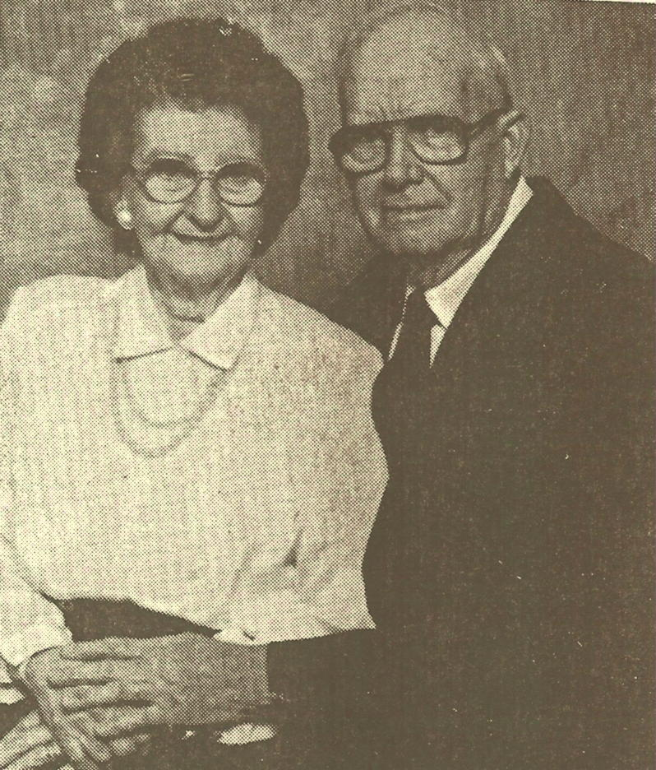

At the time of her death Phoebe had 19 grandchildren, 37 great-grandchildren, and 12 great-great-grandchildren. Her funeral serviced were conducted at the Garrison Funeral Home Chapel by Brother Roy Humble of Michigan and brother Tim Underwood of Garrison, Ky.

Children:
52. i. James Woodrow⁷ Everman born 2 Aug 1936.
53. ii. Glen Allen Everman born 20 Jan 1938.
54. iii. Mary Alice Everman Underwood born 29 Feb 1940.

29. Pansy Everman⁶ Foster, (John David Lee⁵ Everman, William Riley⁴, John Thomas³, Samuel², John¹) born 13 Dec 1916 at Iron Hill, Carter County, Kentucky, died 12 Jun 2001 in South Shore, Greenup Co., Ky., buried 15 Jun 2001 in Everman Cemetery, Grassy, Carter County, Kentucky, occupation Teacher.

On the occasion of their golden anniversary, Pansy and Jim were honored with a reception at their home, hosted by their children. At the time of her death, Pansy had four grandchildren and one great-grandchild. Pansy was a member of the Emmanuel Baptist Church. Her funeral was conducted a the Emmanuel Baptist Church in Oldtown by Rev. John Hatcher.

She married 17 Jan 1946 in Carter County, Kentucky, wedding official Nelson Webb in the home of John Everman at Boone, Carter Co Ky, James R. "Jim" Foster, born 23 Mar 1922 in Gallet, Floyd County, Ky., (son of James Davis Foster and Tempie Leota Bradford Foster) died 7 Nov 2005 in South Shore, Greenup Co., Ky., buried 10 Nov 2005 in Everman Cemetery, Carter County, Kentucky.
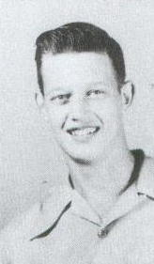

James: Pictured is Jim in 1952 when he was a Sophmore at Carter High School. Jim was the former pastor of First Baptist Church in Garrison, Kentucky; First Baptist Church in South Shore and the Emmanuel Missionary Baptist Church at Oldtown and was a World War II veteran. Jim also worked at John's Lumber Company. At the time of his death Jim had the following great-grandchildren: Abigail Hatcher, Nathalie Hatcher and Camille Hatcher. His funeral services were conducted at Oldtown Missionary Baptist Church with Rev. James Stephens, Elder John Lybrook and Elder John Hatcher officiating, with graveside military services by James L. Flannery, American Legion Post 276 of South Shore, Kentucky.

Children:
i. Peggy⁷ Foster, born 5 Mar 1947.
55. ii. Judy Foster Hatcher born 19 Apr 1953.

30. Arthur⁶ Everman, (John David Lee⁵, William Riley⁴, John Thomas³, Samuel², John¹) born 22 Feb 1923.

He married (1) Mary Boyle Everman, born 18 May 1925, (daughter of Patrick Boyle and Elizabeth Bushy Boyle).

Children:
i. David Patrick⁷ Everman, born 3 Sep 1945.
56. ii. Michael Leonard Everman born 11 Apr 1950.
57. iii. Elizabeth Ann Everman Eckman born 14 Apr 1955.

He married (2) Jerry Cowan Everman.

Children:
iv. Pamela Ruth Everman, born 25 Nov 1965.

He married (3) Patty McCullough Park Everman.

31. Edgar Bruce⁶ Everman, (John David Lee⁵, William Riley⁴, John Thomas³, Samuel², John¹) born 6 Dec 1924 in Gesling, Carter County, Kentucky, occupation Surveyor/Land Developer/Farmer/Merchant/Coal Operator, religion Baptist.

Edgar and Dixie were married in the presence of Willis J. Everman and Garnet B. Carico. Edgar attended Carter High School and served in the U.S. Navy during World War II. Edgar is highly active in the Republican party and campaigns. He is a member of the DAV, VFW and NRA.

He married 2 May 1944 in Carter County, Kentucky, wedding official Alonzo Autland at Grayson, Carter County, Kentucky, Dixie Counts Everman, born 1928 in Carter County, Kentucky, (daughter of Mortan Counts and Georgia Mae Counts).

Dixie: Dixie is the owner of the Grayson Bowling Alley and manages their many rental properties.

Children:
i. Bruce Winston⁷ Everman, born 8 Jan 1950.
58. ii. Kathy Christine Everman Hockley born 23 Mar 1951.
iii. Tamara Diana Everman Burton Williams, born 5 Jan 1959, occupation CPA.

She married (1) Keith Burton.
She married (2) David Williams.
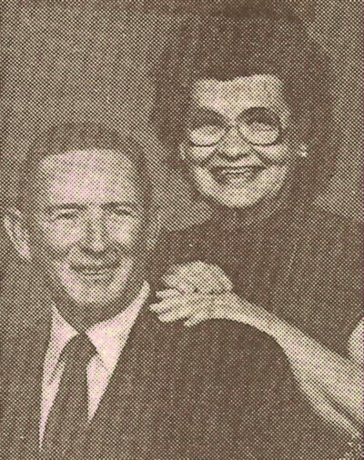

32. Ruth Everman⁶ Connelly, (John David Lee⁵ Everman, William Riley⁴, John Thomas³, Samuel², John¹) born 26 Nov 1927.

She married 22 Jul 1944, John Carl Connelly, born 14 May 1925, (son of Royal Connelly and Verna Evans Connelly).

John: In honor of his 50th wedding anniversary with Ruth, Carl wrote the following poem (the following has been typed exactly as written by John):

Love Letters

Locked away in the attic snug'n a box lay letters of love almost forgotten, but not, for the love expressed their lives on and on and on shared these more than fifty years in our little home.

Our children may not know this that life is not always smoothe, but that which makes it work always is that ever abiding love.

Not all those letters speak of love some may be a little bitter, the ones that reveal a little spat only makes the next one sweeter.

Looking back those fifty years when our marriage vows were spoken. It was God's gift of love and making us one that our vows shall not be broken.

Now looking back more than fifty years it doesn't seem so long at all that we smiled at each other as we changed classes and passed notes in the hall.

Now the children we've been blessed with our daughters, four. All have their own families, our eleven grandchildren and more.

For the love letters in the attic tho at rest for many years, still speak through our children that the things written are dear.

Children:
59. i. Laura Faye Connelly Zamarron⁷ Boswell born 8 Aug 1945.
60. ii. Carlene Sue Connelly Riner born 8 Apr 1949.
61. iii. Verna Kay Connelly McDowell Hardin born 30 Nov 1954.
62. iv. Vickie Lee Connelly Zamarron born 23 Jun 1956.

33. Clarence Edgar "Brownie"⁶ Harris, (Pearl Annis Everman⁵, William Riley⁴ Everman, John Thomas³, Samuel², John¹) born 26 Nov 1920.

He married 10 Apr 1943, Essie Mae Fultz Harris.

Children:
i. Tim⁷ Harris, born 1955, occupation Teacher-Special Ed.

Tim was fortunate to get interested in his family history early, thanks to his grandmother, Pearl. When she passed away, she left all her old pictures to Tim to go with the many stories she had told him.

34. Judy L. Everman⁶ Holbrook, (Ora⁵ Everman, James Lee⁴, John Thomas³, Samuel², John¹) born in Boyd County, Kentucky.
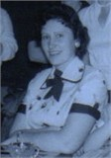

Pictured is Judy Holbrook.

She married Eugene Holbrook.

Children:
i. David⁷ Holbrook.
ii. Randy Holbrook.
iii. Steve Holbrook.
iv. Russ Holbrook.

35. Lillis Bessie Kibbey⁶ Burge, (James Luther⁵ Kibbey, James Thomas "Jim"⁴, John E.³, Malinda Everman², John¹ Everman) born 29 Oct 1915 in Kehoe, Greenup County, Kentucky, baptized in Carter County, Kentucky, died 19 Mar 2003 in Grayson, Carter County, Kentucky, buried in Horsley (Rock Springs) Cemetery, Gesling, Carter County, Kentucky, religion Carter Christian Holiness Church, Carter, Carter County, Kentucky, occupation Carter Elementary School Cook, saved in Carter County, Kentucky, resided 1920 in Charlotte Furnace, Carter County, Kentucky, resided 1930 in Logan, Logan County, West Virginia, resided 2000 in Carter, Carter County, Kentucky.

Pictured is Lillis as a young teenager.

Lillis was a wonderful and joyous person to be around. Even in her last days when she wasn't necessarily feeling well, she had a positive attitude and a bright smile. She was the type of person that would tell it to you, just like it is, whether you wanted to hear it or not, because she knew it was what was best for you.

Lillis was a wonderful cook and worked for many years as a cook for the Carter School system. After she was saved, Lillis loved to go to Church and was there at every opportunity.

Lillis died as a result of colon cancer.

She married 21 Apr 1931 in Carter County, Kentucky, Charles Burge, born 20
Jan 1902 in Iron Hill, Carter County, Kentucky, (son of Floyd Preston Burge
and Matilda Timberlake Burge) and pictured here, died 5 May 1986 in Carter Co.

Children:
- Inez Pauline⁷ Burge, born 4 Feb 1934 in Carter County, Kentucky,
died 4 Feb 1934 in Carter County, Kentucky.
63. ii. Elwood Burge born 3 Jan 1935.
iii. Carl L. Burge, born 15 Oct 1936 in Carter County, Kentucky.

He married Janet Burge.

iv. Steve Paul Burge, born 24 Nov 1938 in Carter County, Kentucky, died 11 Feb 1962 in Boyd County, Kentucky, buried in Horsley (Rock Springs) Cemetery, Gesling, Carter County, Kentucky.
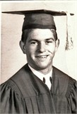

Pictured is Steve Burge in his cap and gown, as he graduated from Carter High School. Steve was killed in an automobile accident.
64. v. Walter Franklin "W.F." Burge born 17 Apr 1941.
vi. Arnold Burge.

He married Linda Burge.

vii. Ronnie Burge.
viii. Charles "Skip" Burge.

He married Ruthann Burge, resided 2006 in Holland, Michigan.

ix. Myrtle Burge Cline, buried 2006 in Flint, Michigan.
x. Judy Burge Cartee, resided 2006 in Carter County, Kentucky.
xi. Bobby G. Burge, born 1953.
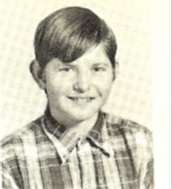

Pictured is Bob Burge as he appeared in the 1968 Wildcat yearbook for Carter High School. After completing the new home he and Joann built, Bob added a large detached garage so he would have room for his hobby of restoring cars. In the latter years of her life, Lillis lived in a trailer in the end of her yard, next to Bob’s house, so that he would be close by to see to her care.

He married Joann Lewis Brown Burge, born 15 May 1949 in Boyd County, Kentucky, (daughter of Edward L. Lewis and Lillian O. Stamper Lewis Greer) died 6 Dec 1995 in King's Daughters' Medical Center, Ashland, Boyd County, Kentucky, buried 9 Dec 1995 in Richardson Family Cemetery., Carter Co., Ky., saved Oct, religion Carter Christian Holiness Church, Carter, Carter County, Kentucky, occupation Teacher.

Joann: Pictured is Joann and her mother-in-law, Lillis, leaving after Sunday morning church services.
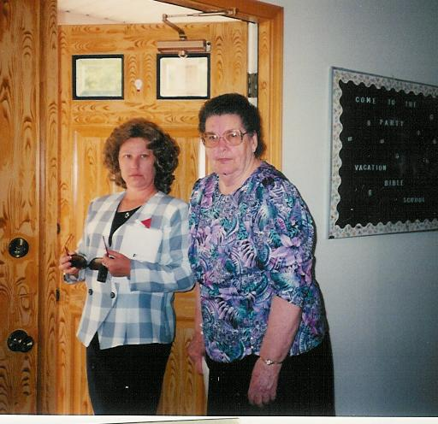

Joann taught music at Carter Elementary School for twenty-five years and was pianist for the Carter Christian Holiness Church. She had played piano for a number of years for the gospel group, "Five for the Gospel". She had a talent that was truly God given. Even more she was a beautiful Christian person who loved to smile and to make others smile with her.

When Joann finally succumbed to cancer, her funeral services were conducted by Bill Burnett, Everett Burnett, and Russell Burnett.

xii. Roscoe Burge, born 1957 in Carter County, Kentucky, died 1957 in Carter County, Kentucky.

36. Lawrence Lee⁶ Kibbey, (Leonard H.⁵, James Thomas "Jim"⁴, John E.³, Malinda Everman², John¹ Everman) born 1 Oct 1925 in Carter County, Kentucky, died 11 Mar 1996 in Grayson, Carter County, Kentucky, buried 14 Mar 1996 in Burnett Cemetery, Tygart's Creek Road, Iron Hill, Carter County, Kentucky, religion Carter Christian Holiness, occupation Farmer/WW II Army Vet.

Lawrence served in Europe aboard a ship with 14,000 other GI's. At the time of his death Lawrence was survived by 19 grandchildren, and two great-grandchildren.

He married (1) 20 Jan 1944 in Carter County, Kentucky, wedding official Andrew F Kiser in Grayson, Carter County, Kentucky, divorced Betty Gose Kibbey, born 1928 in Carter County, Kentucky, (daughter of Ira Lee Gose and Mary Bell King Gose).

Betty: Betty and Lawrence had 3 children. They were married in the presence of Haskell H. Jarvis and Livia Brown.

He married (2) 19 Nov 1957 in Carter County, Kentucky, George Reed in Raceland, Greenup Co., Ky., Eula Fedse Sullivan Kibbey, born 8 Apr 1917 in Greenup County, Kentucky, (daughter of Joe Fedse and Carrie Pence Fedse) died 11 Sep 1975.

Eula: Eula, a widow, and Lawrence were married in the presence of Herman Tingler and Jim Norris.

Children:
65. i. Forrest "Buck"⁷ Kibbey born 17 Jul 1958.

He married (3) Marion Suzy Webb Kibbey, born 27 Jun 1933 in Newberry, Michigan, (daughter of Lester Webb and Edna Best Webb) died 17 Jan 1996 in Grayson, Carter County, Kentucky, buried 19 Jan 1996 in Burnett Cemetery, Tygart's Creek Road, Iron Hill, Carter County, Kentucky, religion Church of God, occupation School Teacher.
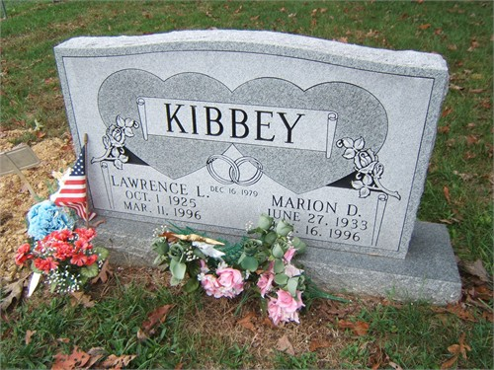

37. Linwood⁶ Kibbey, (Leonard H.⁵, James Thomas "Jim"⁴, John E.³, Malinda Everman², John¹ Everman).

He married unknown Greer Kibbey.

Children:
i. Jerry L.⁷ Kibbey, born 2 Jan 1952, died 23 Feb 1952, buried in Burnett Cemetery, Tygart's Creek Road, Iron Hill, Carter County, Kentucky.
ii. Dale L. Kibbey, born 10 Jun 1956, died 1 Mar 1984, buried in Burnett Cemetery, Tygart's Creek Road, Iron Hill, Carter County, Kentucky.
iii. Living Kibbey.

Generation Seven

38. Jackie Lee⁷ McGlone, (Hazel Harris⁶, Molly Everman⁵ Harris, William Riley⁴ Everman, John Thomas³, Samuel², John¹) born 31 Oct 1936 in Sciotoville, Ohio.

He married (1) 8 May 1955, Kay Bussa McGlone, (daughter of Roscoe Bussa and Mary Price Bussa).

Children:
i. Debra Lynn McGlone McLaughlin⁸ Holbrook, born 14 Jan 1956 in Sciotoville, Ohio.

She married (1) 10 Jul 1976, Dean McLaughlin, (son of Charles McLauglin and Helen Ach McLauglin).
She married (2) Tony Holbrook.

66. ii. Diana "Dede" McGlone Stiltner born 23 Jan 1958.
67. iii. Donna Lou McGlone VanDeusen born 26 Jun 1963.

He married (2) 20 Oct 1973, Elaine Benner McGlone, born 26 Nov 1936, (daughter of Clarence Benner and Dorothy Hancock Benner).

39. Carolyn Sue Harris⁷ Pirschel, (William Edgar "Bill"⁶ Harris, Molly Everman⁵, William Riley⁴ Everman, John Thomas³, Samuel², John¹) born 21 Dec 1941 in Bucyrus, Ohio.

She married 23 Mar 1963, in Findlay, Ohio, Michael David Pirschel, born 11 May 1941 in Los Angeles, California, (son of Albert Pirschel and Jane Dow Pirschel).

Children:
68. i. Holly Renee Pirschel⁸ Fredericks born 28 Sep 1963.
ii. Amy Marie Pirschel Bell, born 12 Jun 1969 in Findlay, Ohio.

She married 3 Sep 1993, Richard Allen Bell.

iii. Heather Leigh Pirshcel Maglicie, born 10 Nov 1970 in Findlay, Ohio.

She married 25 Feb 1995, in Findlay, Ohio, Matthew William Maglicie.

40. Patricia Ann Harris Arlington⁷ Tracy, (William Edgar "Bill"⁶ Harris, Molly Everman⁵, William Riley⁴ Everman, John Thomas³, Samuel², John¹) born 26 Nov 1943 in Bucyrus, Ohio.

She married (1) 3 Nov 1962, in Carey, Ohio, Jerald Lee Arlington, born 18 Jul 1943 in Vanlue, Ohio, (son of Harry Arlington and Maxine Howard Arlington).

Children:
69. i. Robin Denise Arlington Rufty⁸ Grauel born 1 May 1963.

She married (2) 25 Mar 1967, in Tiffin, Ohio, Eugene Franklin Tracy, born 9 Jun 1941 in Baltimore, Baltimore County, Maryland, (son of Hershel F. Tracy and Lola M. Cogar Tracy).

Children:
70. ii. William Ryan Tracy born 25 Oct 1967.

41. Mary Christine Rupert⁷ McGlone, (Ruth Mae Harris⁶ Rupert, Molly Everman⁵ Harris, William Riley⁴ Everman, John Thomas³, Samuel², John¹) born 11 May 1933.
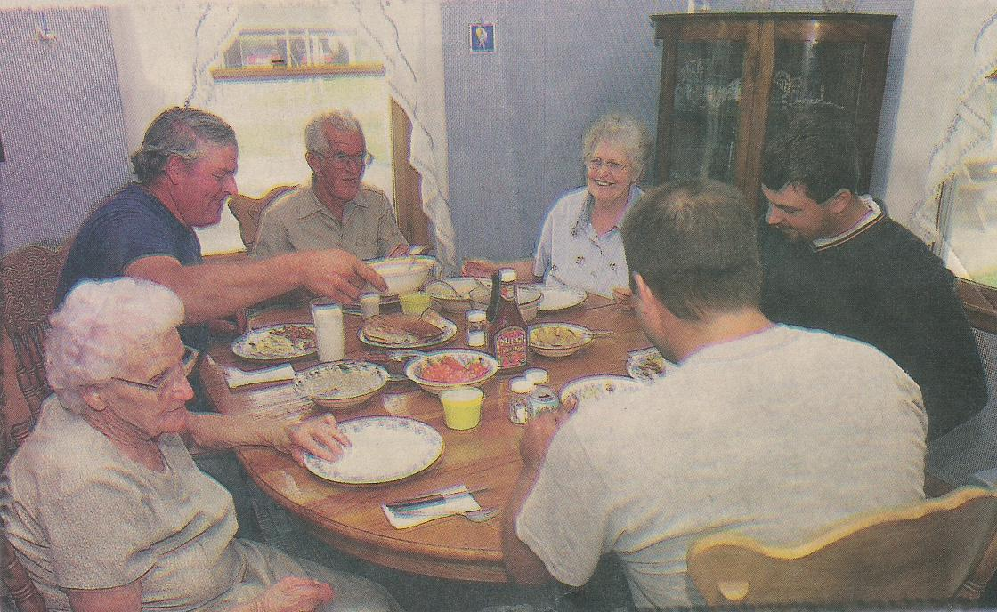

She married 10 Jun 1951 in Carter County, Kentucky, wedding official Fred Griffith in Grayson, Carter County, Kentucky, James Alfred McGlone, born 11 Feb 1924 in Carter County, Kentucky, (son of James Russell "Buck" McGlone and Erie Messer McGlone) occupation Engineer.

James: James and Christine were married in the presence of Hobert Lee Davis and Colleen Porter.

Children:
71. i. James Christopher⁸ McGlone born 17 Nov 1952.
72. ii. Hobert David McGlone born 7 Aug 1954.
73. iii. Carl Wayne McGlone born 21 Apr 1957.

42. Richard Tillman⁷ Underwood, (Mabel Ramey Everman⁶, John David Lee⁵ Everman, William Riley⁴, John Thomas³, Samuel², John¹) born 18 Jul 1929 in Cincinnati, Hamilton County, Ohio, died 3 May 1968 in Cincinnati, Hamilton County, Ohio.

He married Peggy King Underwood, born 10 Jul 1933 in Eldred, Illinois, (daughter of Gerald King and Mable Irene Smith King).

Children:
i. Karen Lynn⁸ Underwood, born 24 Jul 1962 in Hamilton County, Ohio.
ii. Gayle Ann Underwood, born 1 Oct 1965 in Hamilton County, Ohio.

43. Faye Underwood⁷ Hardert, (Mabel Ramey Everman⁶ Underwood, John David Lee⁵ Everman, William Riley⁴, John Thomas³, Samuel², John¹) born 9 Apr 1932 in Cincinnati, Hamilton County, Ohio, died in Cincinnati, Hamilton County, Ohio.

She married 16 May 1953, in Cincinnati, Hamilton County, Ohio, divorced 1993, Jack W. Hardert, born 13 Oct 1928 in Cincinnati, Hamilton County, Ohio.

Children:
74. i. Michael J.⁸ Hardert born 5 Apr 1954.
75. ii. Linda Gaye Hardert McGuire born 8 Nov 1956.
iii. Scott W. Hardert, born 17 Jan 1962 in Cincinnati, Hamilton County, Ohio.

44. Betty Lou Everman⁷ Jackson, (William Russell⁶ Everman, John David Lee⁵, William Riley⁴, John Thomas³, Samuel², John¹) born 22 Jan 1934 in Dayton, Montgomery Co., Ohio.

She married 29 Jan 1954, in Dayton, Montgomery Co., Ohio, Allen Wayne Jackson, born 4 May 1931 in London, Texas, (son of Ed Jackson and Ila Allen Jackson).

Children:
76. i. William Ross Ed⁸ Jackson born 30 Dec 1954.
ii. David Wayne Jackson, born 7 Sep 1956 in Upland, San Bardino County, California.

He married 2 May 1987, in Sylmar, California, Beverlee Jackson.

77. iii. Kenneth Robert Jackson born 24 Aug 1958.

45. Patricia Eleanor Everman⁷ Myers, (William Russell⁶ Everman, John David Lee⁵, William Riley⁴, John Thomas³, Samuel², John¹) born 6 Feb 1939 in Dayton, Montgomery Co., Ohio.

She married 8 Mar 1958, Jack Allen Myers, born 22 Nov 1938 in Dayton, Montgomery Co., Ohio, (son of Joseph Myers and Florence Myers).

Children:
i. Michele Allen⁸ Myers, born 21 Nov 1961 in Dayton, Montgomery Co., Ohio.
78. ii. Todd John Myers born 17 Jan 1963.

46. John Robert⁷ Everman, (William Russell⁶, John David Lee⁵, William Riley⁴, John Thomas³, Samuel², John¹) born 20 Aug 1945 in Dayton, Montgomery Co., Ohio.

He married (1) Kathleen Everman.

Children:
i. Bradford Russell⁸ Everman, born 7 Dec 1968 in Hamilton County, Ohio.

He married (2) 20 Mar 1976, Linda Gordon Everman, born 19 Oct 1948, (daughter of Wilbur Gordon and Sarah Gordon).

Children:
ii. Sarah Jane Everman, born 13 Sep 1980 in Marietta, GA.

47. William John "Bill"⁷ Everman, (Willis James⁶, John David Lee⁵, William Riley⁴, John Thomas³, Samuel², John¹) born 15 May 1934 in Grayson, Carter County, Kentucky, died 27 Mar 2001 in OLBH, Ashland, Boyd Co., Ky., buried 29 Mar 2001 in Everman Cemetery, Grassy, Carter County, Kentucky, occupation Registered Land Surveyor.

Bill was a registered surveyor, a construction superintendent and a retired drug rehabilitation counselor. Bill worked on the State Highway engineering of Interstate 64 at Grayson, Kentucky from 1966-1969.

Bill's funeral services were conducted at the Malone Funeral Home in Grayson by Rev. Tim Underwood. At the time of his death, Bill had six grandchildren. His epitaph reads "Absent from the body, present with the Lord".

He married (1) Mar 1954, Paula Williams Everman, died 1975.

Children:
i. Scott William "Scotty Bill"⁸ Everman, born 29 Sep 1955.

He married (2) Edna Mefford Everman, born 22 Jun 1938, buried in Everman Cemetery, Grassy, Carter County, Kentucky.

Children:
79. ii. Becky Everman Dummit Buckler born 18 Mar 1961.
80. iii. Malissa Everman Stephens born 1 Feb 1966.
iv. Kelly Jane Everman, born 14 Aug 1973.

48. Anna Frances Everman⁷ Worthington, (Willis James⁶ Everman, John David Lee⁵, William Riley⁴, John Thomas³, Samuel², John¹) born 21 Sep 1935.

She married 16 Jan 1954, Carl Worthington.

Children:
81. i. Kimberly Jo Worthington⁸ Singleton born 12 Oct 1957.

49. Hubert Wayne⁷ Everman, (Willis James⁶, John David Lee⁵, William Riley⁴, John Thomas³, Samuel², John¹) born 6 Jan 1938 in Carter County, Kentucky, died 9 Sep 1999 in Portsmouth, Scioto County, Ohio, buried 12 Sep 1999 in Lewis County Memory Gardens, Vanceburg, Lewis County, Kentucky.

He married Nancy Dunaway Everman.

Children:
82. i. Johnny⁸ Dunaway (step) born 16 Apr 1954.
83. ii. Beverly Dunaway Lykins (step) born 24 Dec 1957.
84. iii. Debbie Everman Wilburn born 4 Oct 1960.
85. iv. Bonita Everman Masters born 24 Nov 1961.
86. v. Lorlyn Everman Lawson born 26 Jul 1963.
87. vi. Jolene Everman Adams Ginn born 25 Jul 1965.
vii. Shelia Everman Eddington, born 23 Sep 1966.
She married Michael Eddington.

50. Donald Hugh⁷ Everman, (Willis James⁶, John David Lee⁵, William Riley⁴, John Thomas³, Samuel², John¹) born 20 Jul 1942.

He married (1) Martha Norton Everman.

Children:
88. i. Mindy Lois Everman Jarvis⁸ Davenport born 4 Feb 1964.
89. ii. Christian Hugh Chadwick "Chad" Everman born 14 Jun 1965.

He married (2) Pearl Crum Everman.

51. Robert Clyde⁷ Everman, (Clyde Thomas⁶, John David Lee⁵, William Riley⁴, John Thomas³, Samuel², John¹) born 26 May 1949.

He married 11 Nov, Ruth Marie Park Everman, born 17 Aug 1945, (daughter of James Park and Jean Park).

Children:
90. i. Kim Ruth Everman⁸ Haney born 20 Jul 1968.
ii. Kirk Robert Everman, born 31 Jul 1969.
iii. Kelly Reid Everman, born 10 Oct 1972.

He married Nicole Cummingham Everman.

52. James Woodrow⁷ Everman, (Woodrow Lee⁶, John David Lee⁵, William Riley⁴, John Thomas³, Samuel², John¹) born 2 Aug 1936.

He married (1) 4 Jul 1956, Ethel Mae Anderson Everman, born 23 Aug 1934, (daughter of John Thomas Anderson and Clara Mae Gillum Anderson).

Children:
i. Kathy Joan Everman⁸ Dillow, born 4 May 1957.

She married 1 Oct 1988, Rusty Dillow, born 30 Mar 1961.

91. ii. Mary Ann Everman Bailey born 4 May 1960.
iii. Cindy Lee Everman, born 4 Jan 1966.

He married (2) Margaret Everman.

53. Glen Allen⁷ Everman, (Woodrow Lee⁶, John David Lee⁵, William Riley⁴, John Thomas³, Samuel², John¹) born 20 Jan 1938 in Carter County, Kentucky, died 25 Feb 2002 in Garrison, Lewis County, Kentucky, buried 28 Feb 2002 in Everman Cemetery, Grassy, Carter County, Kentucky.

Glen was retired from the Kentucky Department of Agriculture and served in the U.S. Marine Corps. At the time of his death, Glen had 29 grandchildren, and six great-grandchildren. His funeral services were conducted at the Sullivan Funeral Chapel in Garrison by Rev. Tim Underwood. Glen's epitaph reads "Precious Memories".

He married (1) Nov 1958, Judy Parker Everman, born 1942, (daughter of Harry Parker and Eleanor Parker).

Children:
92. i. Dreama Gaye Everman⁸ Barber born 28 Aug 1959.
93. ii. Gwen Rene Everman Johnson born 25 Jul 1960.

He married (2) Sherry Louise Ferrell Everman, born 10 Sep 1941 in Ironton, Lawrence County, Ohio, (daughter of Ernest Ferrell and Anna Louise Blankenship Ferrell) died 16 Jun 2006 in Hospice Care Center, Ashland, Boyd County, Kentucky, buried 19 Jun 2006 in Everman Cemetery, Grassy, Carter County, Kentucky.

Sherry: Sherry was a member of the Faith Baptist Church in Quincy, Kentucky. She was a homemaker, beloved mother and grandmother who touched many lives and will be missed by all that knew her. At the time of her death, she had 27 grandchildren and 8 great-grandchildren. Her funeral services were conducted at Faith Baptist Church in Qunicy by Rev. Tim Underwood.

Children:
94. iii. Tammy Lynn Nowakowski born 26 Dec 1964.
95. iv. Glenda Dee Everman Tumber born 17 Jun 1967.
96. v. Sandra Leah Everman Lyle born 27 Jul 1968.
97. vi. John David Everman born 9 Jun 1970.

54. Mary Alice Everman⁷ Underwood, (Woodrow Lee⁶ Everman, John David Lee⁵, William Riley⁴, John Thomas³, Samuel², John¹) born 29 Feb 1940, resided in St. Paul, Kentucky, died bef 2007.

She married 25 Jan 1957, William Ginn Underwood, born 21 Jan 1933, (son of Edgar Wells Underwood and Edna Fannin Underwood).

Children:
i. Anthony Allen⁸ Underwood, born 1 Apr 1958.
98. ii. Timothy Lee Underwood born 18 Feb 1961.
iii. William Todd Underwood, born 14 Apr 1965.
99. iv. Phebe Terena Underwood Kraft born 1 Mar 1970.
100. v. Trent Edgar Underwood born 2 Feb 1973.

55. Judy Foster⁷ Hatcher, (Pansy Everman⁶ Foster, John David Lee⁵ Everman, William Riley⁴, John Thomas³, Samuel², John¹) born 19 Apr 1953.

She married 3 Mar 1973, John M. Hatcher, born 7 Jan 1953.

Children:
i. Laura Renee⁸ Hatcher, born 9 Nov 1975 in Evansville, Indiana.
ii. Phillip Hatcher, born 13 Oct 1977 in Evansville, Indiana.
iii. David John Hatcher, born 15 Jun 1980 in Evansville, Indiana.
iv. Lydia Ruth Hatcher Reece, born 5 Sep 1982 in Evansville, Indiana.

56. Michael Lenord⁷ Everman, (Arthur⁶, John David Lee⁵, William Riley⁴, John Thomas³, Samuel², John¹) born 11 Apr 1950, died 31 May 2001 in Mesa, Arizona, buried 3 Jun 2001 in Everman Cemetery, Carter Co., Ky.

Michael resided for a time in Quincy, Ky. before moving to Mesa, Arizona. Michael was a consulting manager with Hunt Jacobs Construction in Phoenix at the time of his death. He attended McKel High School and Navaro College and was a U.S Army veteran and a member of the Arizona Commission of Irish Affairs. A memorial service for Michael was conducted June 3, 2001 at Faith Baptist Church in Qunicy by Pastor Tim Underwood.

He married (1) Marsha Everman.

Children:
i. Melissa⁸ Everman, born 1970.

At the time of her father's death Melissa was residing in Vicksburg, Mississippi.

He married (2) Mildred "Dede" Abrahams Everman.

Mildred: Michael's marriage to Dede was his fifth marriage.

Children:
ii. Emily Louise Everman, born 9 Oct 1983.

At time of her father's death Emily was residing in Gardner, Illinois.
iii. Michael Patrick Everman, born 31 Oct 1986.

At the time of the death of his father, Patrick was residing in Vicksburg, Mississippi.

He married (3) Debbie Everman.

57. Elizabeth Ann Everman⁷ Eckman, (Arthur⁶ Everman, John David Lee⁵, William Riley⁴, John Thomas³, Samuel², John¹) born 14 Apr 1955.

She married James Bigalow Eckman, Jr., (son of James Bigalow Eckman, Sr. and Gene Eckman).

Children:
i. Catlin⁸ Eckman, born Jul 1989.
ii. James Bigalow Eckman, III, born Jan 1991.

58. Kathy Christine Everman⁷ Hockley, (Edgar Bruce⁶ Everman, John David Lee⁵, William Riley⁴, John Thomas³, Samuel², John¹) born 23 Mar 1951 in King's Daughters' Medical Center, Ashland, Boyd County, Kentucky.

Kathy and George were married in the presence of Bonnie Cooper and Billy Ratliff.

She married 6 Jun 1969 in Carter County, Kentucky, wedding official Charles E. Boyd in Grayson, Carter County, Kentucky, George A. Hockley, born 1 Oct 1948 in King's Daughters' Medical Center, Ashland, Boyd County, Kentucky, (son of Lloyd Hockley and Adelaide Meinyer Hockley).

Children:
i. Jenny Sara Hockley⁸ Griffith, born 29 Nov 1977.
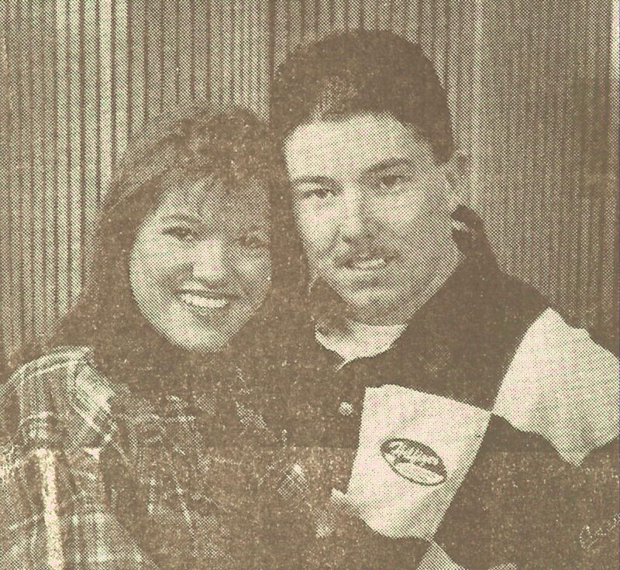

Pictured is Jenny and Kevin's engagement picture.

She married 24 May 1997 in Carter County, Kentucky, in Gregoryville Christian Ch Carter Co., KY, Kevin Edward Griffith, (son of Kevin Edward Griffith and Unknown Suttles Griffith).

ii. Jeremy Stephen Hockley, born 8 Dec 1979.

59. Laura Faye Connelly Zamarron⁷ Boswell, (Ruth Everman⁶ Connelly, John David Lee⁵ Everman, William Riley⁴, John Thomas³, Samuel², John¹) born 8 Aug 1945 in Ashland, Boyd County, Kentucky.

She married (1) 10 Aug 1963, Creighton Rice.

Children:
i. Christina Rice⁸ Ketner, born 4 Jul 1964 in Ohio.

She married 28 Apr 1990, in Kentucky, Wayne Ketner.

ii. Corina Gay Rice Thomas, born 11 Sep 1965.

She married (2) Maurice Zamarron.

She married (3) 15 Oct 1987, Ronald Paul Boswell, born 13 Jan 1938 in Washington, D. C., (son of Paul Boswell and Margaret Tracy Boswell) died 17 Aug 1995 in Harlingen, Texas, buried 20 Aug 1995 in Everman Cemetery, Carter Co., Ky.

Ronald: Ron was a minister at Baptist Temple at Hagerstown and an Air Force veteran. His funeral serviced were conducted at Malone Funeral Home, Grayson, Ky. by Jim Foster and Daris Ford.

Children:
iii. Clare Boswell.
iv. Sarah Boswell.
v. Gary Boswell.

60. Carlene Sue Connelly⁷ Riner, (Ruth Everman⁶ Connelly, John David Lee⁵ Everman, William Riley⁴, John Thomas³, Samuel², John¹) born 8 Apr 1949 in Dayton, Montgomery Co., Ohio.

She married Richard Riner.

Children:
i. Rebecca⁸ Riner, born 20 Oct 1982.
ii. Elizabeth Riner, born 5 Apr 1984.
iii. Jonathan Riner, born 17 Oct 1987.
iv. Anna Riner, born 22 Dec 1990.

61. Verna Kay Connelly McDowell⁷ Hardin, (Ruth Everman⁶ Connelly, John David Lee⁵ Everman, William Riley⁴, John Thomas³, Samuel², John¹) born 30 Nov 1954.

She married (1) 26 Feb 1971, Clyde Earl McDowell, born 7 Oct 1951.

Children:
i. Jonathan Everett⁸ McDowell, born 15 Sep 1971 in Ellsworth A.F.B., South Dakota.
101. ii. Brian Lee McDowell born 22 Dec 1972.

She married (2) 6 Aug 1987, Gary Dale Hardin, born 10 Jan 1942.

62. Vickie Lee Connelly⁷ Zamarron, (Ruth Everman⁶ Connelly, John David Lee⁵ Everman, William Riley⁴, John Thomas³, Samuel², John¹) born 23 Jun 1956 in Ashland, Boyd County, Kentucky.

She married 19 Jul 1975, in Greenup County, Kentucky, divorced 1995, Moe Zamarron.

Children:
i. Carrie Dawn⁸ Zamarron, born 5 Sep 1977 in Ohio.
ii. Jeremy Zamarron, born 4 Oct 1979 in Kentucky.
iii. Nathan Zamarron, born 16 Feb 1982 in Ohio.

63. Elwood⁷ Burge, (Lillis Bessie Kibbey⁶, James Luther⁵ Kibbey, James Thomas "Jim"⁴, John E.³, Malinda Everman², John¹ Everman) born 3 Jan 1935 in Carter County, Kentucky.
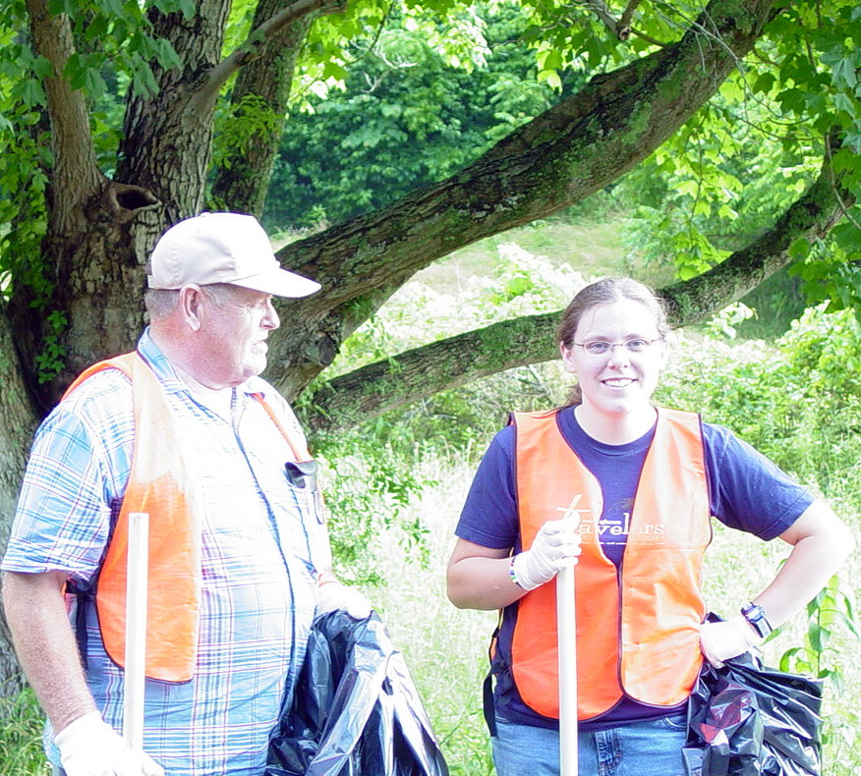

Elwood is always active in the community. As seen here, Elwood is helping Vanessa Carper and other Carter City residents to clean up the highway. Elwood was also instrumental in developing the Carter City Fire Department.

He married Wanda Burge.

Children:
102. i. Pamela Burge⁸ Menix.
ii. Jan Burge.
103. iii. Robin Burge Adkins.

64. Walter Franklin "W.F."⁷ Burge, (Lillis Bessie Kibbey⁶, James Luther⁵ Kibbey, James Thomas "Jim"⁴, John E.³, Malinda Everman², John¹ Everman) born 17 Apr 1941 in Carter County, Kentucky, occupation Owner/Operator of a trucking company, died 24 Dec 2006 at his residence in Olive Hill, Carter County, Kentucky, buried in Garvin Ridge Cemetery, Olive Hill, Carter County, Ky.
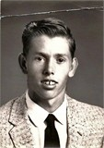

JOURNAL-TIMES
WALTER FRANKLIN BURGE
BORN 1941

OLIVE HILL - Mr. Walter Franklin "W.F." Burge age 65 of Olive Hill, Kentucky passed away Sunday evening, December 24, 2006 at his residence.
"W. F." was born April 17, 1941 in Carter county, Kentucky and is the son of the late Charlie and Lillis Kibbey Burge.
In addition to his parents, one brother proceeded him in death, Steve Burge.
"W. F." was a life long self employed Owner and Operate Truck Driver.
Mr. Burge is survived by his wife of forty-three years, Dottie Davis Burge. Two sons and daughter-in-laws, Jeff and Shirley Burge and Mike and Jennifer Burge, both of Olive Hill. One daughter and son-in-law, Angie and Kevin Parsons of Richmond, Kentucky. Three grandchildren, Megan Michell Burge, Austin Michael Burge and Jessie Curtis parsons. Six brothers and sisters-in-law, Elwood and Wanda Burge, Carl and Janet Burge, Arnold and Linda Burge, Ronnie Burge, ad Bob Burge all of Carter City, Kentucky. Charles "Skip" and Ruthann Burge of Holland, Michigan. Two sisters, Myrtle Cline of Flint, Michigan and Judy Cartee of Carter City, Kentucky.
Funeral services were held l:00 pm Thursday, December 28, 2006 at the Globe Funeral Chapel in Olive Hill, Kentucky. Officiating was Brother Allen Underwood and Brother J. C. Bond. Burial followed in the Garvin Ridge Cemetery in Olive Hill, Kentucky.
Donnie Stapleton, Doug Stapleton, David Utley, Ryan Stamper, Jason Parsons, Tim Burge, Billy Wayne Buckler and Quentine Stamper served as pallbearers.
Bill Buckler, Bud Stapleton, John Derek Davis, Jim Davis, John Paul Davis and Johnny Parsons served as Honorary Pallbearers.

.

He married Dottie Davis Burge.

Children:
i. Jeff⁸ Burge, resided 2006 in Olive Hill, Carter County, Kentucky.

He married Shirley Burge.

ii. Mike Burge.

He married Jennifer Burge, resided 2006 in Olive Hill, Carter County, Kentucky.

104. iii. Angie Burge Parsons.

65. Forrest "Buck"⁷ Kibbey, (Lawrence Lee⁶, Leonard H.⁵, James Thomas "Jim"⁴, John E.³, Malinda Everman², John¹ Everman) born 17 Jul 1958, died 13 Dec 2004.

He married unknown Kibbey.

Children:
i. Eula Lee⁸ Kibbey.
ii. Brenda Kibbey.
iii. Christopher Kibbey.
iv. Christine Kibbey.
v. Charles Kibbey.

Generation Eight

66. Diana "Dede" McGlone⁸ Stiltner, (Jackie Lee⁷ McGlone, Hazel Harris⁶, Molly Everman⁵ Harris, William Riley⁴ Everman, John Thomas³, Samuel², John¹) born 23 Jan 1958.

She married 31 Aug 1979, Mark Stiltner, born 14 Jun 1958, (son of Grant Stiltner and Irene Rogers Stiltner).

Children:
i. Megan Elaine⁹ Stiltner, born 8 Aug 1983.

67. Donna Lou McGlone⁸ VanDeusen, (Jackie Lee⁷ McGlone, Hazel Harris⁶, Molly Everman⁵ Harris, William Riley⁴ Everman, John Thomas³, Samuel², John¹) born 26 Jun 1963.

She married 18 Sep 1981, Joseph Wayne VanDeusen, born 24 Nov 1962, (son of Wayne VanDeusen and Shirley Russell VanDeusen).

Children:
i. Jason Scott⁹ VanDeusen, born 30 Apr 1983.
ii. Jessica Rae VanDeusen, born 6 Jun 1987.

68. Holly Renee Pirschel⁸ Fredericks, (Carolyn Sue Harris⁷ Pirschel, William Edgar "Bill"⁶ Harris, Molly Everman⁵, William Riley⁴ Everman, John Thomas³, Samuel², John¹) born 28 Sep 1963 in Findlay, Ohio.

She married 6 May 1981, in Findlay, Ohio, unknown Fredericks.

Children:
i. Danielle Ashley⁹ Fredericks, born 18 May 1985 in Findlay, Ohio.

69. Robin Denise Arlington Rufty⁸ Grauel, (Patricia Ann Harris Arlington⁷ Tracy, William Edgar "Bill"⁶ Harris, Molly Everman⁵, William Riley⁴ Everman, John Thomas³, Samuel², John¹) born 1 May 1963 in Findlay, Ohio.

She married (1) 6 Jul 1983, in Toledo, Lucas Co., Ohio, Gregory Allen Rufty.

Children:
i. Derek⁹ Arlington, born 19 Oct 1983 in Tiffin, Ohio.

She married (2) 28 Mar 1988, in Van Buren, Ohio, James Grauel, Jr..

Children:
ii. James Jarel Grauel, born 13 Feb 1989 in Findlay, Ohio.

70. William Ryan⁸ Tracy, (Patricia Ann Harris Arlington⁷, William Edgar "Bill"⁶ Harris, Molly Everman⁵, William Riley⁴ Everman, John Thomas³, Samuel², John¹) born 25 Oct 1967 in Tiffin, Ohio.

He married Lisa Ann Schank Tracy.

Children:
i. William Tyler⁹ Tracy, born 13 Jul 1987 in Tiffin, Ohio.
ii. Logan James Tracy, born 18 Jun 1994 in Tiffin, Ohio.

71. James Christopher⁸ McGlone, (Mary Christine Rupert⁷, Ruth Mae Harris⁶ Rupert, Molly Everman⁵ Harris, William Riley⁴ Everman, John Thomas³, Samuel², John¹) born 17 Nov 1952 in Grayson, Carter County, Kentucky.

He married 31 Dec 1982, in Philadelphia, PA, Ellen Sue Gutter McGlone, born 25 Jan 1953, (daughter of Lester Gutter and Vivian Lenker Gutter).

Children:
i. Leah⁹ McGlone, born 12 Mar 1991 in New York City, New York.

72. Hobert David⁸ McGlone, (Mary Christine Rupert⁷, Ruth Mae Harris⁶ Rupert, Molly Everman⁵ Harris, William Riley⁴ Everman, John Thomas³, Samuel², John¹) born 7 Aug 1954 in Grayson, Carter County, Kentucky.

He married 25 Aug 1973, Judy Kaye Callihan McGlone, born 7 Nov 1954, (daughter of Brady Callihan and Frances Waugh Callihan).

Children:
i. Callie Ruth⁹ McGlone, born 2 Jul 1979.
ii. Jason Rupert McGlone, born 12 Feb 1983.

73. Carl Wayne⁸ McGlone, (Mary Christine Rupert⁷, Ruth Mae Harris⁶ Rupert, Molly Everman⁵ Harris, William Riley⁴ Everman, John Thomas³, Samuel², John¹) born 21 Apr 1957 in Grayson, Carter County, Kentucky.

He married 7 Jul 1978, Anna Little McGlone, born 26 May 1960, (daughter of James Little and Danease Sergent Little).

Children:
i. Caleb Wayne⁹ McGlone, (adopted) born 17 Oct 1990.

74. Michael J.⁸ Hardert, (Faye Underwood⁷, Mabel Ramey Everman⁶ Underwood, John David Lee⁵ Everman, William Riley⁴, John Thomas³, Samuel², John¹) born 5 Apr 1954 in Cincinnati, Hamilton County, Ohio.

He married 3 Sep 1977, in Cincinnati, Hamilton County, Ohio, Trudy Louise Wunnenberg Hardert, born 14 Oct 1954 in Tuscula, Illinois, (daughter of Chris Wunnenberg and Verna Walter Wunnenberg).

Children:
i. Michael W.⁹ Hardert, born 24 Feb 1981 in Cincinnati, Hamilton County, Ohio.
ii. Nicholas A. Hardert, born 24 Jun 1990 in Cincinnati, Hamilton County, Ohio.

75. Linda Gaye Hardert⁸ McGuire, (Faye Underwood⁷ Hardert, Mabel Ramey Everman⁶ Underwood, John David Lee⁵ Everman, William Riley⁴, John Thomas³, Samuel², John¹) born 8 Nov 1956 in Cincinnati, Hamilton County, Ohio.

She married 23 Jul 1977, in Cincinnati, Hamilton County, Ohio, divorced 1988, Ted A. McGuire.

Children:
i. Joshua M.⁹ McGuire, born 9 Feb 1980 in Hamilton County, Ohio.
ii. Amy Lyn McGuire, born 17 Jan 1984 in Oxford, Ohio.

76. William Ross Ed⁸ Jackson, (Betty Lou Everman⁷, William Russell⁶ Everman, John David Lee⁵, William Riley⁴, John Thomas³, Samuel², John¹) born 30 Dec 1954 in Dayton, Montgomery Co., Ohio.

He married 26 Aug 1978, in Dinkey Creek Co., Julie Jackson.

Children:
i. Amanda R.⁹ Jackson, born 30 Jun 1979.

77. Kenneth Robert⁸ Jackson, (Betty Lou Everman⁷, William Russell⁶ Everman, John David Lee⁵, William Riley⁴, John Thomas³, Samuel², John¹) born 24 Aug 1958 in Upland, San Bardino County, California.

He married 24 Jun 1978, Robin Jackson.

Children:
i. Kelley Renee⁹ Jackson, born 11 Nov 1985.
ii. Kyle Wayne Jackson, born 23 Sep 1989.

78. Todd John⁸ Myers, (Patricia Eleanor Everman⁷, William Russell⁶ Everman, John David Lee⁵, William Riley⁴, John Thomas³, Samuel², John¹) born 17 Jan 1963 in Columbus, Franklin County, Ohio.

He married 10 Oct 1983, in Marietta, GA, Melanie Myers.

Children:
i. Russell William⁹ Myers, born 4 Apr 1985 in Woodstock, Georgia.

79. Becky Everman Dummit⁸ Buckler, (William John "Bill"⁷ Everman, Willis James⁶, John David Lee⁵, William Riley⁴, John Thomas³, Samuel², John¹) born 18 Mar 1961.

She married (1) Billy Dummit.

Children:
i. Matthew D.⁹ Dummit, born 10 Oct 1975.
ii. Kevin Compton Buckler, born 16 Sep 1986.

She married (2) Luke Buckler.

80. Malissa Everman⁸ Stephens, (William John "Bill"⁷ Everman, Willis James⁶, John David Lee⁵, William Riley⁴, John Thomas³, Samuel², John¹) born 1 Feb 1966.

She married Jon Stephens.

Children:
i. Davin⁹ Stephens, born 19 Sep 1984.

81. Kimberly Jo Worthington⁸ Singleton, (Anna Frances Everman⁷ Worthington, Willis James⁶ Everman, John David Lee⁵, William Riley⁴, John Thomas³, Samuel², John¹) born 12 Oct 1957.

She married Gene Singleton.

Children:
i. Sean Willis⁹ Singleton, born 22 Feb 1979.
ii. Adam Charles Singleton, born 16 Feb 1980.

82. Johnny⁸ Dunaway, (Hubert Wayne⁷ Everman, Willis James⁶, John David Lee⁵, William Riley⁴, John Thomas³, Samuel², John¹) born 16 Apr 1954.

He married Ketrina Stone Dunaway.

Children:
i. Jenifer⁹ Dunaway.
ii. Kevin Dunaway.
iii. Courtney Dunaway.
iv. Colton Dunaway.

83. Beverly Dunaway⁸ Lykins, (Hubert Wayne⁷ Everman, Willis James⁶, John David Lee⁵, William Riley⁴, John Thomas³, Samuel², John¹) born 24 Dec 1957.

She married Terry Lykins.

Children:
i. David Wayne⁹ Dunaway.
ii. Tommy Dunaway.

84. Debbie Everman⁸ Wilburn, (Hubert Wayne⁷ Everman, Willis James⁶, John David Lee⁵, William Riley⁴, John Thomas³, Samuel², John¹) born 4 Oct 1960.

She married Jeff Wilburn.

Children:
i. Brian⁹ Wilburn.
ii. Beth Ann Wilburn.

85. Bonita Everman⁸ Masters, (Hubert Wayne⁷ Everman, Willis James⁶, John David Lee⁵, William Riley⁴, John Thomas³, Samuel², John¹) born 24 Nov 1961.

She married Dean Masters.

Children:
i. Devon⁹ Masters.
ii. Willis Drew Masters.

86. Lorlyn Everman⁸ Lawson, (Hubert Wayne⁷ Everman, Willis James⁶, John David Lee⁵, William Riley⁴, John Thomas³, Samuel², John¹) born 26 Jul 1963.

She married Mike "Pete" Lawson.

Children:
i. Jessica⁹ Lawson.
ii. Shannon Lawson.

87. Jolene Everman Adams⁸ Ginn, (Hubert Wayne⁷ Everman, Willis James⁶, John David Lee⁵, William Riley⁴, John Thomas³, Samuel², John¹) born 25 Jul 1965.

She married (1) Greg Adams.

She married (2) Daren Ginn.

Children:
i. Stephanie⁹ Ginn, born 26 Feb 1991.
ii. Dillon Trent Ginn.

88. Mindy Lois Everman Jarvis⁸ Davenport, (Donald Hugh⁷ Everman, Willis James⁶, John David Lee⁵, William Riley⁴, John Thomas³, Samuel², John¹) born 4 Feb 1964.

She married (1) Kerry Jarvis.

She married (2) Lee Davenport.

Children:
i. Morgan⁹ Davenport, born 19 Jan 1990.

89. Christian Hugh Chadwick "Chad"⁸ Everman, (Donald Hugh⁷, Willis James⁶, John David Lee⁵, William Riley⁴, John Thomas³, Samuel², John¹) born 14 Jun 1965.

He married Jody Lawson Everman.

Children:
i. Chelsie⁹ Everman, born 29 Jun 1991.

90. Kim Ruth Everman⁸ Haney, (Robert Clyde⁷ Everman, Clyde Thomas⁶, John David Lee⁵, William Riley⁴, John Thomas³, Samuel², John¹) born 20 Jul 1968.

She married Mike Haney.

Children:
i. Amanda Marie⁹ Haney, born 30 Jun 1995.

91. Mary Ann Everman⁸ Bailey, (James Woodrow⁷ Everman, Woodrow Lee⁶, John David Lee⁵, William Riley⁴, John Thomas³, Samuel², John¹) born 4 May 1960.

She married 30 Nov 1984, Kenny Bailey.

Children:
i. James Michael⁹ Bailey, born 12 Jan 1979.
ii. Kyle Edward Bailey, born 8 May 1987.
iii. Hanna Claire Bailey, born 27 Jun 1992.

92. Dreama Gaye Everman⁸ Barber, (Glen Allen⁷ Everman, Woodrow Lee⁶, John David Lee⁵, William Riley⁴, John Thomas³, Samuel², John¹) born 28 Aug 1959.

She married 28 Jun 1980, Martin Lee Barber, born 29 Mar 1955.

Children:
i. Adam Martin⁹ Barber, born 11 Jun 1984.
ii. Jarred Allen Barber, born 20 Nov 1992.

Jarred is a twin to his brother, Jacob.
iii. Jacob Russell Barber, born 20 Nov 1992.

93. Gwen Rene Everman⁸ Johnson, (Glen Allen⁷ Everman, Woodrow Lee⁶, John David Lee⁵, William Riley⁴, John Thomas³, Samuel², John¹) born 25 Jul 1960.

She married 4 Dec 1976, Derwood Alton Johnson, born 11 Feb 1955.

Children:
i. Derek Alton⁹ Johnson, born 2 Nov 1979.
ii. Marissa Dell Johnson, born 17 Jan 1982.

94. Tammy Lynn⁸ Nowakowski, (Glen Allen⁷ Everman, Woodrow Lee⁶, John David Lee⁵, William Riley⁴, John Thomas³, Samuel², John¹) born 26 Dec 1964.

She married 22 Jun 1991, Patrick Nowakowski.

Children:
i. Sydney Lynn⁹ Nowakowski, born 12 Oct 1996.

95. Glenda Dee Everman⁸ Tumber, (Glen Allen⁷ Everman, Woodrow Lee⁶, John David Lee⁵, William Riley⁴, John Thomas³, Samuel², John¹) born 17 Jun 1967.

She married 4 Mar 1992, William Tumber, born 4 Nov 1966.

Children:
i. Anna Louise⁹ Tumber, born 29 May 1995.

96. Sandra Leah Everman⁸ Lyle, (Glen Allen⁷ Everman, Woodrow Lee⁶, John David Lee⁵, William Riley⁴, John Thomas³, Samuel², John¹) born 27 Jul 1968.

She married 2 Jun 1990, Cary Quintin Lyle, born 26 Jan 1966.

Children:
i. Cara Dee⁹ Lyle, born 24 Dec 1991.
ii. Cory Quintin Allen Lyle, born 8 Oct 1993.

97. John David⁸ Everman, (Glen Allen⁷, Woodrow Lee⁶, John David Lee⁵, William Riley⁴, John Thomas³, Samuel², John¹) born 9 Jun 1970.

He married 30 Jul 1993, Hope Minton Everman, born Jan 1974.

Children:
i. Johathan Glen⁹ Everman, born 14 Mar 1994.

98. Timothy Lee⁸ Underwood, (Mary Alice Everman⁷, Woodrow Lee⁶ Everman, John David Lee⁵, William Riley⁴, John Thomas³, Samuel², John¹) born 18 Feb 1961.

He married 28 Jul 1978, Sandra Kay Oglesby Underwood, born 27 Nov 1963.

Children:
i. Rebecca Sue⁹ Underwood.
ii. Timothy Underwood.

99. Phebe Terena Underwood⁸ Kraft, (Mary Alice Everman⁷ Underwood, Woodrow Lee⁶ Everman, John David Lee⁵, William Riley⁴, John Thomas³, Samuel², John¹) born 1 Mar 1970.

She married 17 Nov 1988, Douglas Kraft, born 3 Jul 1965.

Children:
i. Kristin Maryann⁹ Kraft, born 7 Jul 1992.
ii. Kameron Douglas Kraft, born 19 Jun 1996.

100. Trent Edgar⁸ Underwood, (Mary Alice Everman⁷, Woodrow Lee⁶ Everman, John David Lee⁵, William Riley⁴, John Thomas³, Samuel², John¹) born 2 Feb 1973.

He married Celina Polley Reed Underwood, born 12 Dec 1974.

Children:
i. Brittney Chanel⁹ Reed, born 5 Oct 1992.

101. Brian Lee⁸ McDowell, (Verna Kay Connelly McDowell⁷ Hardin, Ruth Everman⁶ Connelly, John David Lee⁵ Everman, William Riley⁴, John Thomas³, Samuel², John¹) born 22 Dec 1972.

He married 31 Oct 1992, Nichole Richardson McDowell, born 9 Aug 1973, (daughter of Michael Richardson and Darlene Richardson).

Children:
i. Kimberly Darlene⁹ McDowell, born 21 Aug 1994 in Virginia Beach, VA.
ii. Ashleigh Kay McDowell, born 9 Feb 1996 in Virginia Beach, VA.

102. Pamela Burge⁸ Menix, (Elwood⁷ Burge, Lillis Bessie Kibbey⁶, James Luther⁵ Kibbey, James Thomas "Jim"⁴, John E.³, Malinda Everman², John¹ Everman).

She married William "Bill" Menix.

Children:
i. Scott⁹ Menix.

103. Robin Burge⁸ Adkins, (Elwood⁷ Burge, Lillis Bessie Kibbey⁶, James Luther⁵ Kibbey, James Thomas "Jim"⁴, John E.³, Malinda Everman², John¹ Everman).
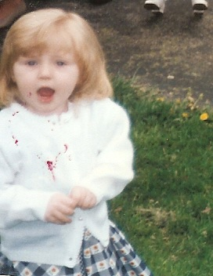
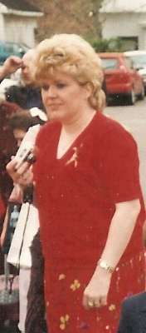
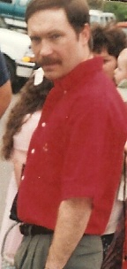
She married Kenny Adkins.

Children:
- Kendall⁹ Adkins.

Pictured are Kenny, Robin and
Kendall Adkins.

104. Angie Burge⁸ Parsons, (Walter Franklin "W.F."⁷ Burge, Lillis Bessie Kibbey⁶, James Luther⁵ Kibbey, James Thomas "Jim"⁴, John E.³, Malinda Everman², John¹ Everman) resided 2006 in Richmond, Madison County, Kentucky. She married Kevin Parsons.
Children:
- Jessie Curtis⁹ Parsons.

Adams
Greg 37
Adkins
Kendall 40
Kenny 40
Robin Burge 32, 40
Anderson
Clara Mae Gillum 28
John Thomas 28
Arlington
Derek (b. 1983) 34
Harry 25
Jerald Lee (b. 1943) 25
Maxine Howard 25
Bailey
Hanna Claire (b. 1992) 38
James Michael (b. 1979) 38
Kenny 38
Kyle Edward (b. 1987) 38
Mary Ann Everman (b. 1960) 28, 38
Barber
Adam Martin (b. 1984) 38
Dreama Gaye Everman (b. 1959) 29, 38
Jacob Russell (b. 1992) 38
Jarred Allen (b. 1992) 38
Martin Lee (b. 1955) 38
Bell
Amy Marie Pirschel (b. 1969) 25
Richard Allen 25
Benner
Clarence 24
Dorothy Hancock 24
Boswell
Clare 31
Gary 31
Laura Faye Connelly Zamarron (b. 1945) 20, 31
Margaret Tracy 31
Paul 31
Ronald Paul (b. 1938) 31
Sarah 31
Boyle
Elizabeth Bushy 19
Patrick 19
Buckler
Becky Everman Dummit (b. 1961) 27, 36
Kevin Compton (b. 1986) 36
Luke 36
Burchett
Bruce 12
Burge
Arnold 22
Bobby G. (b. 1953) 22
Carl L. (b. 1936) 22
Charles "Skip" 22
Charles (b. 1902) 22
Dottie Davis 33
Elwood (b. 1935) 22, 32
Floyd Preston 22
Inez Pauline (b. 1934) 22
Jan 32
Janet 22
Jeff 33
Jennifer 33
Joann Lewis Brown (b. 1949) 22
Lillis Bessie Kibbey (b. 1915) 13, 21
Linda 22
Matilda Timberlake 22
Mike 33
Ronnie 22
Roscoe (b. 1957) 23
Ruthann 22
Shirley 33
Steve Paul (b. 1938) 22
Walter Franklin "W.F." (b. 1941) 22, 32
Wanda 32
Burnett
Henry "Poppy" Newman (b. 1872) 13
Lucy Jane Wicker (b. 1878) 13
Burton
Keith 20
Bush
Arminta "Minta" Stephens (b. 1877) 12
Edward Clayton (b. 1872) 12
Bussa
Mary Price 24
Roscoe 24
Callihan
Brady 35
Frances Waugh 35
Cartee
Judy Burge 22
Clark
General George (b. 1752) 1
Jane Mercer 1
Cline
Myrtle Burge 22
Connelly
John Carl (b. 1925) 20
Royal 20
Ruth Everman (b. 1927) 10, 20
Verna Evans 20
Counts
Georgia Mae 19
Mortan 19
Crum
Mary Tom Harris (b. 1923) 10
Mat 10
Davenport
Lee 38
Mindy Lois Everman Jarvis (b. 1964) 28, 37
Morgan (b. 1990) 38
Dillow
Kathy Joan Everman (b. 1957) 28
Rusty (b. 1961) 28
Dummit
Billy 36
Matthew D. (b. 1975) 36
Dunaway
Colton 36
Courtney 36
David Wayne 37
Jenifer 36
Johnny (b. 1954) 27, 36
Ketrina Stone 36
Kevin 36
Tommy 37
Eckman
Catlin (b. 1989) 30
Elizabeth Ann Everman (b. 1955) 19, 30
Gene 30
James Bigalow, III (b. 1991) 30
James Bigalow, Jr. 30
James Bigalow, Sr. 30
Eddington
Michael 28
Shelia Everman (b. 1966) 28
England
Elizabeth Yates 7
Manuel (b. 1853) 7
Thelma McGlone (b. 1909) 7
William Lee (b. 1823) 7
Everman
Alphamenta "Alpha" Nevada McGinnis (b. 1859) 4
Anne or Brunetta 1
Arthur (b. 1923) 10, 19
Bea Pelfrey 12
Betty Jean 14
Betty Laura (b. 1940) 17
Bonnie 12
Bradford Russell (b. 1968) 27
Bruce Winston (b. 1950) 20
Chelsie (b. 1991) 38
Christian Hugh Chadwick "Chad" (b. 1965) 28, 38
Cindy Lee (b. 1966) 28
Clyde 5
Clyde Thomas (b. 1913) 10, 17
David Patrick (b. 1945) 19
Debbie 30
Dixie Counts (b. 1928) 19
Donald Hugh (b. 1942) 17, 28
Edgar Bruce (b. 1924) 10, 19
Edgar T. (b. 1883) 5, 7
Edna Mefford (b. 1938) 27
Elwood W. (b. 1909) 8, 14
Emily Louise (b. 1983) 30
Ethel Mae Anderson (b. 1934) 28
Ethel May Zornes (b. 1890) 8
Eva Lee 6
George 2
George (b. 1883) 6
Glen Allen (b. 1938) 18, 28
Harriett Eliza B. 1
Hope Minton (b. 1974) 39
Hubert Wayne (b. 1938) 17, 27
James Lee (b. 1859) 3, 6
James Woodrow (b. 1936) 18, 28
Jerry Cowan 19
Jody Lawson 38
Johathan Glen (b. 1994) 39
John 1
John David (b. 1921) 10
John David (b. 1970) 29, 39
John David Lee (b. 1888) 5, 9
John Robert (b. 1945) 16, 26
John Thomas (b. 1829) 1, 2, 3
John, Jr. 1
Joseph S. 1
Judy Parker (b. 1942) 29
Karen 12
Katherine "Katie" Forrest (b. 1895) 11
Kathleen 27
Kelly Jane (b. 1973) 27
Kelly Reid (b. 1972) 28
Kirk Robert (b. 1969) 28
Laura Gertrude Ramey (b. 1886) 9
Lilly M. (b. 1919) 10
Linda Gordon (b. 1948) 27
Louise Southerland 12
Margaret 28
Margaret Barnes 1
Marsha 30
Martha 2
Martha Ann Kibbey (b. 1829) 2, 3
Martha Norton 28
Mary Boyle (b. 1925) 19
Melissa (b. 1970) 30
Michael Lenord (b. 1950) 19, 29
Michael Patrick (b. 1986) 30
Mildred "Dede" Abrahams 30
Mildred Opal Kiser (b. 1909) 17
Minnie Louise Bradford (b. 1909) 16
Myrtle Burchett (b. 1932) 12
Myrtle Williams (b. 1913) 16
Nancy Dunaway 27
Nicole Cummingham 28
Ora (b. 1895) 6, 11
Orra (b. 1895) 6
Oscar 6
Pamela Ruth (b. 1965) 19
Patty McCullough Park 19
Paula Williams 27
Pearl Crum 28
Phoebe Isabelle McDaniel (b. 1918) 17
Phoebe Skidmore (b. 1809) 1
Raymond R. 11
Robert Clyde (b. 1949) 17, 28
Ruby Javins Pretty (b. 1911) 14
Russell R. (b. 1924) 12
Ruth Marie Park (b. 1945) 28
Samuel (b. 1803) 1
Samuel, Jr. 1
Sarah Allen Huffman (b. 1856) 6
Sarah Clark (b. 1787) 1
Sarah Jane (b. 1980) 27
Scott William "Scotty Bill" (b. 1955) 27
Sherry Louise Ferrell (b. 1941) 29
Tom 6
Virgil H. (b. 1925) 11
William 1
William (b. 1808) 1
William Ellis (b. 1884) 6
William John "Bill" (b. 1934) 17, 27
William Riley (b. 1851) 3, 4
William Russell (b. 1908) 10, 16
Willis James (b. 1910) 10, 16
Woodrow Lee (b. 1914) 10, 17
Woody 14
Fedse
Carrie Pence 23
Joe 23
Ferrell
Anna Louise Blankenship 29
Ernest 29
Forrest
Mary Lumpkies (b. 1864) 11
Samuel Hansford (b. 1854) 11
Foster
James Davis 19
James R. "Jim" (b. 1922) 19
Pansy Everman (b. 1916) 10, 18
Peggy (b. 1947) 19
Tempie Leota Bradford 19
Fox
Sarah Everman 3
Fredericks
Danielle Ashley (b. 1985) 34
Holly Renee Pirschel (b. 1963) 25, 34
unknown 34
Gilliam
Stella Munia Lawhorn Burchett 12
Ginn
Daren 37
Dillon Trent 37
Jolene Everman Adams (b. 1965) 28, 37
Stephanie (b. 1991) 37
Gordon
Sarah 27
Wilbur 27
Gose
Ira Lee (b. 1905) 23
Mary Bell King (b. 1913) 23
Grauel
James Jarel (b. 1989) 34
James, Jr. 34
Robin Denise Arlington Rufty (b. 1963) 25, 34
Greer
Lillian O. Stamper Lewis (b. 1925) 22
Griffith
Jenny Sara Hockley (b. 1977) 30
Kevin Edward 31
Unknown Suttles 31
Grubb
Andrew 6
Elizabeth Burchett 7
Gutter
Lester 34
Vivian Lenker 34
Haney
Amanda Marie (b. 1995) 38
Kim Ruth Everman (b. 1968) 28, 38
Mike 38
Hardert
Faye Underwood (b. 1932) 15, 26
Jack W. (b. 1928) 26
Michael J. (b. 1954) 26, 35
Michael W. (b. 1981) 35
Nicholas A. (b. 1990) 35
Scott W. (b. 1962) 26
Trudy Louise Wunnenberg (b. 1954) 35
Hardin
Gary Dale (b. 1942) 32
Verna Kay Connelly McDowell (b. 1954) 20, 31
Harris
Alpha Bernice (b. 1915) 10
Anna Fern (b. 1931) 11
Betty Ruth Lewis 10
Clarence Edgar "Brownie" (b. 1920) 10, 21
Cyrus Grimms "C. G." (b. 1882) 8
David R. 8, 10
Eldeane Logan (b. 1912) 14
Essie Mae Fultz 21
Fanny Maddox 8, 10
Jack Lee (b. 1925) 10
Joan Frances (b. 1941) 14
Molly Everman (b. 1884) 5, 8
Pearl Annis Everman (b. 1894) 5, 10
Roy Haven 10
Russell Everman (b. 1927) 10
Tim (b. 1955) 21
William David (b. 1918) 10
William Edgar "Bill" (b. 1908) 8, 14
Hatcher
David John (b. 1980) 29
John M. (b. 1953) 29
Judy Foster (b. 1953) 19, 29
Laura Renee (b. 1975) 29
Phillip (b. 1977) 29
Hockley
Adelaide Meinyer 30
George A. (b. 1948) 30
Jeremy Stephen (b. 1979) 31
Kathy Christine Everman (b. 1951) 20, 30
Lloyd 30
Holbrook
David 21
Debra Lynn McGlone McLaughlin (b. 1956) 24
Eugene 21
Judy L. Everman 12, 21
Randy 21
Russ 21
Steve 21
Tony 24
Jackson
Allen Wayne (b. 1931) 26
Amanda R. (b. 1979) 35
Betty Lou Everman (b. 1934) 16, 26
Beverlee 26
David Wayne (b. 1956) 26
Ed 26
Ila Allen 26
Julie 35
Kelley Renee (b. 1985) 36
Kenneth Robert (b. 1958) 26, 35
Kyle Wayne (b. 1989) 36
Robin 36
William Ross Ed (b. 1954) 26, 35
Jarvis
Kerry 37
Johnson
Derek Alton (b. 1979) 38
Derwood Alton (b. 1955) 38
Gwen Rene Everman (b. 1960) 29, 38
Marissa Dell (b. 1982) 38
Ketner
Christina Rice (b. 1964) 31
Wayne 31
Kibbey
Bernie L. (b. 1915) 13
Betty Gose (b. 1928) 23
Brenda 33
Charles 33
Christine 33
Christopher 33
Dale L. (b. 1956) 24
Edna Bell Burnett (b. 1907) 13
Ellen Martha Grubb (b. 1871) 6
Ethel L. (b. 1906) 7
Eula Fedse Sullivan (b. 1917) 23
Eula Lee 33
Forrest "Buck" (b. 1958) 23, 33
Francis Lawson (b. 1861) 4
Hazel Pence (b. 1910) 7
Herbert P. (b. 1910) 7
Jacob 2
James Luther (b. 1891) 7, 12
James Thomas "Jim" (b. 1860) 4, 6
Jerry L. (b. 1952) 24
John E. (b. 1835) 2, 3
Lawrence Lee (b. 1925) 13, 23
Leonard H. (b. 1900) 7, 13
Linwood 13, 24
Living 24
Malinda Everman (b. 1806) 1, 2
Marion Suzy Webb (b. 1933) 24
Mary Lucy Morris (b. 1844) 4
Moses 2
Norman (b. 1927) 13
Orville E. (b. 1895) 7
Robert E. (b. 1902) 7
Rosa Alice Bush (b. 1896) 12
Samuel E. (b. 1908) 7
Sarah Everman 2
unknown 33
unknown Greer 24
Walter C. (b. 1904) 7
King
Gerald 26
Mable Irene Smith 26
Kiser
Bettie Turner 17
Noah 17
Kraft
Douglas (b. 1965) 39
Kameron Douglas (b. 1996) 39
Kristin Maryann (b. 1992) 39
Phebe Terena Underwood (b. 1970) 29, 39
Lawson
Jessica 37
Lorlyn Everman (b. 1963) 28, 37
Mike "Pete" 37
Shannon 37
Lewis
Edward L. (b. 1929) 22
Little
Danease Sergent 35
James 35
Logan
Amy Jesse 14
Marshall F. 14
Lykins
Beverly Dunaway (b. 1957) 27, 37
Terry 37
Lyle
Cara Dee (b. 1991) 39
Cary Quintin (b. 1966) 39
Cory Quintin Allen (b. 1993) 39
Sandra Leah Everman (b. 1968) 29, 39
Maglicie
Heather Leigh Pirshcel (b. 1970) 25
Matthew William 25
Masters
Bonita Everman (b. 1961) 28, 37
Dean 37
Devon 37
Willis Drew 37
McDaniel
Arminta "Minnie" Felty 17
Samuel Allen 17
McDowell
Ashleigh Kay (b. 1996) 40
Brian Lee (b. 1972) 32, 40
Clyde Earl (b. 1951) 31
Jonathan Everett (b. 1971) 32
Kimberly Darlene (b. 1994) 40
Nichole Richardson (b. 1973) 40
McGinnis
George David (b. 1829) 4
Sarah Ann Dysard (b. 1839) 4
Mcglone
Alvis D. (b. 1899) 7
McGlone
Anna Lee Harris (b. 1913) 8
Anna Little (b. 1960) 35
Benjamin Franklin "Frank" (b. 1869) 7
Bess 13
Caleb Wayne (b. 1990) 35
Callie Ruth (b. 1979) 35
Carl Wayne (b. 1957) 26, 35
Charles E. 14
Denver (b. 1901) 7, 14
Edgar Allen "Jake" (b. 1897) 7, 13
Elaine Benner (b. 1936) 24
Elizabeth Messer 9, 14
Ellen Sue Gutter (b. 1953) 34
Erie Messer 25
Frances Ann McCleese (b. 1841) 7
Goldie Fannin 14
Hazel Harris (b. 1907) 8, 14
Henry F. 13
Hobert David (b. 1954) 26, 35
Jackie Lee (b. 1936) 14, 24
James Alfred (b. 1924) 25
James Christopher (b. 1952) 25, 34
James D. 14
James Russell "Buck" 25
Jason Rupert (b. 1983) 35
Joseph Harvey (b. 1839) 7
Judy Kaye Callihan (b. 1954) 35
Kay Bussa 24
Laura Jane "Jennie" Kibbey (b. 1877) 4, 7
Leah (b. 1991) 34
Mary Christine Rupert (b. 1933) 15, 25
Noah "Cap" 9, 14
Oscar Epperson "Epp" (b. 1906) 14
Phyllis 13
Roberta 13
Russell "Rags" (b. 1913) 9
Wilma Ann (b. 1934) 14
McGuire
Amy Lyn (b. 1984) 35
Joshua M. (b. 1980) 35
Linda Gaye Hardert (b. 1956) 26, 35
Ted A. 35
McLaughlin
Dean 24
McLauglin
Charles 24
Helen Ach 24
Menix
Pamela Burge 32, 40
Scott 40
William "Bill" 40
Morris
John G. (b. 1817) 4
Rebecca Coburn 4
Myers
Florence 26
Jack Allen (b. 1938) 26
Joseph 26
Melanie 36
Michele Allen (b. 1961) 26
Patricia Eleanor Everman (b. 1939) 16, 26
Russell William (b. 1985) 36
Todd John (b. 1963) 26, 36
Nowakowski
Patrick 39
Sydney Lynn (b. 1996) 39
Tammy Lynn (b. 1964) 29, 39
Offill
Elzaphan 1
Martha "Patsy" Everman 1
Park
James 28
Jean 28
Parker
Elenor 29
Harry 29
Parsons
Angie Burge 33, 40
Jessie Curtis 40
Kevin 40
Patton
George W. (b. 1824) 3
Samuel (b. 1870) 3
William G. (b. 1864) 3
Pence
Jossie Ash 7
Lewis 7
Pirschel
Albert 25
Carolyn Sue Harris (b. 1941) 14, 24
Jane Dow 25
Michael David (b. 1941) 25
Ramey
Alice Crowe 10
James William 10
Reece
Lydia Ruth Hatcher (b. 1982) 29
Reed
Brittney Chanel (b. 1992) 40
Rice
Creighton 31
Richardson
Darlene 40
Michael 40
Riner
Anna (b. 1990) 31
Carlene Sue Connelly (b. 1949) 20, 31
Elizabeth (b. 1984) 31
Jonathan (b. 1987) 31
Rebecca (b. 1982) 31
Richard 31
Rufty
Gregory Allen 34
Rupert
Christopher 15
Elton Christopher "Dick" (b. 1903) 15
Katharine "Kate" Everman 15
Ruth Mae Harris (b. 1912) 8, 15
Singleton
Adam Charles (b. 1980) 36
Gene 36
Kimberly Jo Worthington (b. 1957) 27, 36
Sean Willis (b. 1979) 36
Stephens
Davin (b. 1984) 36
Jon 36
Malissa Everman (b. 1966) 27, 36
Stiltner
Diana "Dede" McGlone (b. 1958) 24, 33
Grant 33
Irene Rogers 33
Mark (b. 1958) 33
Megan Elaine (b. 1983) 34
Thomas
Corina Gay Rice (b. 1965) 31
Tracy
Eugene Franklin (b. 1941) 25
Hershel F. 25
Lisa Ann Schank 34
Logan James (b. 1994) 34
Lola M. Cogar 25
Patricia Ann Harris Arlington (b. 1943) 14, 25
William Ryan (b. 1967) 25, 34
William Tyler (b. 1987) 34
Tumber
Anna Louise (b. 1995) 39
Glenda Dee Everman (b. 1967) 29, 39
William (b. 1966) 39
Underwood
Anthony Allen (b. 1958) 29
Celina Polley Reed (b. 1974) 40
Edgar Wells 29
Edna Fannin 29
Gayle Ann (b. 1965) 26
Karen Lynn (b. 1962) 26
Mabel Ramey Everman (b. 1907) 10, 15
Mary Alice Everman (b. 1940) 18, 29
Mary Elizabeth "Lizzie" Harris (b. 1873) 15
Peggy King (b. 1933) 26
Rebecca Sue 39
Richard Tillman (b. 1929) 15, 26
Robert Daniel (b. 1860) 15
Sandra Kay Oglesby (b. 1963) 39
Tillman (b. 1895) 15
Timothy 39
Timothy Lee (b. 1961) 29, 39
Trent Edgar (b. 1973) 29, 39
William Ginn (b. 1933) 29
William Todd (b. 1965) 29
VanDeusen
Donna Lou McGlone (b. 1963) 24, 34
Jason Scott (b. 1983) 34
Jessica Rae (b. 1987) 34
Joseph Wayne (b. 1962) 34
Shirley Russell 34
Wayne 34
Webb
Edna Best 24
Lester 24
Wilburn
Beth Ann 37
Brian 37
Debbie Everman (b. 1960) 28, 37
Jeff 37
Williams
Anna McCleese 16
David 20
Tamara Diana Everman Burton (b. 1959) 20
William Hugh "Hughy" 16
Worthington
Anna Frances Everman (b. 1935) 17, 27
Carl 27
Wunnenberg
Chris 35
Verna Walter 35
Zamarron
Carrie Dawn (b. 1977) 32
Jeremy (b. 1979) 32
Maurice 31
Moe 32
Nathan (b. 1982) 32
Vickie Lee Connelly (b. 1956) 21, 32
Zornes
Jarrette (b. 1842) 8
Mary Smith (b. 1859) 8

