

**The *Jenny Wiley Trail*, located in eastern Kentucky, was established in memory of the courageous pioneer, Jenny Wiley.  Although this trail is not the actual historic route Jenny traveled with her captors, it gives the hiker a feel of the eastern Kentucky hills and the type of terrain and conditions that Jenny had to endure.**

**The *Jenny Wiley Trail* is a 163 mile cross-country backpacking trail that crosses portions of nine counties.  It was constructed originally by the FIVCO Area Development District in cooperation with more than 200 land owners who granted permission for the trail to cross their property.**

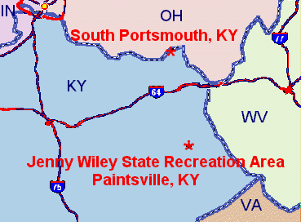

**Connecting with the *Jenny Wiley Trail* are the *Michael Tygart* and *Simon Kenton* trails.  Together, the three trails total more than 196 miles, and serve to link Greenbo Lake State Resort Park and the Carter Caves State Resort Park, to the *Jenny Wiley Trail*.**

**Primative camp shelters are located along the trail at different intervals.   Most shelters have a cistern water supply or a spring or nearby well.  All water should be treated.**