The picture was taken at Leon, KY of the RR bridge. Not sure what year the picture was taken, maybe around early 1920’s.

This is one of the stories

I Remember the Night that the Bridge Came In:
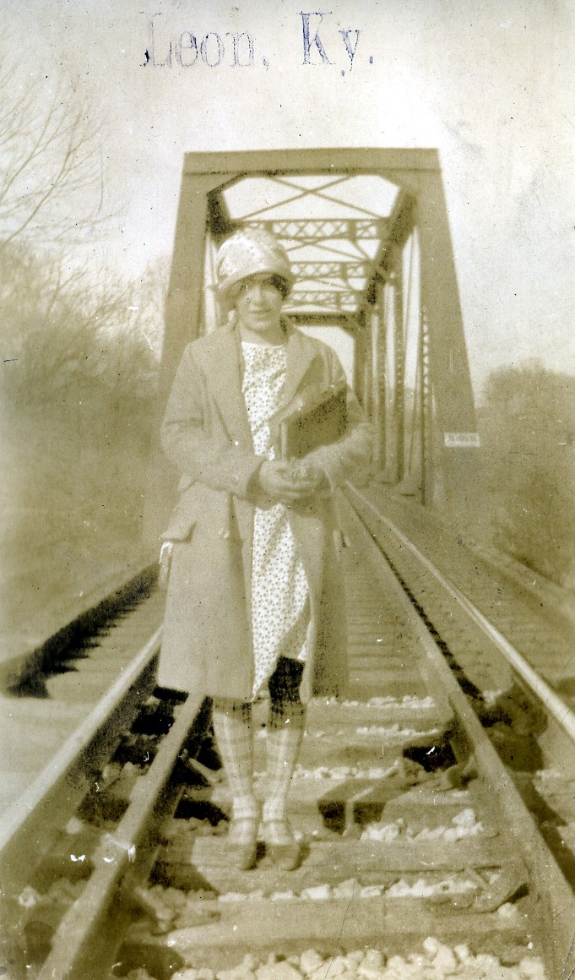
There were people staying at our house. They’d been there for a long time. There was a man and a woman and a grown son. I don’t know how long they’d been there and bridge still hadn’t come in. So the man watched and when the first train would come in, if it were going to set something off on the side, he would always be out there watching. And that night he saw it was a train that was going to put some cars off on the side, and he went to see what it was and it was the bridge coming in. Oh, was there excitement in Leon! They had a big to-do. Everybody was out there looking and everybody was excited. So they could get started on the bridge the next day. They worked all winter on putting that bridge in. That’s when the war was going on, the war to end all wars. We moved to the farm in 1918, in March, when the bridge was new.

Leon Described:
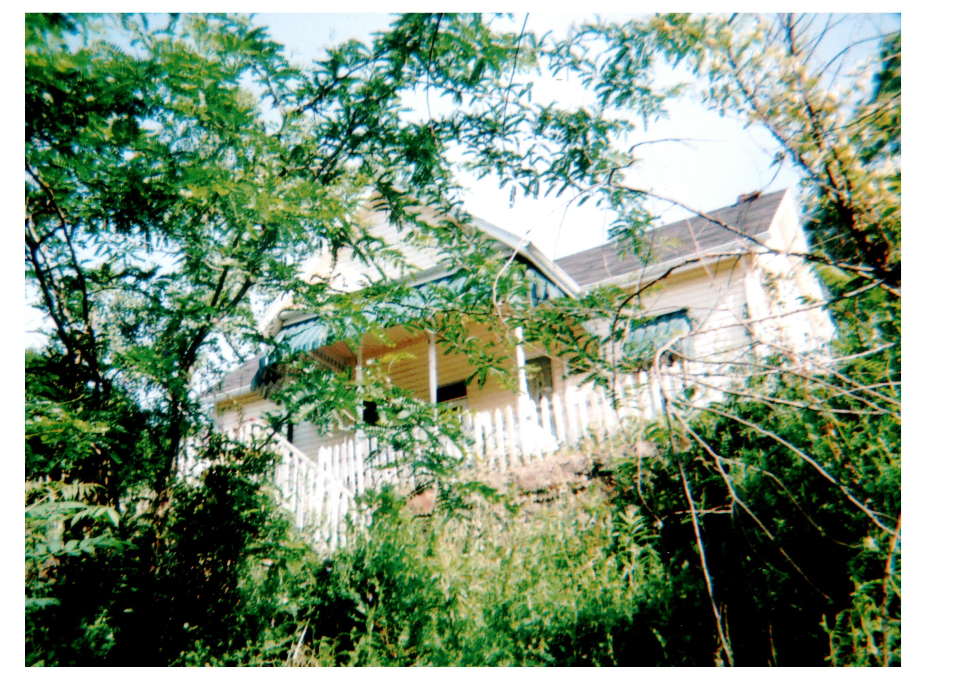
The water tank was just a little below our house. The road went along in front of our house, of course, down the hill, we were up on the hill. You went down the steps and there went the road along there was the same road that went out in front of the store and was going on a plummet. It went down there along below our house, right in front of our house and the railroad run right along that real close and down just a little way, right in front of our house over there was a crossing. See they had to have railroad crossings for the wagons and everything. And right below the crossing was the water tank. This was fascinating to see the fast trains pickup their water. There was a thing that the pump man fixed before they got along, they had their regular time and they run on it. And this big arm come over it, it was looked like a big wooden arm that come over it and the brakeman or somebody grabbed it and put the water in and that fast train just went flying on and never stopped and took up water because these were steam engines. That was fascinating to see. On up the railroad was a tunnel and just before you got to the tunnel was a pump station. (A pump station for the water.) And he kept that tank pumped up full. (I asked, “They pumped water from that point down to the water tank?”) The pump was there, but I expect that the line just come straight from, see the river was just straight over back of that too, down along there too, and see the water came from the river. And I expect the line was there just to come from the river. But his pump house was up the railroad a little bit. I can just see him in my mind’s eye too, a little bitty man, John Damron. The depot over there, it was a nice depot for that time too. You wouldn’t, but that long ago and that little place it was a nice building. It was a two-story building; it had a nice big waiting room in it. And Tip’s office, he was a telegraph operator too, and of course, he sold tickets and took care of the freight that came in and all that. His office and then on the end of that was a great big storage room for freight that came in there for the farmers to come down and get another time that weren’t there to get it right then. Then they had an apartment upstairs. Pearat’s had an apartment, or whoever lived there; in my time it was Pearats there. They had a nice big apartment upstairs. Tip Pearat, have you ever heard me talk about Parker Pearat? Tip and Mable lived there. He was the depot agent and the telegraph operator. (I asked, “Did your dad ever run the telegraph?) I don’t know if he ever did or not. He and Tip were real good friends, but I don’t remember if he ever did that. (I asked, “He went to the telegraphic school, so I wondered if he ever ran the telegraph.”) I don’t know if he learned that telegraphy or not I don’t remember. I don’t remember him ever using it, because his line was bookkeeping. Tip would have taught anybody, any of the young people around there that wanted to know telegraphy. He was a nice person, and a good man. That was the place for everybody to loaf, around the depot. People would come in go down and watch the trains come in. Who got off and who got on.

The Blue Goose Ride into Grayson:
Mom’s school day began early. After she did her chores, she ate a huge breakfast probably consisting of eggs and ham or bacon and biscuits, maybe some gravy too. She then rode horse back to her best friend’s home, Christine. The people living along mom’s path said they could set their watch as Nadine rode past. Mom boarded her horse at Christine’s. Together, the girls walked down to where they could catch the train. A kindly old woman they called Granny Loudenback lived near this point. During the winter months Granny Loudenback would bring the frozen girls into her home and warm them before they caught the Blue Goose into Grayson.
However, on “court day,” the coach was full of people going to court, either as participants or as spectators. So instead of riding inside the coach, the girls had to ride the Blue Goose hanging on to the outside of it. From the Grayson station, Christine walked to Pritchard High School and mom walked her last miles to Christian Normal Institute (CNI) for her four years of high school.

