The Lyons Family Part III
By Jan Horne

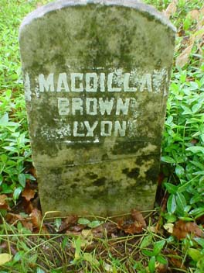
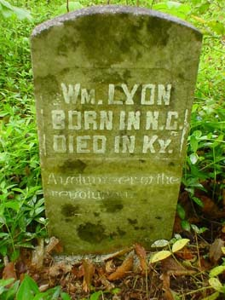

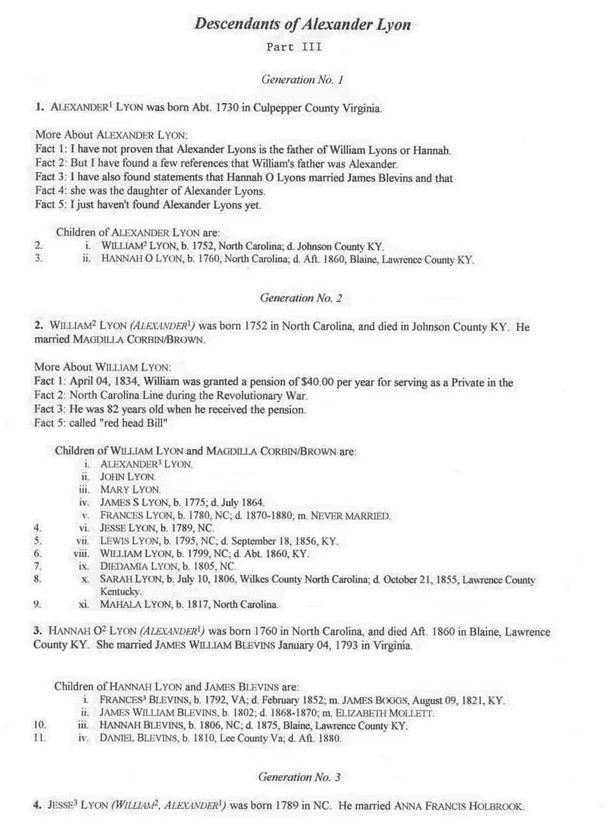

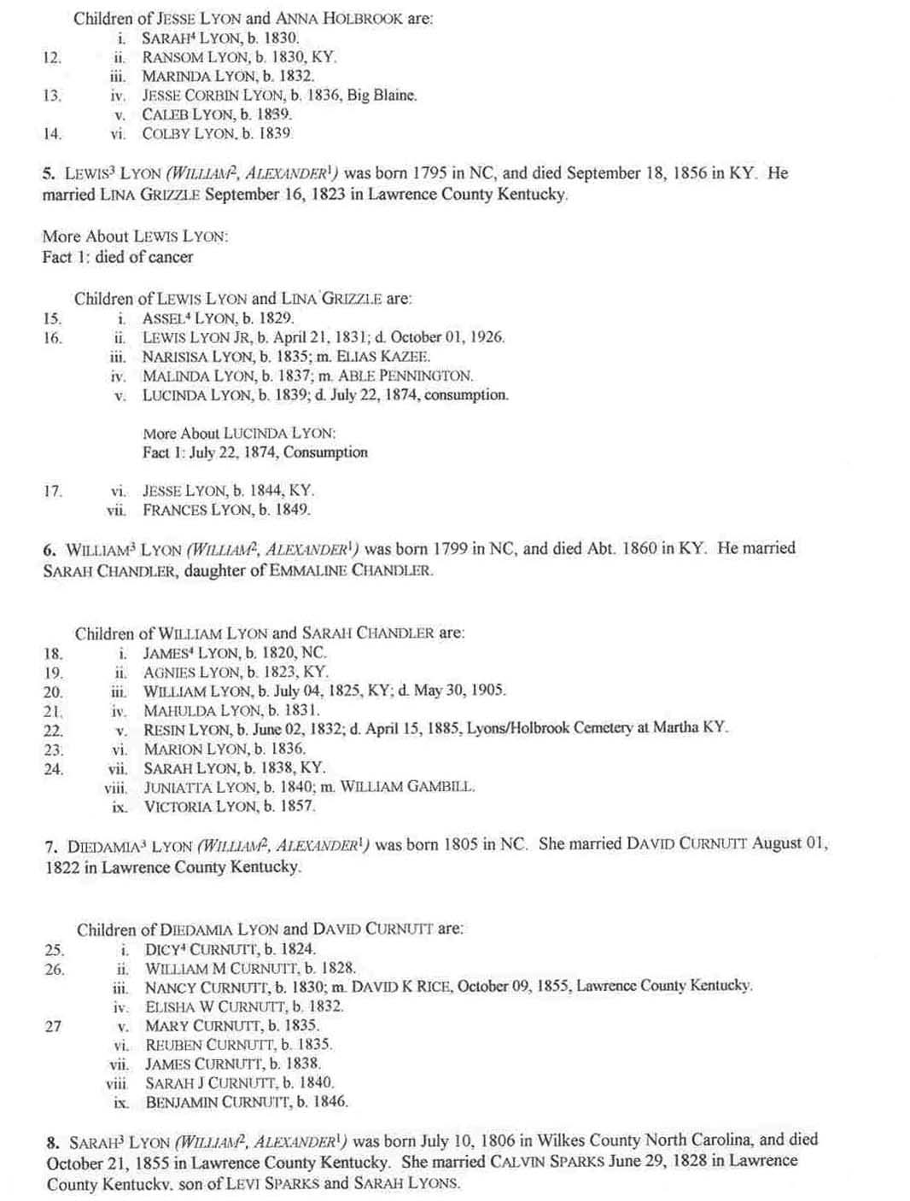
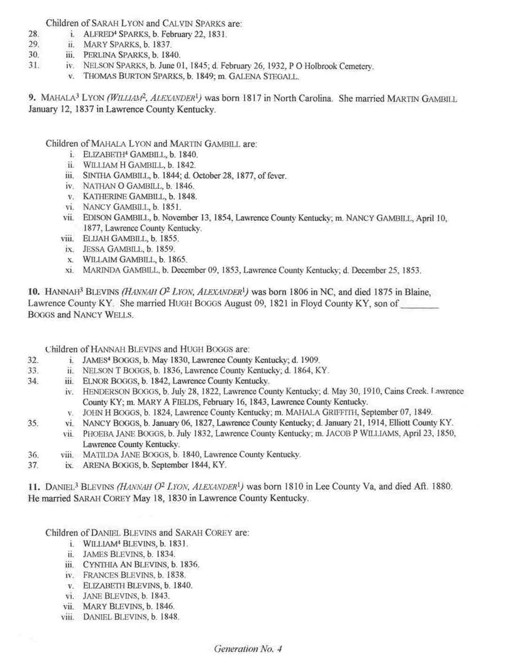
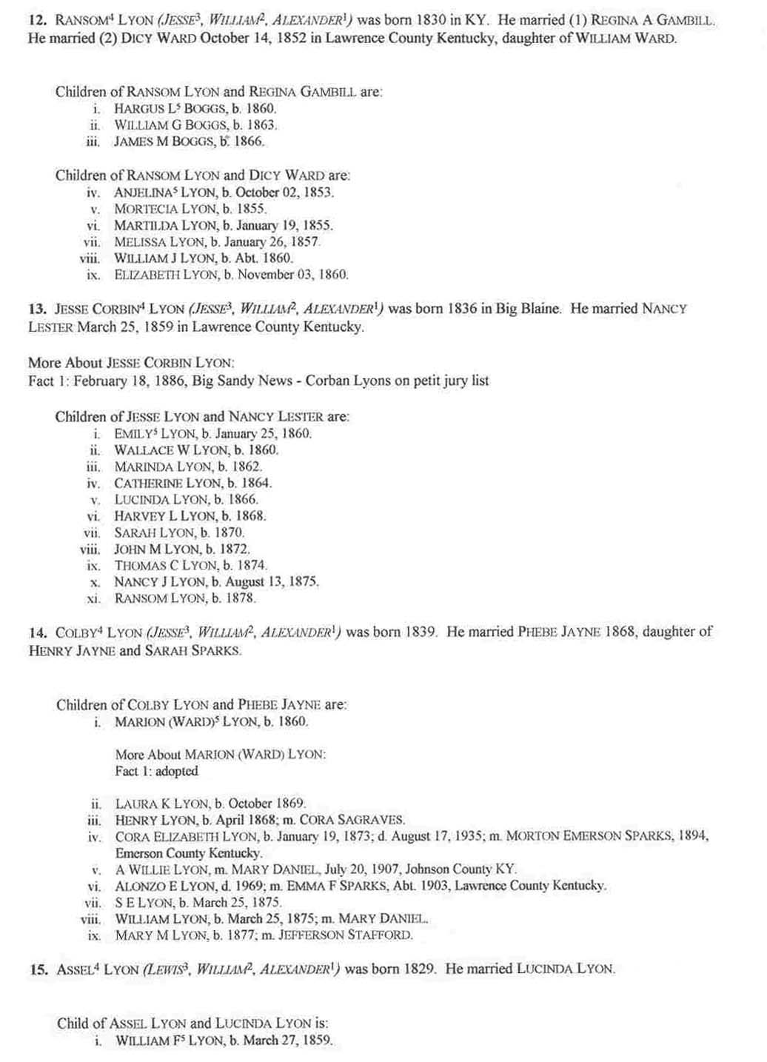
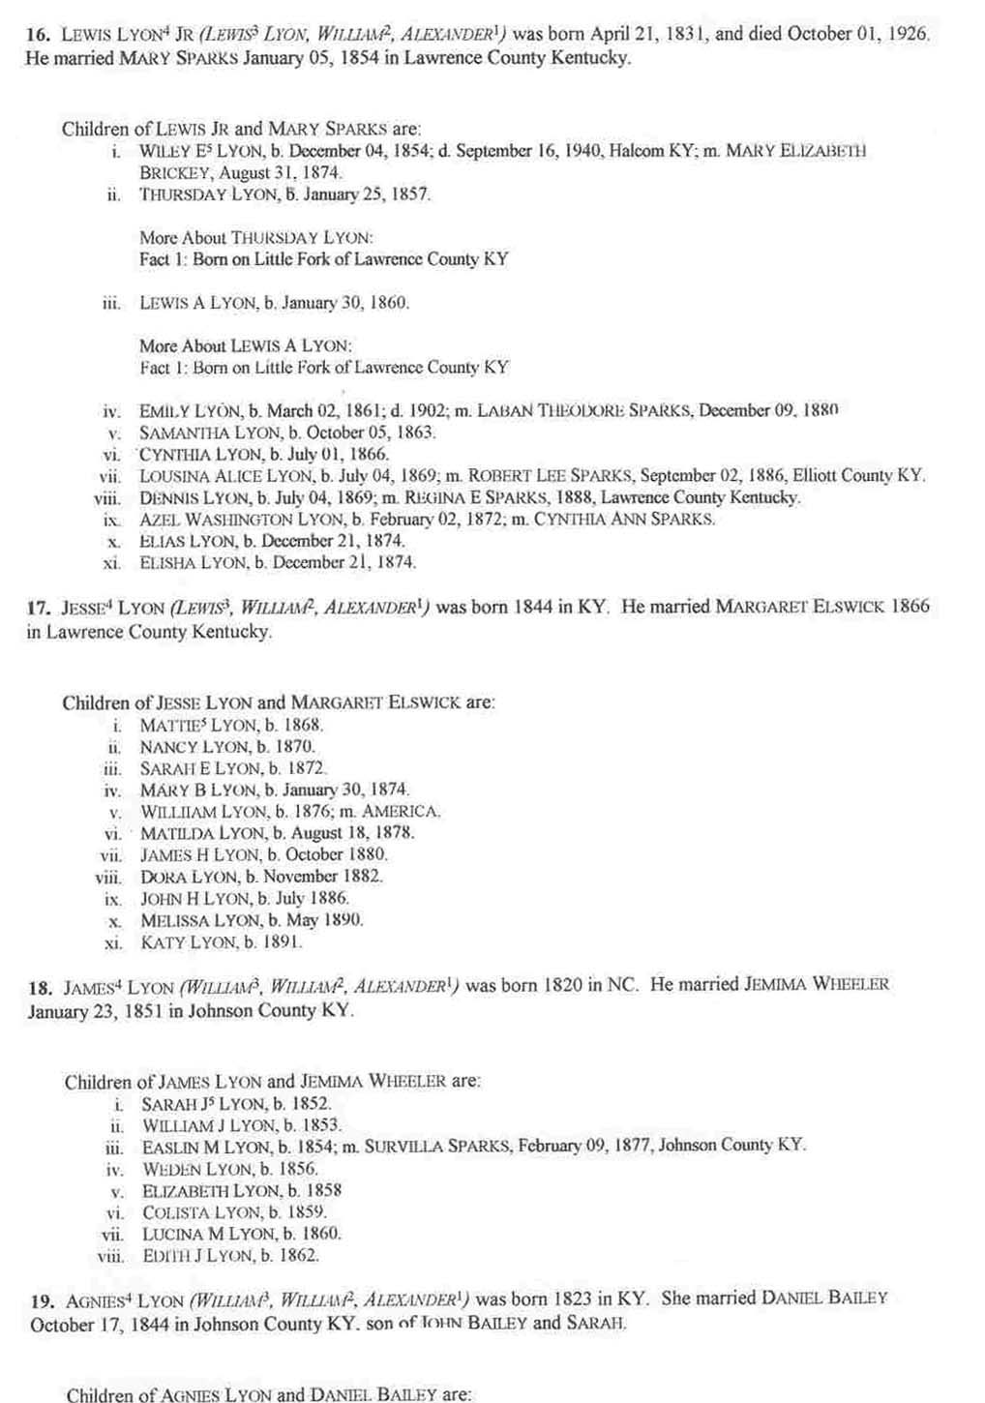
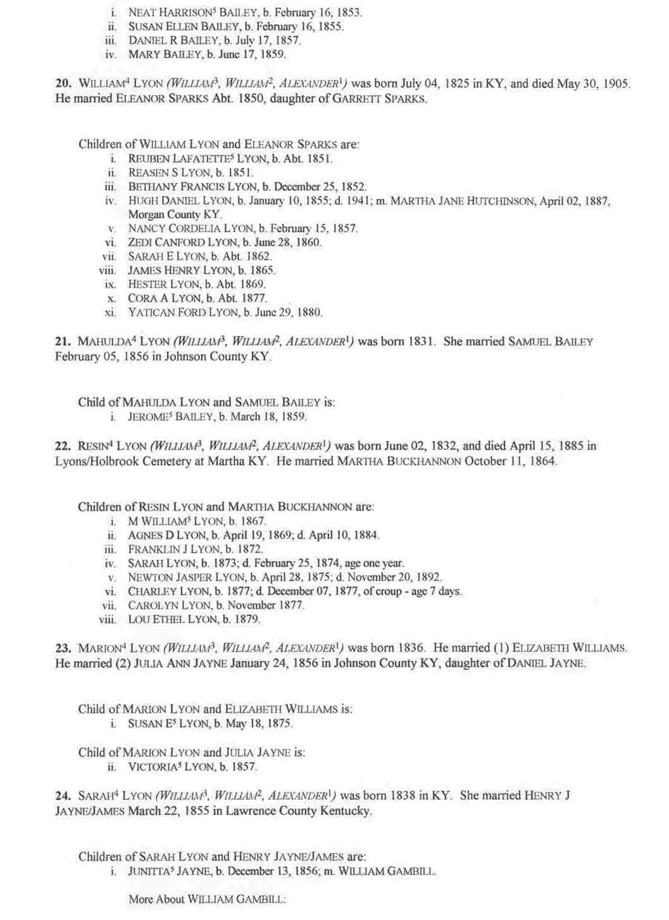
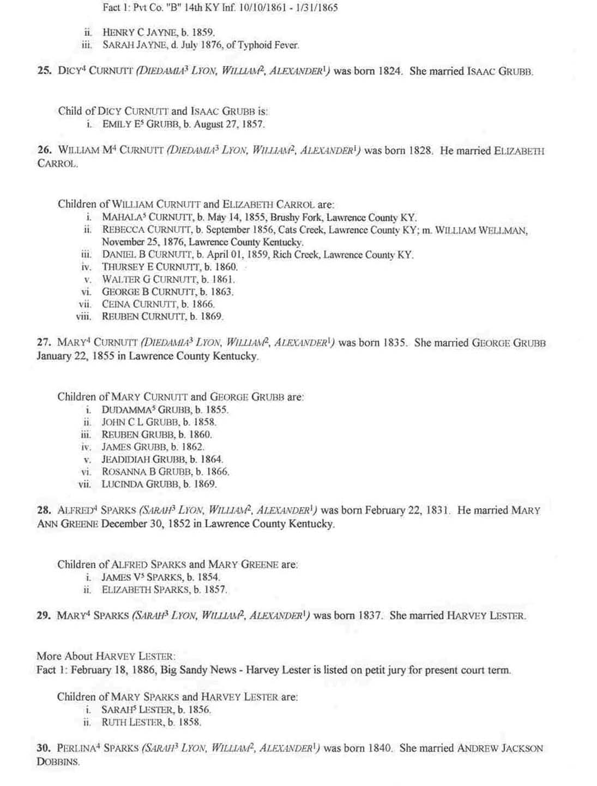
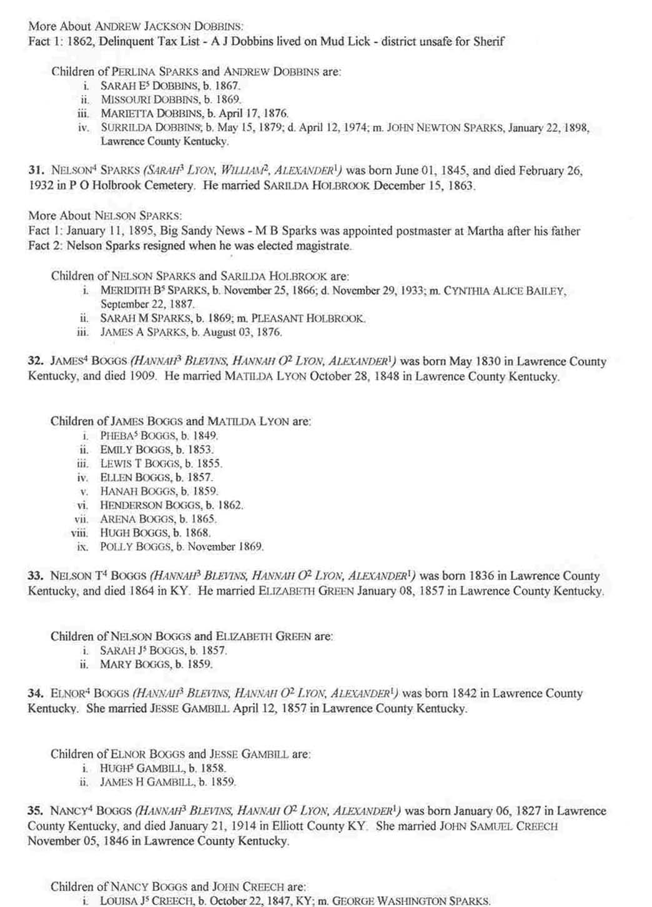
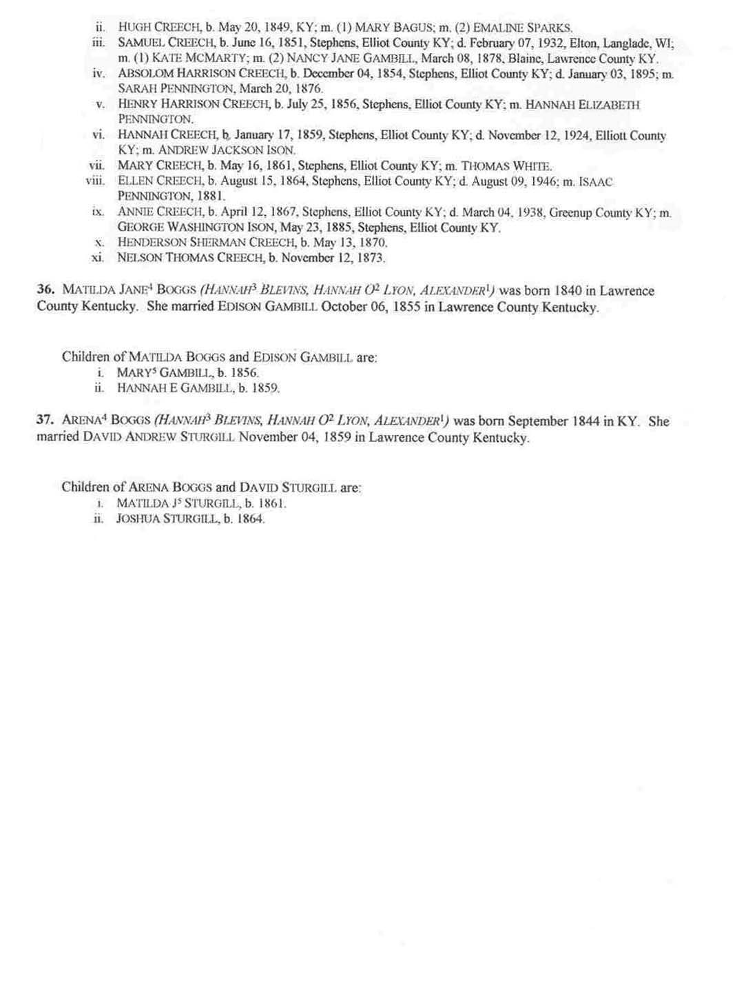
There is one final installment to this series of articles on the Lyon (s) family. It will be on the ones who came from Virginia. Please refer any comments or additional information to me, Jan Horne, 242 Frank Street, Paintsville, Kentucky 41240

JCHGS Meeting Schedule For 2005

March 5, 2005 at 10:00 AM in the Creekside Room of the Johnson County Public Library

June 4, 2005 at 10:00 AM in the Creekside Room of the Johnson County Public Library

September 10, 2005 at 10:00 AM in the Creekside Room of the Johnson County Public Library

December 3, 2005 at 10:00 AM in the Creekside Room of the Johnson County Public Library

