Lyons Family Genealogy (Ohio Group)
By Janet Horne

1st Generation

A. James Lyons was born about 1785 and died January 1, 1865. He was a Baptist Minister. In 1801 he was a member of the Columbia Baptist Church in Hamilton County Ohio. On November 11, 1799 in Hamilton County Ohio, a James Lyons married Rebecca Lines. James Lyons also married Marie Corder, the daughter of John and Mary Corder.

James and Marie Corder Lyons had a daughter Eliza Lyons who was born in 1823 and died March 25, 1846. She is buried in the Duck Creek Baptist Church Cemetery in Hamilton County Ohio.

It appears that David Lyons was a son of James and Marie Corder Lyons, also, but isn’t proven yet. David Lyons was born about 1818 in Hamilton County Ohio. He married Manerva Burton about the time he came to this area. Following is the genealogy of David Lyons.

2nd Generation

I. David Lyons was born about 1818 in Hamilton County Ohio. He married about 1842, possibly Lawrence County Kentucky to Manerva Burton. Manerva was born about 1817 in Kentucky.
He married second on November 13, 1873 in Johnson County Kentucky to Susanna O’Bryant, the daughter of William O’Bryant and Mary Chandler. His children were.

1 Maria J Lyons born 1843 died 1854 age 10
2 William L Lyons born 9/1/1845 died 7/4/1923 married Fanny Bowen*
3 Susannah Lyons born 1847 married Isaac Athenton
4 Mary F Lyons born 1849 died 4/15/1854
5 Andrew J Lyons born 1850 married Catherine Bowen
6 Samantha Lyons born 3/16/1853 died married
7 John W Lyons born 2/24/1855 died 1910 married (1)Phebe
Bowen & (2)Essie Lyons
8 George W Lyons born 2/24/1855 died 1/13/1913 married Kesiah
Hampton
9 ________ Lyons born 7/18/1857 died married
10 Trinvilla Lyons born 1858 died married F M Pack
11 Anna Lyons born 11/26/1859 died married
12 Lanel/Louella Lyons born 11/9/1874 died married
13 Maranda Lyons born 11/1878 died married

- daughter of Henry Bowen and Mary Pack

January 30, 1852, David and Manerva Lyons sold to John Salyer, 50 acres of land for $125.00. Mentioned in deed, a conditional line between David Lyons and Andrew Burton. “David and Manerva defend against themselves and their heirs, William Burton and his heirs, Jonathan Sparks and his heirs. The deed was recorded in Lawrence County KY April 18, 1856. It was recorded in Johnson County KY November 21, 1857.

3rd Generation

I-1 Maria J Lyons was born about 1843 and died about 1854 at age 10. No other information is available on her.

I-2 William L Lyons was born September 1, 1845 and died July 4, 1923. He married Fanny
Bowen, the daughter of Henry Bowen and Mary Pack. William served in the Civil War
January 26, 1864 through September 5, 1866 in the 39th Kentucky Volunteers.

William and Fanny had the following children:

1 Henry David “Bud” Lyons born 1867 married Celia Conley
2 Alafair Lyons born 11/1869 married
3 General Sherman Lyons born 1872 married
4 Mary Lyons born married
5 Anjelina Lyons born married
6 Julia Ann Lyons born 6/25/1883 died 12/19/1968 married Farris
Castle
I-3 Susannah Lyons was born about 1846. She married Isaac Athenton/Arrington
about 1863. Their chidren were:

1 Minerva J Athenton/Arrington born 1864
2 Mary F Athenton/Arrington born 1869

I-4 Mary F Lyons was born about 1848 and died April 15, 1854 of inflammation of the
lungs. No other information is available on Mary.

I-5 Andrew J Lyons was born about 1850 and married August 19, 1876 in Lawrence
County Kentucky to Catherine Bowen. Catherine was born in January 1861, per census records. Andrew and Catherine had the following children, perhaps others.

1 I Lyons born 1871 married
2 Laura B Lyons born 8/1882 married Sam Castle
3 Mary E Lyons born 11/1890 married Pete Charles
4 John H Lyons born 6/1893 married

I-6 Samantha Lyons was born March 16, 1853. No other information is available at this
Time.

I-7 John W Lyons was born February 24,1854 in Kentucky, and died in 1910. His father was born in Ohio. He was a Blacksmith. He married first in 1873 in Lawrence County Kentucky to Phebe Bowen. Phebe was born in about 1855. John married second to Essie Lyons on October 16, 1902 in Johnson County. Essie was born about 1882 in Kentucky, the daughter of James Lyons and Arminta Stafford. She was the granddaughter of Hamilton Lyons, born in Pennsylvania. However, his children who came to Kentucky with him were all born in Ohio. John’s children were:

1 Frank Lyons born 1874 married Lizzie Lowe

2 Charles Lyons born 6/1876 died 7/1/1876
3 George Lyons born 1879 married Julia Castle
4 James Lyons born 1905 married Juanita Perry
5 Ethel Lyons born 1911 married Arbie Meek
6 Ruth Gertrude Lyon born 1913 married Ochel/Oscar Lemaster
7 Lucy May Lyons born 6/20/1915 married (1) Woodrow Gibson (2)
Joseph Justice (3) Unknown
8 Thomas Lyons born 1919 married
9 Jewell K Lyons born 1921 married
10 John H Lyons born 1924 married

I-8 George W Lyons was born February 24, 1854, a twin to John W. George died
January 13, 1913. He married Kesiah Hampton on January 30, 1879 in Johnson County
Kentucky. Kesiah was born about 1867 and died August 31, 1930 in Johnson County.
George and Kesiah’s children were:

1 Harry Lyons born 1/1881 married Allie Price
2 Clyde Lyons born 2/1883 married Martha Conley
3 John Lyons born 10/1886 married (1) Laura Castle (2)Sallie Allen
4 Charley Lyons born 3/1892 married Pearl Moore
5 Ben Lyons born 8/1895 married
6 Daisy Lyons born 11/1897 married Talbert H Barnett

I-9 ____________ Lyons was born July 18, 1857. No other information available.

I-10 Trinvilla Lyons was born about 1858 in Lawrence County Kentucky and died before 1957.
She married on March 3, 1877 in Lawrence County to Frances Marion “FM” Pack. FM was
born October 27, 1853 in Lawrence County and died before 1957. Trinvilla and FM’s child
was:

1 Drew Pack born 1889 married Nancy Cross

I-11 Anna Lyons was born November 26, 1859. No other information is available.

I-12 Lanel/Louella Lyons was born November 9, 1874. No other information is available.

I-13 Maranda Lyons was born November 1878. No other information is available.

4th Generation

I-2-1 Henry David “Bud” Lyons was born July 1868. He married Celia Conley.
Celia was born June 1868 and died about 1939. She was the daughter of
William and Rachel Conley. Their children were:

1 Luverna Lyons born 5/1887 married John S Vanhoose 9/5/1902
2 Samuel Lyons born 9/1888 married Mary Bell Wiley
3 Emma Lyons born 9/1889 married Marion Francis Vanhoose 2/18/1908
4 Willie Lyons born 8/1890 married
5 Fannie Lyons born 10/1892 married
6 Ora Lyons born 4/1897 married Madgie Wiley 4/25/1918
7 Andy Lyons born 5/1900 married Lidda Meadows 4/11/1911

I-5-2 Laura B Lyons was born August 1882. She married John S “Sam” Castle, who was born about 1881. Their children were.

1 Virgie Castle born 1902 married Willie Lyons

2 Burns Castle born 1915
3 Richard Castle born 1918
4 Anna Castle born 1917 (adopted)
5 Ransom Castle born 1924

I-5-3 Mary Elizabeth Lyons was born November 1890. She married Pete Charles. He
was born about 1888. Their children were:

1 Delpha Charles born 1910
2 Charles T Charles born 1914
3 Myrtle F Charles born 1916

4 Dorothy Charles born 1918
5 Harkless Charles born 1922

I-7-1 Frank Lyons was born about 1874. He married Lizzie Lowe. Their child was:

1 Willie T Lyons born 1898 married Gypsie Fraley

I-7-2 Charles Lyons was born June 1876 and died July 1, 1876. No other information
is available.

I-7-3 George Lyons was born about 1879. He married Julia Castle. Their children
Were:

1 Rennie Lyons born married ___ Borders
2 Arthur Lyons born 5/15/1900 died 3/25/1950 married Alice Daniel
3 Norah Lyons born 1905 died married
4 Walter Lyons born 1909 died married Oma Daniels
5 Mona/Monnie Lyons born 2/8/1913 married Arlie Vanhoose

I-7-4 James Lyons married Juanita Perry. Their children were:

1 Francis Lyons born 5/22/1926 married John
Stambuagh
2 James Harlan Lyons born 2/17/1928 married
3 Nanette Lyons born 3/19/1930 married
4 John Southwell Lyons born 5/5/1932 married

5 John Lyons born 1/18/1936 married
6 Robert H Lyons born 5/29/1938 married
7 William C Lyons born 12/14/1940 married

I-7-5 Ethel Lyons was born about 1911. She married Arbie Meek on November 19, 1930. The Certificate was not returned to the courthouse. Arbie Meek was born about 1908, the son Winifred and Vina Meek. No other information available.

I-7-6 Ruth Gertrude Lyons was born about 1913. She was married to Ochel or Oscar Lemaster on January 1, 1931 by D G Harris in Johnson County. Ochel/Oscar was born about 1906, the son of Bascom and Florence Lemaster. No other information is available.

I-7-7 Lucy May Lyons was born June 20, 1915. She married (1) on November 13, 1931 to Woodrow Gibson. Guy W Preston performed the ceremony. Woodrow was born about 1914. He was the adopted son of Theadore and Sarah Walker. She married (2) to Joseph Justice; and (3) to an unknow man. This is all the information I have on Lucy May.

I-7-8 Thomas Lyons was born about 1919. No other information found on him.

I-7-9 Jewell K Lyons was born about 1921. No other information found on her.

I-7-10 John H Lyons was born about 1924. No other information available at this time.

I-8-1 Harry Lyons was born January 1881. He married Allie Price on April 9, 1904 in Johnson County. Their children were:
1 Arnold Lyons born 1907 married Mintie Stambaugh
2 Hazzel Lyons born 1910 married

3 Raymond Lyons born 9/12/1911 died 11/14/2001 married
4 George Martin Lyons born 3/12/1914 married
5 Edgar Lyons born 1917 married
6 Harry Lons Jr born 3/1/1920 died 9/12/2000 married
7 Roger Lyons born 3/18/1924 married

I-8-2 Clyde Lyons was born February 1883. He married Martha Conley on May 5, 1906 in Johnson County. No other information available at this time.

I-8-3 John Lyons was born October 1886. He maried (1) Laura Castle on April 20, 1907 in Johnson County; and (2) Sallie Allen on May 24, 1912 in Johnson County. No other information available at this time.

I-8-4 Charley Lyons was born March 1892. He married Pearl Moore on April 6, 1918 in Johnson County. Their children were:

1 Charles Clarence Lyons born 1919 Boyd Co. married Nancy Mae
Steele
2 Mary Louise Lyons born 1922 married
3 Helen J Lyons born 1924 married
4 George E Lyons born 5/13/1926 married
5 Robert C Lyons born 1934 married

I-8-5 Ben Lyons was born August 1895. No other information was found on Ben.

I-8-6 Daisy Lyons was born November 1897. She married Talbert Barnett on June 11, 1917 in Johnson County. Their child was:

1 Dorothy Barnett born 1919

I-10-1 Drew Pack was born in 1889. He married Nancy Cross on February 18, 1909 in Johnson County. Nancy was the daughter of M C and Nancy Cross.

5th Generation

I-2-1-1 Lou Verna Lyons was born May 1887. She married
John Samuel Vanhoose on September 5, 1902. He was
Born May 9, 1997. Their children are:

1 Herman Vanhoose born 1901
2 Hershel Vanhoose born 1911
3 Angus Vanhoose born 1915
- Cora Ethel Vanhoose born 1920
- Marie Vanhoose born 1923
- Sammie Vanhoose born 1925
- Curtis Vanhoose born 1928

I-2-1-2 Samuel L Lyons was born September 1888. He married
Mary Belle Wiley. Their children are:

1 Florida Lyons born 1911 m Eldannia Vanhoose
2 Bert Lyons born 1912 m Margie Ward
3 Edgar Lyons born 1915 m Alice Adams
- Wa;ter Lyons
- Mitchell Lyons
- Herbert Lyons
- Zilphia Lyons m ____ Shannon
- Opal Lyons m ____ Church

I-2-1-3 Emma Lyons was born September 1889. She married
Marion Francis Vanhoose on February 18, 1908. He was
Born November 14, 1890. No other information found.

I-2-1-4 Willie Lyons was born August 1890. He married Virgie
Castle. Their children are:

Orville Lyons born 1919 m Helen Daniel
Arvil Lyons born 8/11/1920
Rosa Lyons born 5/18/1923

I-2-1-5 Fannie Lyons was born October 1892. No other
Information found.

I-2-1-6 Ora Lyons was born April 1897. He married Madgie
Wiley on April 25, 1918. Their children are:

1 Bruce Lyons born 1/27/1919 m
2 Anthony Lyons born 1922 m Ruby Williams

I-2-1-7 Andy Lyons was born May 1910. He married Liddia
Meadows on April 11, 1921. Their children are:

1 James Harrison Lyons b 4/23/1922 m Helen Dove
- Henry Lyons b 1924
- Mitchell Lyons b 1925
- Madaline Lyons b 1928
- George Lyons b 1929
- Paul Thomas Lyons b 2/3/1933
- Emmaline Lyons b 8/21/1935
- Betty H Lyons b 9/2/1939
- Clarence E Lyons b 7/24, 1941
- Billie R Lyons b 8/10/1943

I-7-1-1 Walter Franklin Lyons was born 1921. He was married
To Audrey Lowe on February 2, 1940 by Guy W Preston
in Johnson County. Audrey was born about 1922. She was the daughter of Ray Lowe and Zella Stephens. No other information was discovered on this couple.

I-7-3-1 Arthur Lyons was born May 15, 1900 and died
March 25, 1950. He is buried in the Brown Cemetery.
He married Alice Daniel. Their children are:
1 Homer Lyons b 1925 m Edna Borders
2 Pansy Lyons b 1929 m Floyd Castle
3 _____ Lyons b m Richard Murray
4 James A Lyons b 12/15/1934

I-8-1-4 George Martin Lyons was born March 12, 1914 and died August
14, 1998. He married Essie Vanover, the daughter of Henry
Vanove And Dora Tackett. Essie was born November 5, 1917 in
Magoffin County and died July 17, 1997. Their children are:

1 Martina Lyons b 7/27/1936 d 7/5/1994 m _____ Estep
- Mike Lyons

I-8-1-5 Edgar Lyons was born about 1917 and died November 19, 1916.
No other information is available.

I-8-1-6 Harry Lyons Jr was born March 1, 1920 and died September 12, 2000. He was a Conductor on a train and a member of United Trainsmen Association & Union. He married Henrietta Osborne. Their child was:

1 Dianna L Lyons m ______ Kuhnle of
Louisville

I-8-1-7 Roger Lyons was born March 18, 1924 and died May 24, 2002.

I-8-1-8 Raymond Lyons. No other information available at this time.

I-8-4-2 Mary Louise Lyons was born about 1922 in Johnson County. She
Married Kenneth Leedy on September 13, 1941 in Johnson
County. Roscoe Lemaster performed the wedding. Kenneth was
born about 1920 in Franklin County Ohio, the son of John Leady
and Maude Thompson. No other information available.

I-8-4-3 Helen J Lyons was born about 1924. No other information found.

I-8-4-4 George Lyons was born about 1924. No other information found.

6th Generation

I-2-1-2-1 Florida Lyons was born April 26, 1910 and died March 1, 1985. He is buried in the Old Hood Cemetery at Sitka KY. He married Eldanna Vanhoose. She was born January 26, 1913, daughter of Martin Vanhoose and Selina Ward. Their children are:

1 Anna Bell Lyons b 8/3/1928 m Lacy E Puckett
2 Franis Faye Lyons b 2/5/1930 m 1 Robert Cottle 2 Harold Preston 3 Cora Lee Lyons b 6/7/1933 m James Walters 4 Nora Lee Lyons b 6/7/1933 d 10/19/1933 5 Wanda Lou Lyons b 9/29/1934 m _____ Peters 6 Peggy Marie Lons b 3/29/1938 m James Wallen 7 Linda Sue Lyons b 1/4/1945 m Edwin Spencer 8 Maryland Kaye Lyons b 8/5/1953 m Roy Daniel
Florida Lyons was a member of the Paint Union Association of the United Baptist and was moderator at the following churches:

- Alder’s Chapel
- Hood Fork
- Low Gap
- Rocky Branch
- Fish Trap
- Jenny’s Creek
- Abbott
- Hickory Grove

I-2-1-2-2 Bert Lyons was born about 1912. He died in 1993. He married Margie Ward on October 18, 1934 in Johnson County. Arthur Greene performed the ceremony. Margie was born June 20, 1915 and died May 26, 2000. She was the daughter of Paris Ward and Maudie Preston. Their children are:

1 Bessie Lyons b 11/7/1935

2 Roy M Mitchell Lyons b 4/2/1938 died 5/29/1956

3 Anna Louise Lyons b 7/20/1940 m _____ Bowers

4 James Robert Lyons b /24/1942

5 Dennis Ray Lyons b 11/4/1947

6 Charles Arthur Lyons

7 Alberta Lyons m _____ Buckley

8 Lanny Keith Lyons b 11/10/1951

I-2-1-2-3 Edgar Lyons was born about 1915. He married Alice Adams on

December 3, 1934 by Guy W Preston. Alice was born January 17,

1917 and died April 27, 2002. She was the daughter of Ashland

Adams and Rose Hampton. Their children are:

1 Edna A Lyons b 1/12/1941 m _____ Fannin

James Edgar Lyons b 3/26/1936

Howard G Lyons b 1/31/1938

Faye Lyons b m _____ Castle

I-2-1-4-1 Orville Lyons was born about 1919 in Johnson County. He was a

Miner living at Thealka. He married Helen Daniel on November 1, 1941 in Johnson County. H E Trent performed the ceremony.

Helen was born about 1923 in Johnson County. She was the

Daughter of King Daniel and Georgia Bowling. She lived at Offutt.

Their children are:

1 Orville D Lyons b 3/24/1943

2 Ronald L Lyons b 12/7/1944

I-2-1-6-1 Anthony Lyons was born about 1922 in Floyd County. He was a Store Clerk and resided at Glo KY at the time of his marriage to Ruby Williams on August 11, 1943. They were married in Johnson County by Noah M Ward. Ruby was born about 1925 in Floyd County. She was the daughter of Walter Williams and Stella Hampton. She lived at Williamsport. Their children were:

- Michael Robert Lyons b 3/27/1947 d 9/8/1995 married Connie Spradlin. One son Anthony Bryan Lyons and one daughter Amy Beth (Lyons) Meek.

I-2-1-7-1 James Harrison Lyons was born about 1921. He was married to Helen Dove on May 14, 1938 by Guy W Preston. Helen was born about 1923. She was the daughter of Ernest Dove and Hattie Castle. Their children are:

1 Ernest K Lyons b 6/16/1941

2 Carolyn Lyons b 1/13/1943
3 Connie M Lyons b 1/2/1953

I-2-1-7-2 Henry Lyons was born 1924. No other information available.

I-2-1-7-3 Mitchell Lyons was born about 1925. No other information available.

I-7-3-1-1 Homer Lyons was born about 1925. He married Edna Borders on
May 5, 1941. Their children are:

1 Wanda B Lyons b 10/9/1944
2 Ralph V Lyons b 1/26/1951
3 Roger D Lyons b 9/19/1953
- Sharon K Lyons b 7/27/1955

I-8-1-1-1 Raymond Lyons was born September 12, 1911 and died November 14,
- He married Flora Montgomery. Their children are:

- Vinton Lyons
- Judy Lyons m _____ Evans of Flatwood

Raymond V Lyons b 8/6/1952

The 2nd installement of the Lyons will appear in the September issue of the Highland Echo and will outline the descendants of Hamilton Lyons of Pennsylvania and Ohio.

Murray School Group Circa 1952-53
From Janet Horne

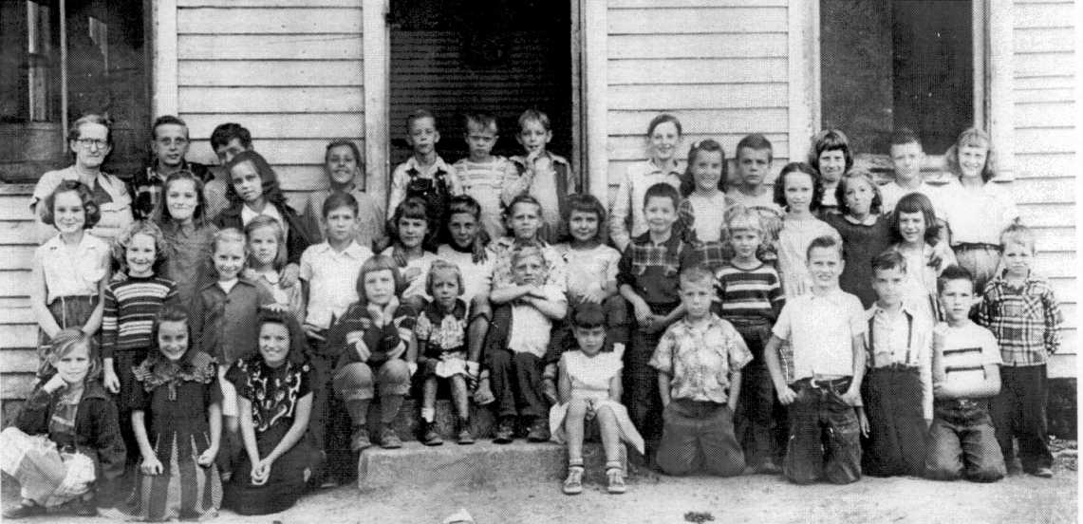

Top Row
Left to Right: Teacher Ella Rice; Jerry VanHoose; William McKenzie; Frankie McKenzie; Buddy VanHoose; Roy VanHoose; ____ Estep; Gene Burke; Wanda Mae VanHoose; Joe Hale; Rose Marie McKenzie; James Roy Fannin; Gracie Carol Lemaster
Second Row
Left to Right: Franco Fairchild; Anna Jane Estep; Wilma Long; Tom Lemaster; Paulette Fairchild; Louise VanHoose; Russell Lemaster; Rosetta Estep; Ronnie Davis; Patty Crislip; Ruby VanHoose
Third Row
Left to Right: Brenda Fairchild; Jewell VanHoose; Mary Lou Long; Betty Lou McKenzie; Betty VanHoose; Frank Lemaster; Marlene Crislip; Carolyn Sue VanHoose
Fourth Row
Left to Right: Edna Long; Della Burke; Nancy Burke; Phyllis Fairchild; John Jr. VanHoose; Eugil VanHoose; Ruby Fairchild; Jackie Crislip; Truman VanHoose

The Lyons Family Part 2
LYONS FAMILY GENEALOGY

This second installment of the Lyons Family Genealogy is the Hamilton Lyons family. Hamilton Lyons was born in Alleghany County Pennsylvania but lived in Hamilton County Ohio before coming to Kentucky. He is buried on Rt 460/23. The cemetery was moved when Rt 23 was widened. May have been moved up the hill. His parents were possibly Abraham Lyons and Margaret Shaw. Abraham was the son of Sam Lyons Jr. He may have had a brother Samuel who was also born in Pennsylvania. I haven’t proven these parents and brother of Hamilton Lyons.

In an 1840 Cincinnati Ohio Directory is listed the following:

“Hamilton Lyons born in Pennsylvania, worked at Lyon & Bell, Ohio Bell & Brass Foundry.” (r Pike b Congress & 3)

“Samuel Lyons born in Pennsylvania, an Engineer on the River.” (r Pike b 3 & Congress)

“Mrs. Jane Lyon born in Pennsylvania, Seamstress.” (r Ludlow b 3 & 3)

1ST GENERATION

Hamilton Lyons was born about 1806 in Pennsylvania and died in the mid 1880’s. He is listed in the 1840-1850-1860 Hamilton County Ohio Census. He is in the 1870 Johnson County Kentucky Census. The census lists that he and both his parents were born in Pennsylvania. In about 1830 he married Frances Royce (per Barbara Lyon Harrison). He married second to an Anna, last name unknown.

Hamilton Lyons had thirteen children of record, all born in Ohio. They were:

1. Hamilton Lyons b 1832 Ohio
2. William Devine Lyons b 1833 Ohio lived in Missouri
3. Samuel Lyons b 1836 Ohio lived in Tennessee
4. Southwell Lyons b 3/2/1839 d 1899 Ohio married Roseanna Risner
5. Missouri Lyons b 1840 Ohio married ______ Moyer, lived in Cincinnati
6. Margaret Lyons b 1840 Ohio
7. James Lyons b 1844 Ohio married Araminta Stafford
8. Francis Lyons b 1846 Ohio married John W Turner
9. John Lyons b 1848 Ohio
10. Ellen Lyons b 1849 Ohio
11. Charlotte Lyons b 1852 Ohio
12. Anna Lyons b 1855 Ohio
13. William Lyons b 1860 Ohio married Manerva J Caudill

2nd GENERATION

  - Hamilton Lyons was born about 1832 in Ohio. His father was born in Pennsylvania and his
Mother was born in New Jersey. No other information has been obtained about him at this time.

  - William Devine Lyons was born about 1833 in Ohio. No other information available on him.

  - Samuel Lyons was born about 1836 in Ohio. No other information available on him.

  - Southwell Lyons was born March 2, 1839 in Ohio. He died January 5, 1899 at Coon Creek KY. He enrolled April 22, 1863 in the US Navy on the USS Covington and was discharged November 1, 1865 in Washington DC. He was Acting Asst. Engineer Gun Boat Captain. He married Roseanna “Anna” Risner on November 6, 1867 in Magoffin County. Anna was born March 1846 and died February 22, 1902, the daughter of John Risner and Elizabeth Howard. John was the son of Michael Risner and Sarah Howard. Anna was listed as a widow in the household of Hamilton Lyons in the 1900 Magoffin County Census. Southwell was a Blacksmith. He lived in Morgan, Johnson and Magoffin County. They had the following children:

1. John Lyons born 1865 married Eliza A Howard
2. William Sherman Lyons born 8/1869 d 1924 married Drusilla Howard
3. Hamilton Lyons born 5/5/1872 married (1) Matilda Howard (2)Mary B Howard
4. J W Lyons born 1879 married (2) Lula Hensley

Additional information on Southwell and his family can be found in Legends In Blue And Gray, Volume III,
page 1052 – 1059, by the Magoffin County Historical Society, Salyersville KY. 1998.

  - Missouri Lyons was born about 1840 in Ohio. No other information has been located.

  - Margaret Lyons was born about 1840 in Ohio. I presume she and Missouri were twins. No other
Information has been located.

  - James Lyons Sr was born March 1844 in Ohio. He lived in Johnson County. He died about 1909 and is buried in the F M Stafford Cemetery in Paintsville KY. He married on July 10, 1882 in Johnson County KY to Arminta Stafford. Mintie was born February 19, 1861 in Johnson County and died February 15, 1948. She was the daughter of F M Stafford and Marietta Lavender. She married second to D R Wheeler who was born in 1839. James and Mintie’s children were:

1. Francis Marion Lyons born 6/19/1885 married (1) Rhoda Ellen Lyons
2. Essie Lyons born 3/1887 married John W Lyons
3. Zula Mae Lyons born 10/1891 married Horatio Daniels Sr
4. Ruth Lyons born 4/1894
5. Marie Etta Lyons born 3/1898 married Walter Albert Ross Sr
6. Carrie Lyons born 3/1900 married Joe Patton Beverly
7. James Lyons Jr
8. John Lyons died young
- Earl Lyons

  - Francis F Lyons was born about 1847 in Ohio. Her father was born in Pennsylvania and her
Mother was born in New Jersey. She married on March 20, 1873 in Johnson County to John W Turner. He was born in 1844 in Floyd County, the son of James W Turner and Ann Waller. Their children were:

1. H S Turner born 2/15/1874
2. Ernest G Turner born 1874
3. Nellie Turner born 12/28/1875
4. Ray Turner born 5/1886

  - John Lyons was born about 1848 in Ohio. (no other information has been located on him)

  - Ellen Lyons was born about 1849 in Ohio. (no other information has been located on her)

  - Charlotte Lyons was born about 1852 in Ohio. Her father was born in Pennsylvania. (no other information is available.

  - Anna C Lyons was born about 1855 in Ohio. Her father was born in Pennsylvania. (no other information has been found)
  - William Lyons was born about 1860 in Ohio. He married February 25, 1889 in Johnson County to Manerva J Caudill. She was born about 1872 in Johnson County, the daughter of Jesse Cordle and Elizabeth Jordan. They had the following children:

1. Eva Lyons born 10/1891 married Frank Anderson
2. Arnold Lyons born 11/22/1892 -12/15/1874 married Mintie Stambaugh
3. Mason M Lyons born 7/1895
4. Pauline Lyons born 4/1897
5. Teri Lyons born 5/21/1900 – 5/12/1975 married Thomas Cordle
6. Patsy Lyons born 1902 married ______ Jones
7. Zora Lyons born 1905
8. Estill Lyons born 1907
9 Troy E Lyons born 1910

More information can be found on this family in Appalachian Crossroads, the Caudills by Clayton Cox, Vol 3, Chapter 109, page 1673.

3rd GENERATION

    - John Lyons was born January 1867 and died between 1900 and 1910. He married about 1886 to
(1) Eliza A Howard; (2) Essie Stafford; (3) ______ Hensley. Per 1900 Johnson Census Eliza was born January 1869. Also the census shows they have eight children with four living. The children of John and Eliza were:

1. Rhoda E Lyons born 2/1888 married Frank M Lyons
2. Richard Lyons born 11/1889 married Virgie Risner, lived in Lucasville OH
3. Fannie Lyons born 2/1893 married Grover Franklin
4. Walter Lyons born 6/1896 married Mary Bowen

John and Essie’s children were:

5. Lucy Mae Lyons married ______ Justice, lived at Mt. Sterling
6. Ethel Mae Lyons lived in Covington
- John Lyon
- Thomas Lyon
- _______ Lyon lived in Indiana

Richard and Fannie were in their Uncle Hamilton’s household in the 1910 census.

    - William Sherman Lyons was born August 5, 1869 and died September 8, 1924. He married
January 23, 1895 in Magoffin County KY to Drusilla Howard. She was born July 9, 1877 and died March 5, 1963 the daughter of Richard “French” Howard and Polina Howard. She is buried in the Lyons Cemetery at Maggard KY. Their children were:

1. Millie Mae Lyons born 4/24/1896 – 5/20/1979 married Clarence Hensley
2. Samuel Lyons born 4/1899 – 11/7/1933 married Annie Hall
3. Hassel Lyons born 1/6/1902 – 10/20/1980 married Bertha Caudill
4. Gladys Lyons born June 6, 1904 married Lewis Arthur Bodger
5. Ethel Lyons born February 15, 1907 married Dewey Cooper
6. Maxine Lyons born September 29, 1909 married Roosevelt Adams
7. Edgar Lyons born July 2, 1912 married Lena May
8. Edna Faye Lyons born May 11, 1915 married Raymond Harold Early

Additional information can be found on this family in the Magoffin County Historical Society’s the Howards,
Vol I, page 106 – 111.

    - Hamilton “Ham” Lyons was born May 5, 1872 and died July 24, 1939 at Maggard KY of a heart attack. He married about 1894 to (2)Mary Bell Howard. She was born June 1880 and died 1971. She was the daughter of Moses Howard and Nancy Arnett. He was also married to (1) Matilda “Tilda” Howard, the daughter of Moses Howard and Arzilla Howard. Here are the children:

1. Essa Lyons born 5/1898 married Lloyd Murray
2. Mandie Lyons born 9/10/1902 married Jonah Johnson
3. Harry Lyons born 1903 died as a teenager
4. Henry Hamilton Lyons born 1904 (1893-1983) married Wonnie Hortense Howard
5. Jim Lyons born married Cindy Helton

    - J W Lyons was born in 1879 in Magoffin County KY. He was a mechanic. I haven’t located his first marriage record. He married second on December 27, 1943 to Lula Hensley. She was born in 1917 in Magoffin County, the daughter of Willie Hensley and Lizzie Howard. Their child was:

1. Fannie Jean Lyons born 1937 married Larry Wheatley

    - Francis Marion “Frank” Lyons was born June 19, 1885 and died July 1, 1958. He is buried in the Stafford Cemetery. He married Rhoda Ellen Lyons, and two others. He was a nurseryman, merchant and civil engineer.
His children were:

1. Arthur Francis Lyons born 1901 USAF – Korea married Alice Daniel
2. Edwin Earl Lyons born 1907 lived in Ironton Ohio
3. Sheila May Lyons born 1909 lived in Ashland married a Winter
4. Paul Roger Lyons born 1/6/1914 lived in S Point Ohio
5. Ruth Irene Lyons born 11/7/1915 lived in Ashland married a Day
6. Edith Lorraine Lyons born 4/15/1919 lived in S Point Ohio married a West
7. James Lyons born 1923
8. Richard Hamilton Lyons born 1923 lived in S Point Ohio
9. John Lyons died young
10. Lorena Lyons died young

    - Essie Lyons was born March 1887. She married on October 16, 1902 John W Lyons. He was born
In 1878. Their children were:

1. James Lyons born 1905 married Juanita Perry
2. Ethel Lyons born 1911
3. Ruth Gertrude Lyons born 1913 lived in Indianapolis IN married Oscar Lemaster
4. Lucy Mae Lyon born 1915 lived in Mt Sterling married (1)Woodrow Gibson (2,3)
5. Thomas Lyons born 1919 married Oakie Morris Perry
6. Jewell K Lyons born 1921
7. John H Lyons born 1924

    - Zula Mae Lyons was born October 21, 1891 and died May 17, 1954. She married June 29, 1910 to Horatio Daniel Sr. He was born November 27, 1884 and died May 14, 1960. He was the son of Joseph Daniel and Rebecca Stapleton. Zula and Horatio lived in Ashland then in Pennsylvania. Their children were:

1. Everett Daniels lived in Youngstown Ohio
2. Evelyn Gretchen Daniels
- Horatio Daniels Jr
- Carrie Francis Daniels
- Oschell Daniels born September 23, 1925 died young
- Daniel Owen Daniels “Dan”

    - Ruth Lyons was born April 26, 1894 and died April 15, 1924 of TB. She had one child:

1. Talmadge Lyons born April 21, 1917

    - Marie Etta Lyons was born March 18, 1898. She married on July 4, 1917 to Walter Albert Ross, Sr. He was Born October 29, 1898 and died December 1, 1972, the son of Charles Ross and Minerva Slone. Their children were:

1. Nellie Inez Ross born 1918 married Tivis Lyons
2. James Marshall Ross born 1920
3. Walter Albert Ross Jr born 1922
4. Edgel Langley Ross born 3/4/1923 married (1) Herma Lee Murray
(2) Virginia Mae Marble White
5. Harold Ross born 1925
6. Carrie Ross born 1927
7. Earl Ross born 1928

    - Corrie Lyons was born March 1900. She lived at Drift KY, then Dearborn Michigan. She married November 22, 1921 To Joe Patton Beverly. He was born 1895 and died in 1959. He was the son of Martin Beverly and Fannie Roberts. Their children were:

1. Joyce Beverly married __________ Belfiora
2. Fannie Beverly married Clifford Schultz
- Roberta Beverly
- Mildred Beverly
- Jo Ann Beverly

    - James Lyons Jr. No other information obtained at this time.

    - H S Turner was born February 15, 1874. No other information.

    - Ernest Turner was born February 1874. He married about 1896 to Mollie _________ who was born April 1877. He was a carpenter and lived at Turner Branch. Their children were:

1. Faye Turner born March 1897
2. Dick Bae Turner (dau) born 1919

    - Nellie Turner was born December 28, 1875. No other information.

    - Ray Turner was born 1887. He married Virgie Conley. She was born 1888. They lived at Turner Branch. Their children were:

1. Ruth Turner born 1910 married C W Compton
2. John W Turner born 1915 married Pauline Davis

    - Eva Lyons was born 1891. She married about 1915 in Lawrence County KY to Frank Anderson. He was
born 1893. No other information.

    - Arnold Lyons was born November 22, 1892 and died December 15, 1974. He married on March 22, 1916
in Johnson County to Mintie Stambaugh. She was born 1895, the daughter of Thomas Stambaugh and
Malissa Bays. Their children were:

1. Raymond Lyons born 12/22/1916 died 1/16/1985 married Jane Ellen/Junella Preston
2. Emory Lyons born 3/19/1919 married Shirley Combs
3. Ester Lyons born 1922 married Arnold Rice
4. Elva Lyons born 1922 married June Preston
5. Edith Lyons born 1927 married C J Sipple

    - Mason M Lyons was born July 1895. No other information

    - Pauline Lyons was born April 1897. No other information

    - Teri Lyons was born May 21, 1900 in Johnson County KY and died May 12, 1975. She married September 3, 1921 to Thomas Cordial. He was born 1902 in Johnson County and died 1972. Their children were:

1. Herman Orville Cordial born 3/28/1924 - 9/7/1980
2. Kathleen “Katie” Cordial born 9/15/1926 - 4/14/1978 married Harman Holbrook
3. Charles E Cordial born 4/17/1930 married Ruby Birchfield

    - Patsy Lyons was born 1902. No other information.

1-13-7 Zora Lyons was born 1905. No other information

1-13-8 Estill Lyons was born 1907. No other information.

    - Troy E Lyons was born 1910. No other information.

4th GENERATION

      - Rhoda E Lyons was born February 1888. She married on October 19, 1905 to Frank M Lyons born October 19, 1885. He was the son of James Lyons and Arminta Stafford. They were married by B G Howard at F C
Howards. Frank ran a store at Frank’s Creek. Their children were:

1. Paul Rodger Lyons born 1/6/1914
2. Ruth Irene Lyons born 11/7/1915
3. Richard Hamilton Lyons grew up in Ashland
4. Edith Loraine Lyons born April 15, 1919

      - Richard Lyons was born November 1889. He married August 31, 1910 to Virgie Risner. They were married at Filmore Risner’s home by B G Howard. Their children were:

1. Ersel Lyons born 9/8/1911
2. Walter Lyons born 5/20/1914

      - Fannie Lyons was born February 1893. She married Grover C Franklin on December 24, 1910 at Sherman
Lyons home, by I C Howard. Harm Lyon and Sherman Lyons was their witness. Grover was born 1885,
the son of John and Pauline Franklin. No other information available.

      - Walter Lyons was born June 1896. He married Mary Bowen. Their children were:

1. Pauline Lyons born 12/23/1927 married Grady Daniel
2. Irene Lyons born 12/23/1927 married Randall R Brown
3. Maxine Lyons born 2/2/1931 married Earl Hampton
4. Helen Faye Lyons born 3/22/1935
5. Julia Mae Lyons born 3/22/1935
6. Deloris G Lyons born 3/27/1943

      - Mellie Mae Lyons was born April 24, 1896 at Plutarch KY and died May 20, 1979. She married Clarence
Hensley on April 25, 1913 at Sher Lyons by A C Murray. Clarence was born March 15, 1892 in Lawrence
County KY and died May 16, 1956 in the Paintsville Hospital. Their children were:

1. Edward Hensley born 1916 married Madgie Howard
2. Dennis Hensley born 1/19/1921-4/30/1978 married Thelma Howard
3. Paul Hensley born 4/27/1923 married Ruie Howard
4. Margaret Hensley married Joe Isaac Jr
5. Loran Hensley married Mattie Howard
6. Sam Hensley married Ethel Howard
7. Howard Hensley married _____ Isaac
8. William Hensley
- Georgia Hensley

      - Samuel Lyons was born April 1899 and died November 7, 1933 from gunshots (see excerpt from Paintsville
Herald) He married Annie Hall on July 25, 1918 by I C Howard, Magoffin County. Annie was born 1903
in Knott County KY, the daughter of Harlan Hall and Martha Mann. Their children were:

1. Wellington Lyons born 1919? married Minnie Harvey
2. Gustena Lyons born 7/8/1920 married Ivan Ruthrauff
3. Reda Lyons born 8/2/1923 married Chester Harvey (1914-1984)
4. Dawson Lyons born 4/22/1924 d 9/4/1980 married Charlott Farris, he buried
Oakgrove Cem
5. James Lyons born 9/15/1925 died 9/15/1925 Michigan
6. Reena Lyons born 12/2/1926 married Ray Carr
7. Ruth Lyons born 12/2/1926 married Victor Ward
8. Mary Sue Lyons born 1/18/1929

      - Hassel Lyons was born January 6, 1902 and died October 20, 1980. He married Bertha Caudill on December 29, 1924 in Magoffin County by W C Howard. He is buried in the Lyons Cemetery at Maggard KY. Bertha was born April 11, 1907 and died July 20, 1979, the daughter of John Caudill and Ella Jane Collett. Their children were:

1. Junious Lyons born 11/29/1926 lived in Louisville married _____ Lyons
2. John Lyons born 5/15/1928
3. Betty Lou Lyons born 7/13/1929 lived in Cincinnati married _____Reed
4. Rebecca Elizabeth Lyons born 4/15/1931 lived in Louisville married _____ Clubb
5. Southwell Lyons born 12/12/1932 lived in Salyersville married Beulah Ward
6. Melissa Lyons born 8/29/1935 lived in West Liberty married _____ Francis
7. Samuel Lyons born 6/11/1937 married Sylvia Ward
8. William Lyons born 5/27/1946 lived at Cisco
9. May Lyons lived at West Liberty married ______ Helton

More information can be found in the Caudill’s, Vol 3, Chapter 83, page 1223 and 1252.

      - Gladys Lyons was born June 6, 1904. She married Lewis Arthur Badger. Lived in Indiana. No other information
.
      - Ethel Lyons was born February 15, 1907 in Magoffin County KY. She married Dewey Cooper on June 30,
1926 by Brack Howard, Regular Baptist. Dewey was born July 31, 1901 in Magoffin County and died February 10, 1986, the son of Willie Cooper and Eliza Gullett. Dewey is buried in the Lyons Cemetery at Maggard. Their children were:

1. Dewey Cooper Jr died 7/18/1930 in Salyersville at age 7 months, 22 days of Infantile Paralysis
- Lyon Cooper

      - Maxine Lyons was born September 29, 1 909. She married September 26, 1936 to Roosevelt Adams. They were Married by Alonzo Conley. Roosevelt was born 1914, the son of J D Adams and Ella Roark. Their children were:

- Sharon Adams
- Mary Catherine Adams

      - Edgar Lyons was born 1912 at Maggard in Magoffin County. He died August 25, 1998 and is buried in the Lyon Cemetery at Maggard KY. He married Lena May on July 17, 1934. They were Married by Brack Howard. Lena was born 1918 in Magoffin County, the daughter of Clarence May and Stella Helton. Their children were:

1. Calvin Lyons born 8/7/1935 married _____ Helton
2. Peggy Jean Lyons born 12/19/1938 married Louis Howard
3. Sherman C Lyons born 11/26/1942 married _____ Jenkins
4. Louis Lyons born 3/12/1948 died 4/5/1952 (4 yr 27 days) enlarged heart
5. Edgar Lyons born 3/12/1948

      - Edna Faye Lyons was born May 11, 1915. She married Raymond Harold Early. They lived in Cincinnati. Their children were:

- Steve Early
- Janis Early

      - Essa Lyons was born May 1898. She married Lloyd Murray on November 26, 1913 at Ham Lyon’s by A C Murray.
Their children were:

- Lucy Murray
- Alka Murray
- Myrtle Murray
- May Murray
- Faye Murray
- Frank Murray

      - Mandie Lyons was born September 10, 1902. She married Jonah Johnson on March 2, 1915 by I C Howard. Their children were:

1. Curtis Johnson married Emmy Tackett
2. Clyde Johnson married Delcie Gillum
3. Hargis Johnson married Joanne Storey
4. Price Johnson married Avonell Howard

Additional information on this family in Howards, Vol 1, page 67.

      - Harry Lyons was born 1903. No other information.

      - Henry Hamilton Lyons was born December 19, 1893 and died March 11, 1983 and is buried in the Blue Grass Cemetery in Salyersville. He married Wonnie Hortense Howard on October 13, 1915 at B F Howard’s by I C Howard. Wonnie was born February 16, 1895 and died July 16, 1965. She was the daughter of William O Howard and Phebe Arnett. Their children were:

1. Marian Elizabeth Lyons born 7/22/1916 d 1968 married (1) Halmer Ward
(2) Skaggs Jackson
2. Willaim Hamilton Lyons born 8/12/1917 d 10/10/1995 married Emily Chandler
3. Edwin Paul Lyons Sr born 3/26/1920 d 8/29/1986 married Christine Carpenter
4. Phoebe Ann Lyons born 3/27/1925 married Allison H Caudill

Additional information on this family in Howard’s, Vol II, pages 438-439

      - Jim Lyons married Cindy Helton on October 6, 1930 in Magoffin County by A J Howard. Cindy was born
July 10, 1911 and died May 3, 1986. She is buried in the Lyons Cemetery at Maggard. She was the
daughter of George Helton and Alvany Howard. Their children were:

1. Joe Lyons born 8/14/1931 married Lelliabelle Howard, lived I Morrow OH
2. Henry (John) Lyons born 1/11/1933 married Deloris Williams, buried in Waverly OH
3. Lucille Lyons born 5/30/1934 married Bob Damron, lived in Ashland KY
4. Shirley Anne Lyons born 1936 lived at Edna
5. Virginia Lyons born 1/29/1936
6. Douglas Lyons born 7/12/1940 lived at Edna
7. James Lyons born 7/14/1944 married Janet Dingus, lived at Edna
8. Steve Lyons born 8/1954 d 12/20/1989 married Tammy Allen, buried Allen Cem at Edna

      - Arthur Lyons* was born May 15, 1900 and died March 25, 1950. He is buried in the Brown Cemetery.
He married October 9, 1918 in Johnson County to Alice Daniel. She was born 1901, the daughter of W S Daniel and Melvina Music. Their children were:

1. Fanny Lyons born 1921 married Richard Murray
2. Homer Lyons born 1923 married Edna Borders
3. Pansy Lyons born 1929 married Florida Castle
4. James A Lyons born 1935 marrried Mae Castle

*(There was another Arthur Lyons who was the son of George Lyons and Julia Castle. I may have the information confused on these two Arthur Lyons.)

      - James Lyons was born 1905. He married Juanita Perry. Their children were:

1. Frances Mae Lyons born 1927 married John Stambaugh
2. John S Lyons born 1931 married Josephine Little
3. Frank Lyons born 1936 married Loraine Staniford
4. Robert Lyons born 1936 married Augustine Ward

      - Thomas C Lyons was born 1918 in Johnson County and lived in Marion Indiana when he married (2)Oakley Morris Perry on August 21, 1946. It was also her second marriage. She was born 1916 in Johnson County and lived at River, the daughter of Harlan Perry and Nancy Ward. Thomas was a carpenter. No other information available.

      - Ruth Turner was born 1910. She married Chester Compton, born 1905. They were married September 15, 1927 by Arthur Green. Chester was the son of John Compton and Cora French. Their children:

1. Jack T Compton born 1928

      - John W. Turner was born 1915. He married Pauline Davis on August 22, 1933. She was the daughter of W R Davis. No other information.

1-13-2-1 Raymond Lyons was born December 22, 1916 in Johnson County and died January 16, 1985. He lived at
Sitka. He married Jane Ella or Junella Preston on September 4, 1942 in Johnson County. They were
married by W H Horne a Freewill Baptist Minister. Jane Ella or Junella was born 1924 in Johnson
County and lived at Nippa. She was the daughter of Claude Preston and Nellie Vanhoose. No other
information.

1-13-2-2 Emory Lyons was born March 19, 1919 in Magoffin County. He married Shirley Combs on September
16, 1939. She was born 1911 in Johnson County, the daughter of Robert Combs and Melinda Preston.
No further information.

1-13-2-3 Ester Lyons was born 1922 in Johnson County. She married Arnold Rice on June 20, 1947 by L E Wells.
Arnold was born 1922 in Magoffin County, the son of Fred Rice and Georgeann Pennelton. Witnesses
were C J Sipple and Edyth Lyons. No further information.

1-13-2-4 Elva Lyons was born in 1924 in Johnson County. He was a discharged vet residing at Sitka when he
married June Preston on October 31, 1946. They were married by C E Brown a Baptist Minister. June
was born 1924 in Lewis County KY, the daughter of Russell Preston and Ethel Batkins. No further
information.

1-13-2-5 Edith Lyons was born 1927 in Johnson County. She lived at Sitka at the time of her marriage to C J
Sipple Jr in January 29, 1948 by Rev. Clarence W Krebs, Methodist. C J was born 1917 in Laurell
County KY and lived at Salyersville. He was the son of C J Sipple and Martha Best. His
occupation was Contractor. No further Information.

5th GENERATION

1-4-2-2-1 Reda Lyons was born 1923 in Magoffin County. She married on June 27, 1938 to Chester Harvey.
Chester was born February 19, 1914 in Magoffin County and died September 25, 1980, the son of
George Harvey and Pearlie Risner. He is buried in the Lockwood Cemetery in Michigan. They
were married by G W Collinsworth, County Judge. Their children were:

- Larry Harvey
- Douglas Harvey
- Linda Harvey married _______ Ethington
- Benny Sue Harvey married Harry Winfrey
- Louse Harvey married David Wardell
- Peggy Jo Harvey

1-4-2-3-1 Southwell Lyons was born December 12, 1932 in Magoffin County. He lived Maggard in
Salyersville at the time of his marriage to Beulah Ward. She was born December 8, 1936. They
had the following children:

1. Judy Ann Lyons born 7/31/1952 died 12/8/1952 buried in Howard Cemetery

1-4-2-3-2 Samuel Lyons was born June 11, 1937. He married Sylvia Ward, who was born March 20, 1940.
They had the following children:

1. Scott Lyons born 6/17/1958 Magoffin County
2. Stewart Lyons born 12/12/1959 Johnson County
3. Shelly Lyons born 11/11/1962 Morgan County
4. Sherry Lyons born 11/11/1962 Morgan County
5. Stacy Lyons born 12/20/1963 Johnson County
6. Mary Sue Lyons married Robert Olds

1-4-3-3-1 Marian Lyons was born July 22, 1916. She married Holmer Ward on August 25, 1936. He was
born 1913, the 1-4-3-3-3 Edwin Paul Lyons Sr was born March 16, 1920 and married Christine
Carpenter. Their children were:

1. Edwin Paul Lyons Jr born 11/13/1945 lived in Salyersville
2. Richard Green Lyons born 2/15/1948 – 1994 married Rebecca McIntyre, lived in
Paris
3. Henry Hamilton Lyons lived in Paintsville
4. Hobart McKinney Lyons lived at Garrett
5. Susie Lyons married _____ Oremsby

1-4-3-3-4 Phoebe Ann Lyons was born March 27, 1925. She married Allison Holland Caudill on December
19, 1949 at Salyersville. Allison was born October 17, 1926. He served in the US Navy in 1945 –
1946. He has a BS Degree in Mechanical Engineering from UK. Phoebe Ann also attended UK.
They lived in Martinsville VA 1951 – 53; Ohio 1953 – 1964; Colorado in 1973 and in Charlotte
NC. No other information is available.

1-4-3-4-2 William Hamilton Lyons married Emily Chandler. Their children were:

1. James William Lyons born 1942 married Linda Neice
2. Emily Anne Lyons born 1944 married Granville V Joseph Jr
3. Nancy Jane Lyons born 1948 married Eugene Ward Hale II, lived at Harold KY
4. Amanda Elizabeth Lyons married Scott May, lived at Florence KY

1-4-3-4-3 Edwin Paul Lyons, Sr. married Hortense Howard. Their children were:

1. Henry Hamilton Lyons born 1942 married Patricia Ann Standifer
2. Edwin Paul Lyons II born 1945 married Jo Ann Jayne
3. Dorcas Susanne Lyon born 1946 married Guy Ornsby II, lived in Paris KY
4. Richard Green Lyon married Rebecca Ann McIntyre
5. Hobert McKinley Lyon married Lema _________

1-7-1-8-2 Homer Lyons was born 1923 in Lawrence County. His residence at the time of his marriage was
Lowmansville. He married Edna Borders on May 5, 1941 in Johnson County. They were married
by Robert Castle, United Baptist Minister. Edna was born 1924 in Lawrence County and lived at
Ulysses. She was the Daughter of Hobert Borders and Gracie DeBoard. Their children were:

1. Wanda Sue Lyons born 10/9/1944
2. Sharon K Lyons born 7/27/1955
3. Alice Jean Lyons born 1942 married William F Rice
- Janet Lou Lyons
- Deborah Fay Lyons
- Homer Lee Lyons
- Ralph Vencil Lyons
- Roger Dean Lyons

1-7-1-8-3 Pansy Lyons was born 1929 in Johnson County. She lived at Lowmansville. She married Florida
Castle on October 29, 1945. The were married by Lonza Reed, with witnesses Arthur Lyons and
Monroe Castle.Florida was born 1927 in Johnson County and lived at Lowmansville. He was the
son of Monroe Castle and Nolda Castle. No other information is available.

1-7-1-8-4 James A Castle was born in 1935 in Johnson County. He married Mae Castle July 12, 1954, the
daughter of Edgar Castle and Lorena Daniel. Mae was born 1937.

1-7-2-1-1 Frances Mae Lyons was born 1927 in Johnson County and lived at River. She married John
Stambaugh on January 26, 1946 by Lonza Reed. John was born 1916 in Johnson County, the son
of Rhode Stambaugh and Viola Belcher. He lived at Tutor Key. No further information is
available.

1-7-2-1-2 John S Lyons was born 1931 in Johnson County and lived at River. He was a Mail Carrier. He
married Josephine Little on October 18, 1951. They were married by W W Conley, “Minister
Church Lord Jesus My God”. She was born in 1931 in Johnson County, the daughter of Tom
Little and Mary Johnson. She lived at Collista. No other information is available.

6th GENERATION

          - Henry Hamilton Lyons married Patricia Ann Standifer. Their children were:

1. Tracy Marie Lyons born 1968
2. Christopher Lyons born 1973
3. Nicole Suanne Lyons born 1975

          - Edwin Paul Lyon II was born 1945 and married Jo Ann Jayne. Their children were:

- Edwin Paul Lyon III
- Bradley Scott Lyon
- Matthew Shawn Lyon
- Joshua Lyon

          - Dorcus Susanne Lyon was born in 1949 and married Guy Ormsby II. They lived at Paris KY. Their children were:

- Thomas Ferguson Ormsby
- Steven Lyon Ormsby
- Jennifer Ormsby

          - Richard Green Lyon married Rebecca Anne McIntyre. Their child was:

- Morgan Stokes Lyon

          - Hobert McKinley Lyon married Lema _____. Their child was:

- Anthony Lyon

          - Phoebe Ann Lyon was born 1925 and married Allison Caudill, born 1926. Their children were:

1. Marianne (Chari Maria) Caudill married Roger M Garrison
2. John Andrew Caudill born 1953 married (1) Pamela Hinson (2) Susan Lancaster Lemons

          - Emily Anne Lyon was born 1944 and married Granville V Joseph, Jr. Their children were:

1. Margaret Anne Joseph married Michael Barnes and lived in Frankfort
- Charles Hamilton Joseph
- Mary Jane Joseph

1-4-3-4-2-2 James William Lyon was born 1942 and married Linda Neice. Their children were:

- Rebecca Ruth Lyon
- William Hamilton Lyon II

          - Nancy Jane Lyon was born 1048 and married Eugene Ward Hale II. Their children were:

- Eugene Ward Hale III
- Leigh Anne Hale

          - Frank Lyons was born in 1936 in Johnson County and lived at River. He was a Mail Carrier. He married Loraine Staniford on December 8, 1954 by Woodrow White, Church of God. Loraine was born in 1937 in Johnson County, the daughter of Mike Staniford and Amanda Mollett. She lived in Paintsville. Their children were:

1. James M Lyons born 12/2/1955

          - Robert Lyons was born 1936 in Johnson County. He lived in Amelia Ohio and worked at General Motors. He married May 18, 1957 to Augustine Ward by F F Rigsby, United Baptist. They divorced and Augustine married November 27, 1961 Jack Conley. They were married by Otto Baldridge, JP. Augustine was born 1940 in Logan County WV, daughter of Robert Ward and Minnie Hager. She lived at Williamsport. Jack Conley was born 1938, the son of Earl Conley and Ethel Fairchild. No other information is available on Robert Lyons.

7TH GENERATION

            - Margaret Anne Joseph married Michael Barnes. Their children were:

- Robert Michael Barnes

1-4-3-4-2-4-2 John Andrew Caudill married (1⁾ Pamela Hinson and (2) Susan Lancaster Lemon. Their children were:

1. Jordan Andrew Caudill born 1983
- Charles Lemons
- Andrew Lemons

SOURCES

The Lyon Family by Allison Caudill.
The Howard’s by the Magoffin County Historical Society, Salyersville KY.
Legends in Blue and Gray, Volume III, by the Magoffin County Historical Society, Salyersville KY
Appalachian Crossroads, by Clayton Cox, Lexington KY.
Jenny Wiley Country, by Mitchel Hall, Paintsville KY.
Akers, Conley, Rice, Stambaugh and Witten, by John Haden Rice, Stambaugh KY.
Best of the Big Sandy Valley Historical Society, by same.
Big Sandy News
Johnson County Family History Book by the Johnson County Historical & Genealogical Society, Paintsville KY.
Johnson, Magoffin, Floyd, Lawrence and Morgan county census’, marriage records, vital statistics, obits & cemeteries, and many other records and family histories. Also, various records from Hamilton County (Cincinnati) Ohio, via the internet.

If anyone can contribute any information on this Lyons family, please contact me. Jan Horne, 242 Frank Street, Paintsville KY 41240.

The Lyons Family Part III
By Jan Horne

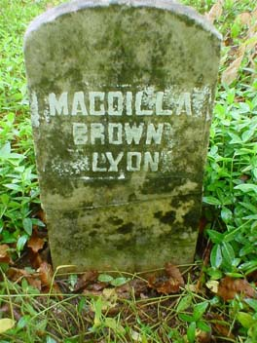
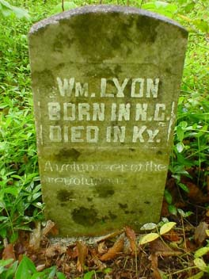

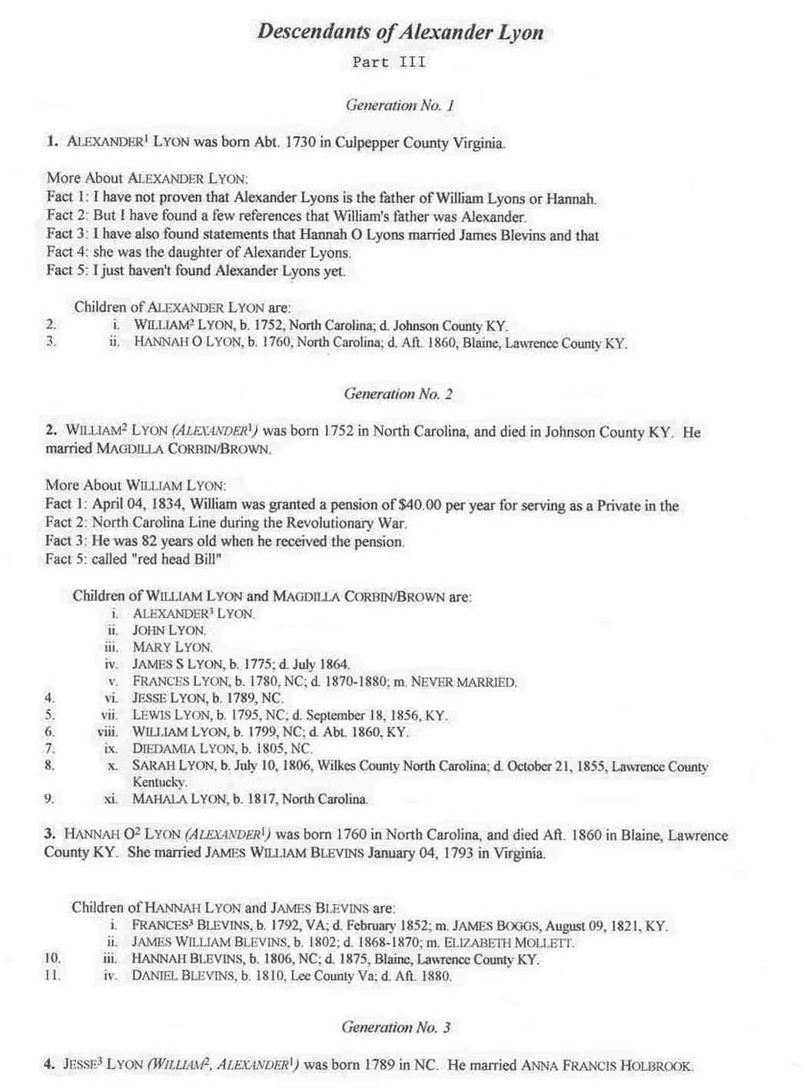

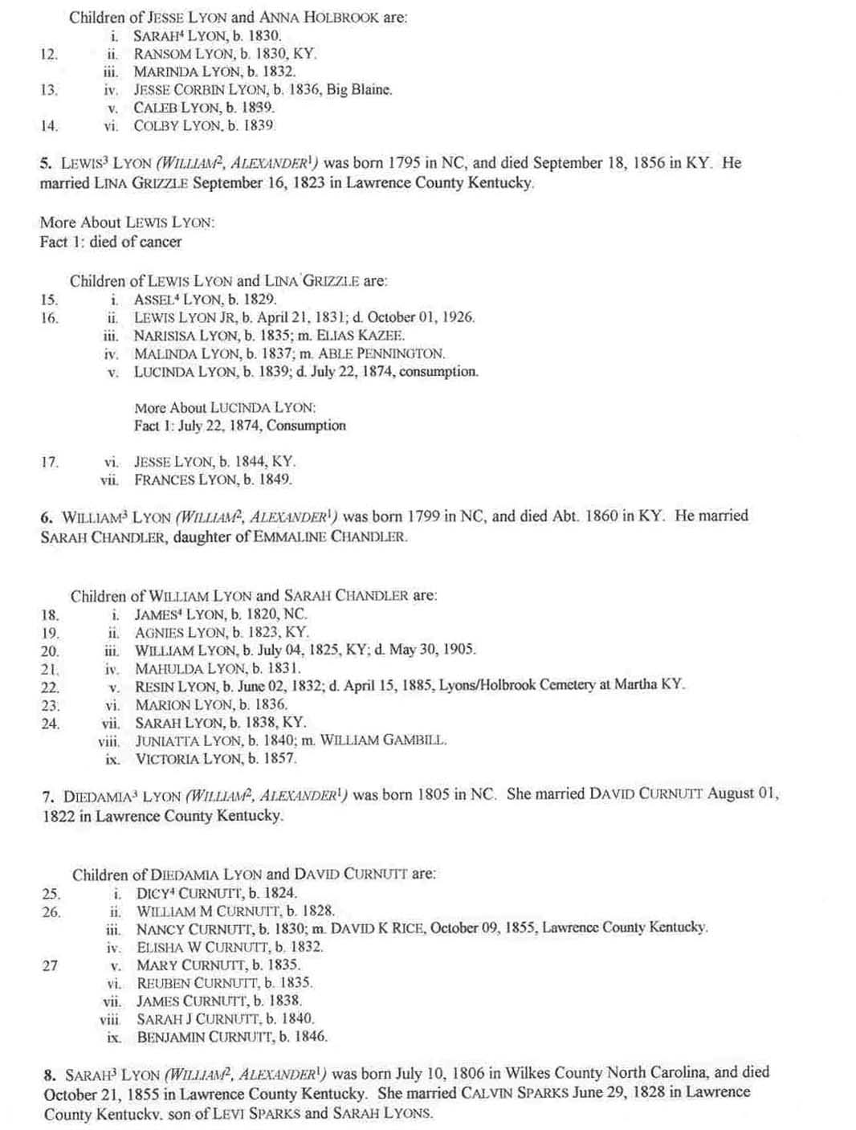
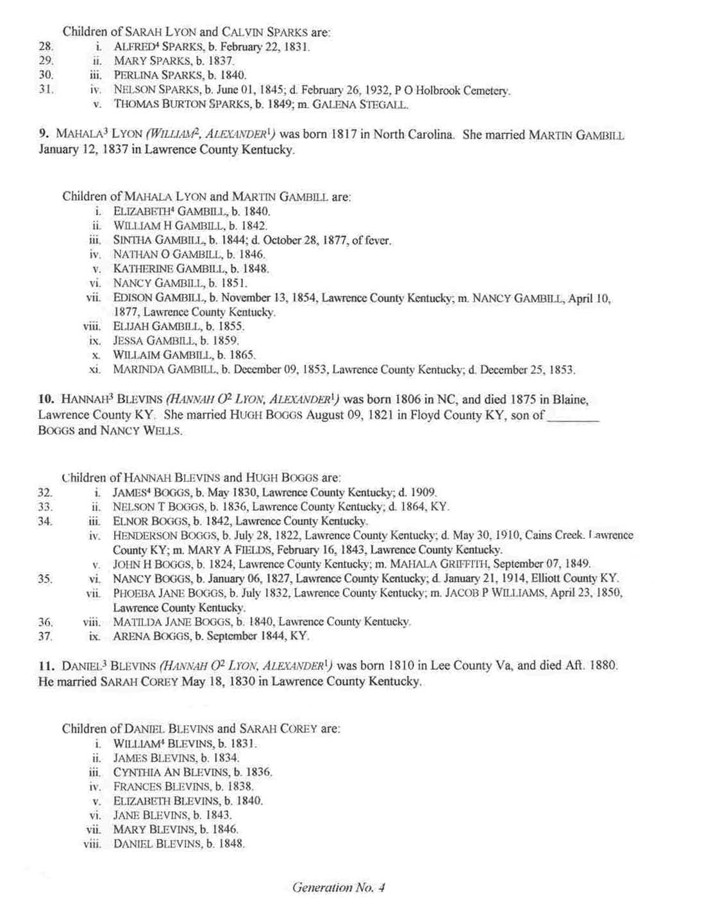
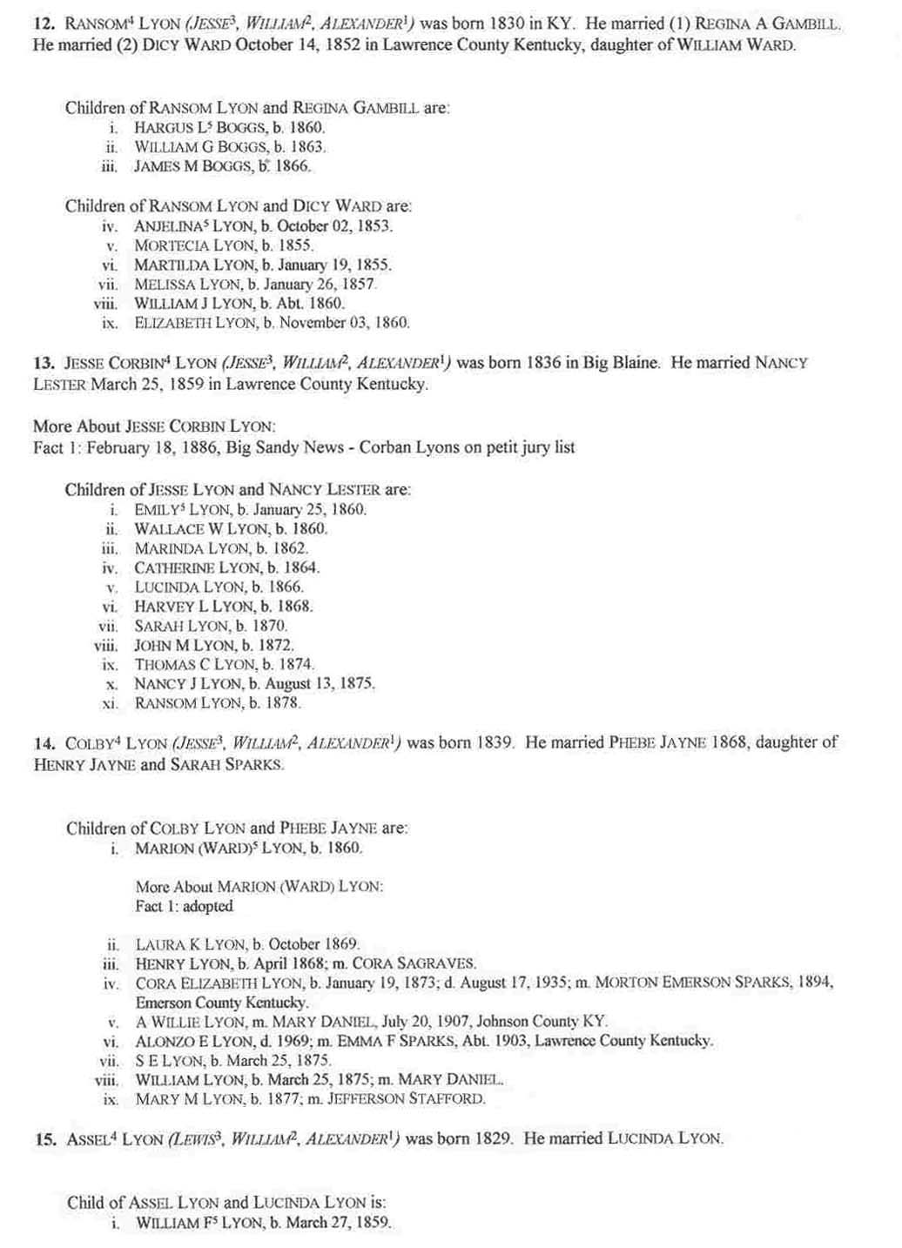
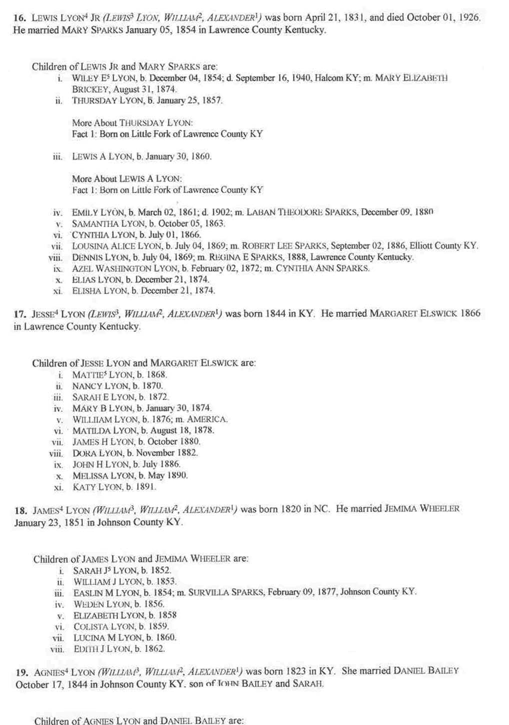
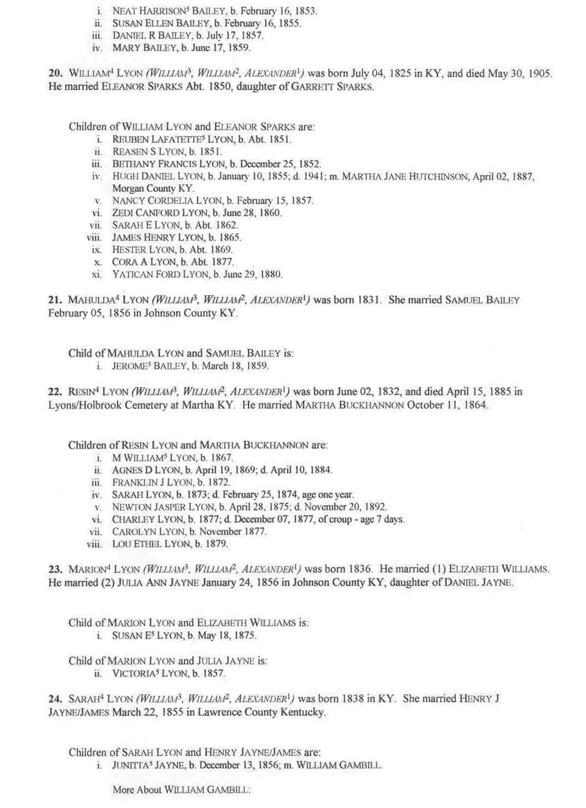
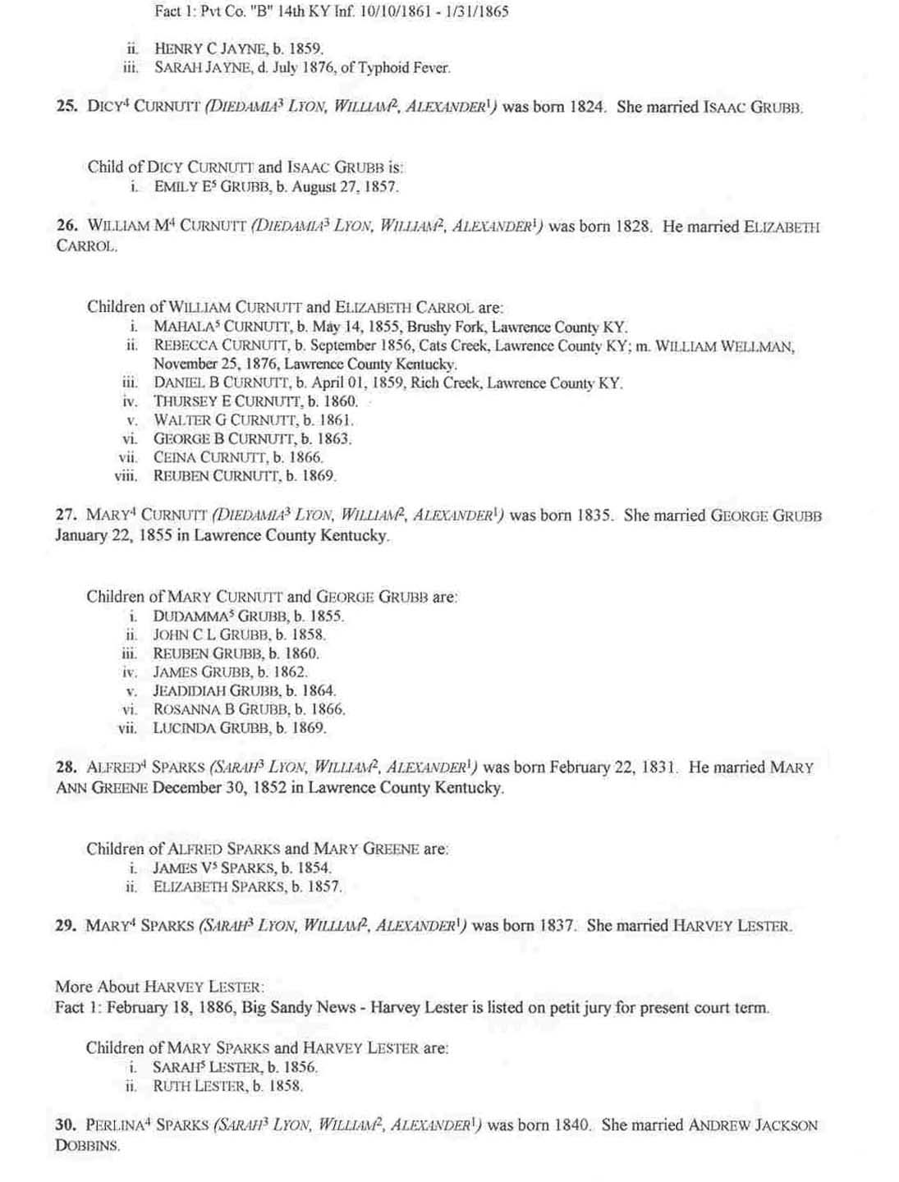
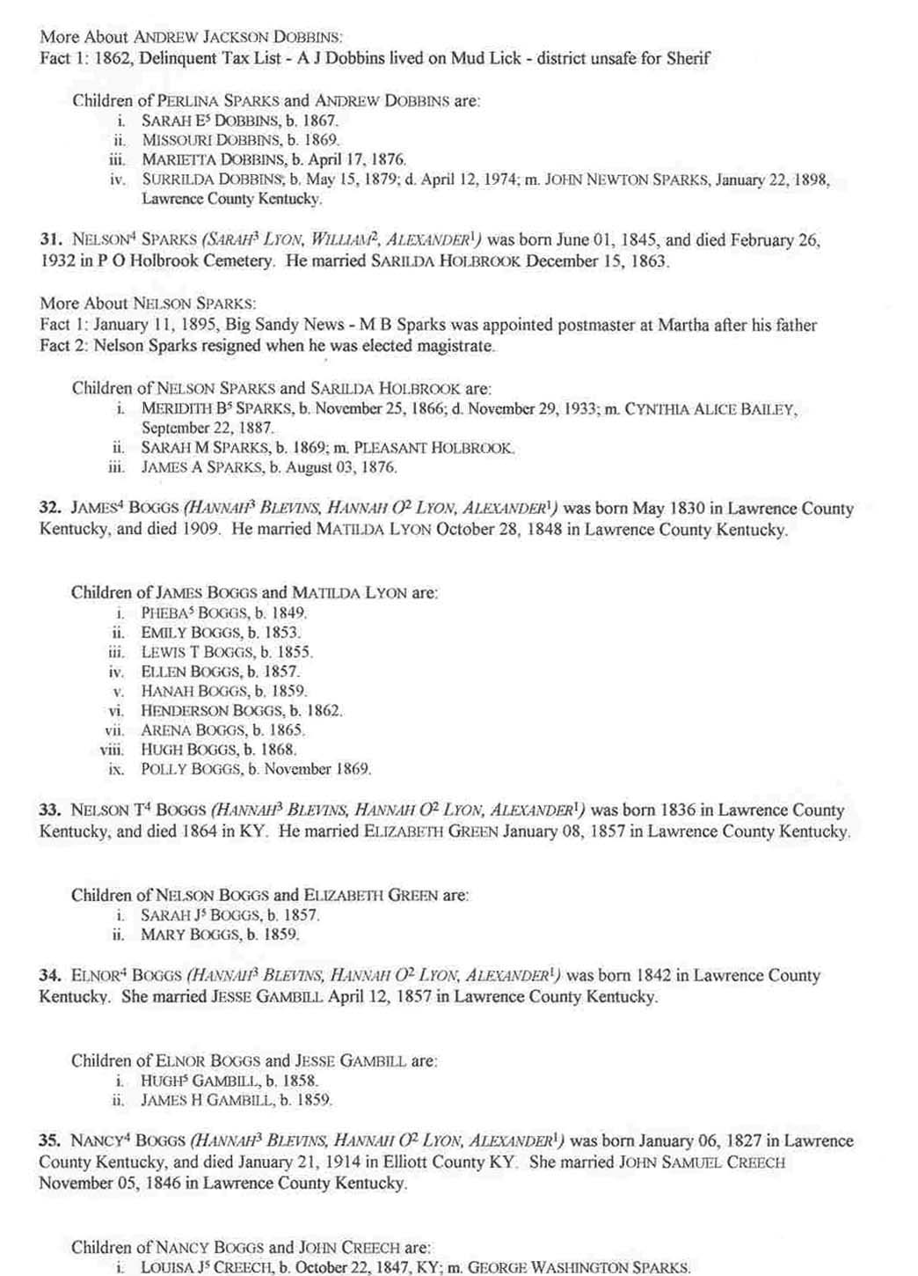
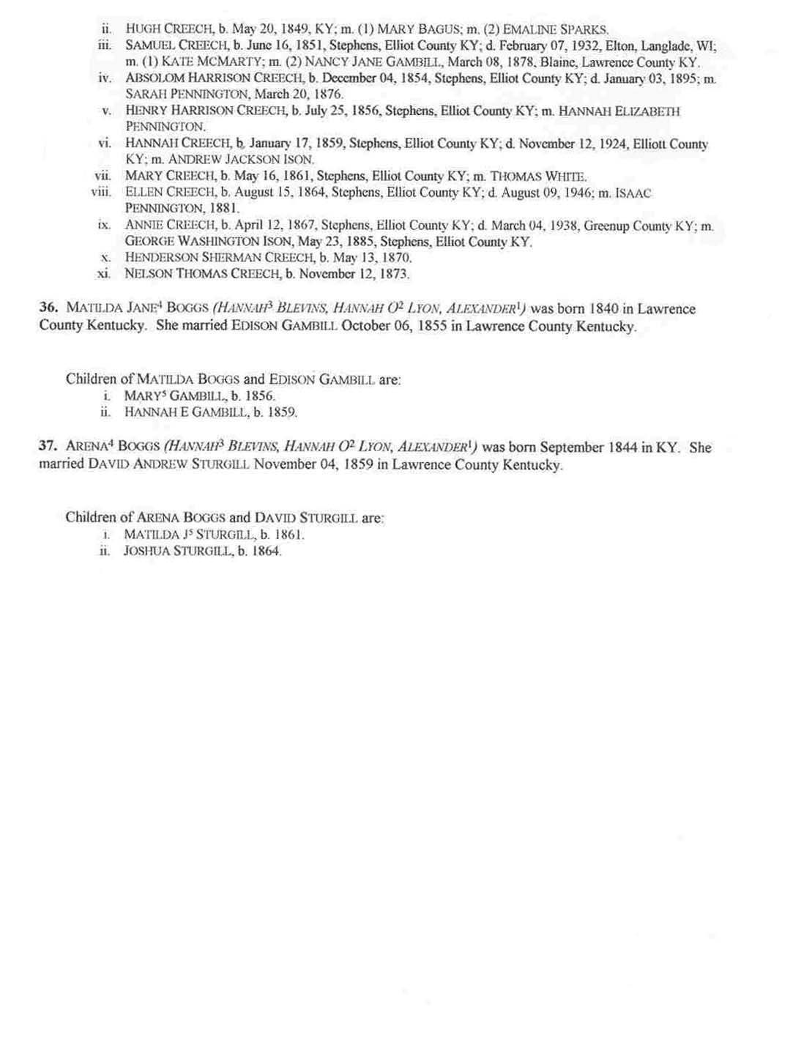
There is one final installment to this series of articles on the Lyon (s) family. It will be on the ones who came from Virginia. Please refer any comments or additional information to me, Jan Horne, 242 Frank Street, Paintsville, Kentucky 41240

JCHGS Meeting Schedule For 2005

March 5, 2005 at 10:00 AM in the Creekside Room of the Johnson County Public Library

June 4, 2005 at 10:00 AM in the Creekside Room of the Johnson County Public Library

September 10, 2005 at 10:00 AM in the Creekside Room of the Johnson County Public Library

December 3, 2005 at 10:00 AM in the Creekside Room of the Johnson County Public Library

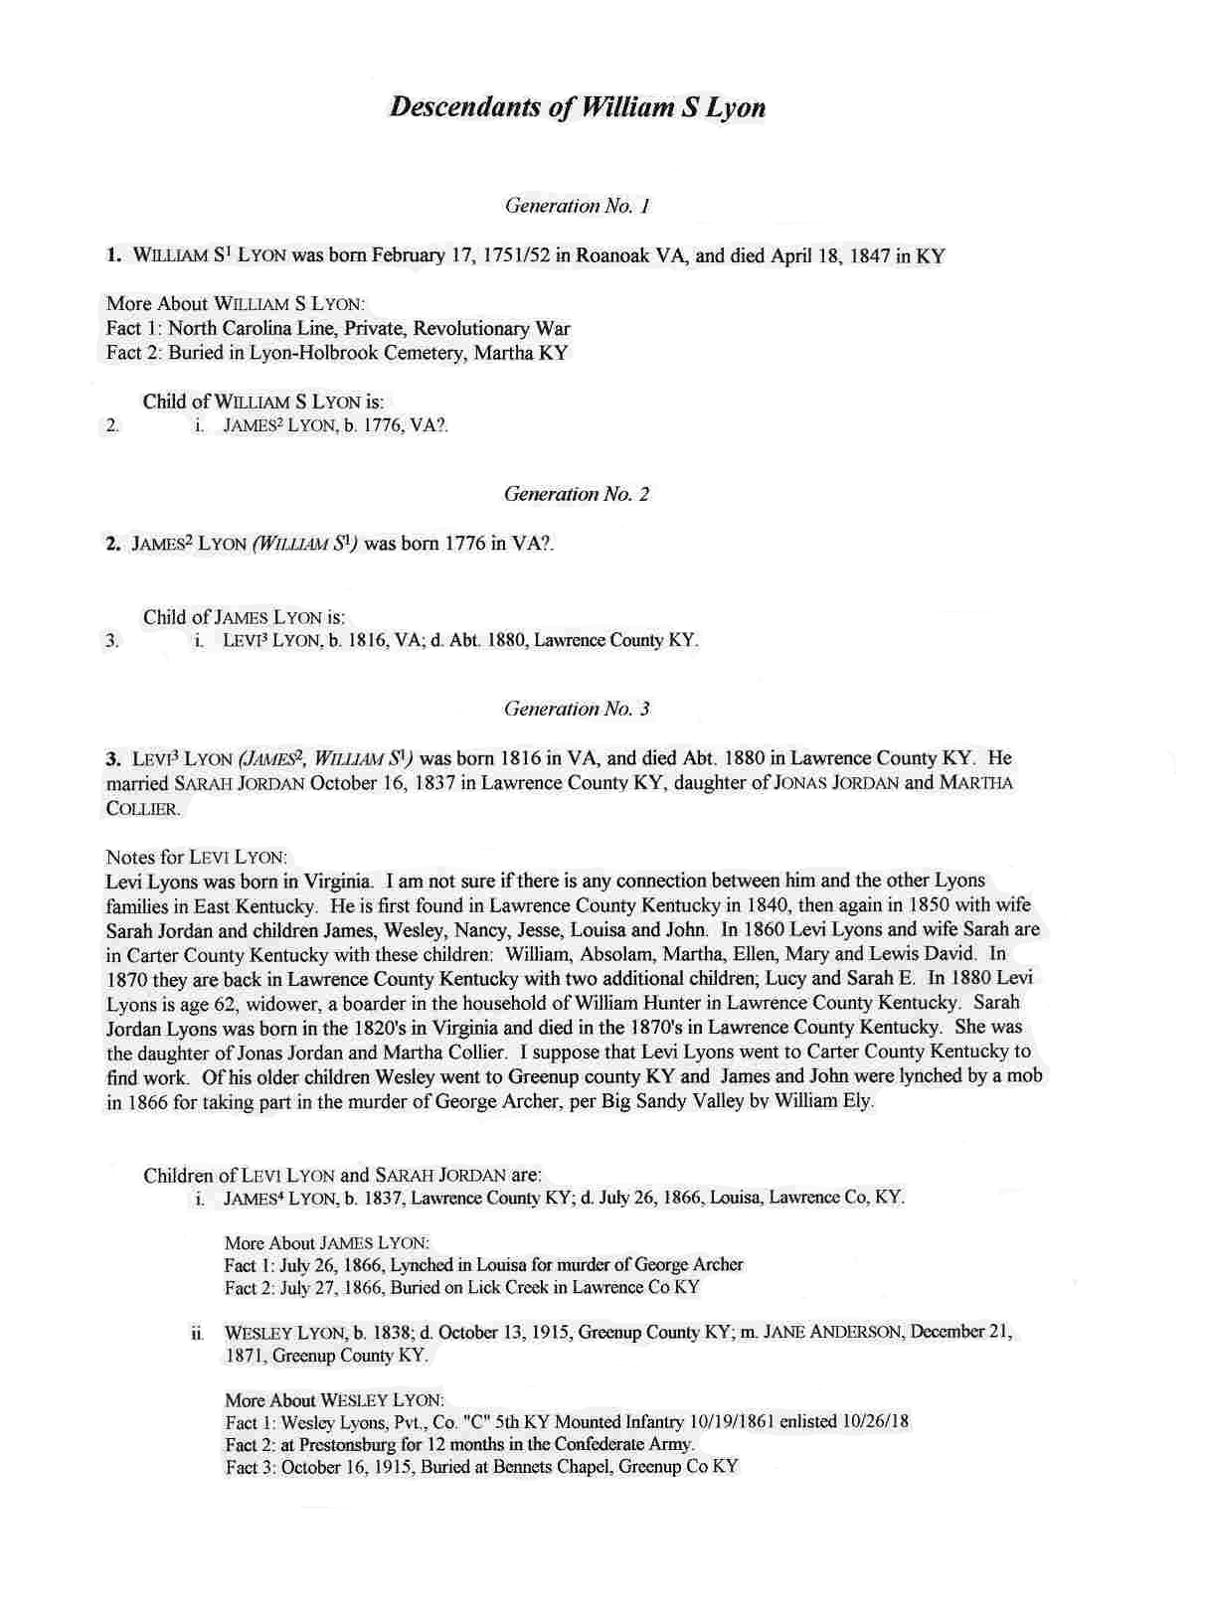
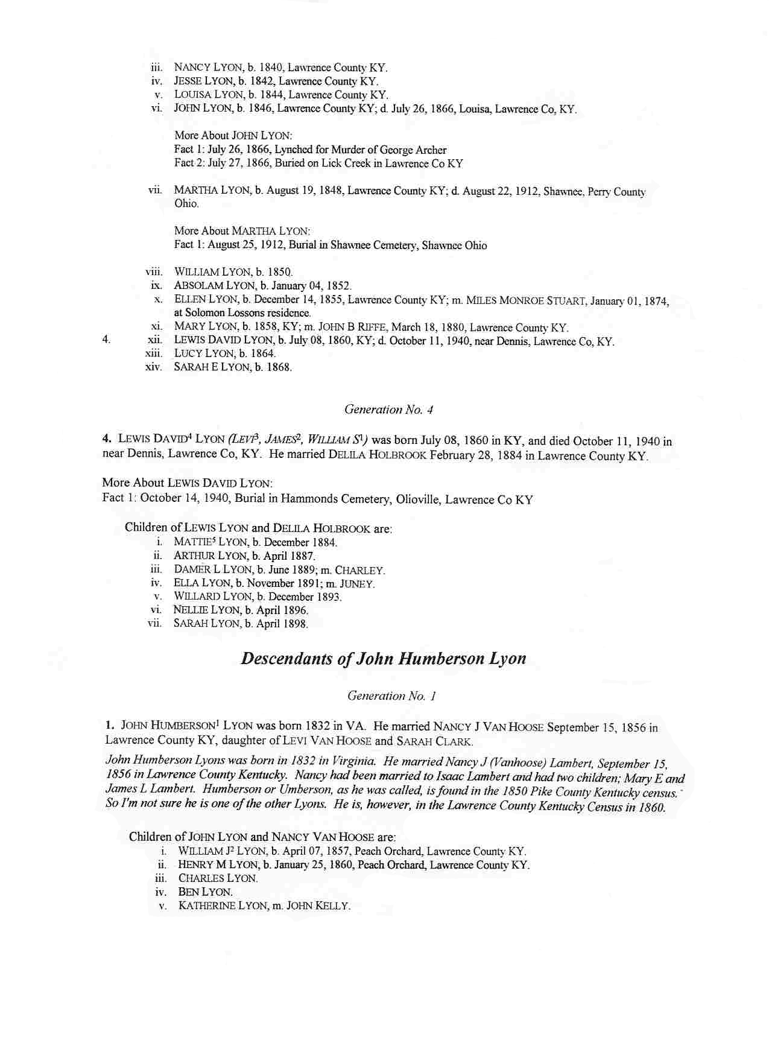
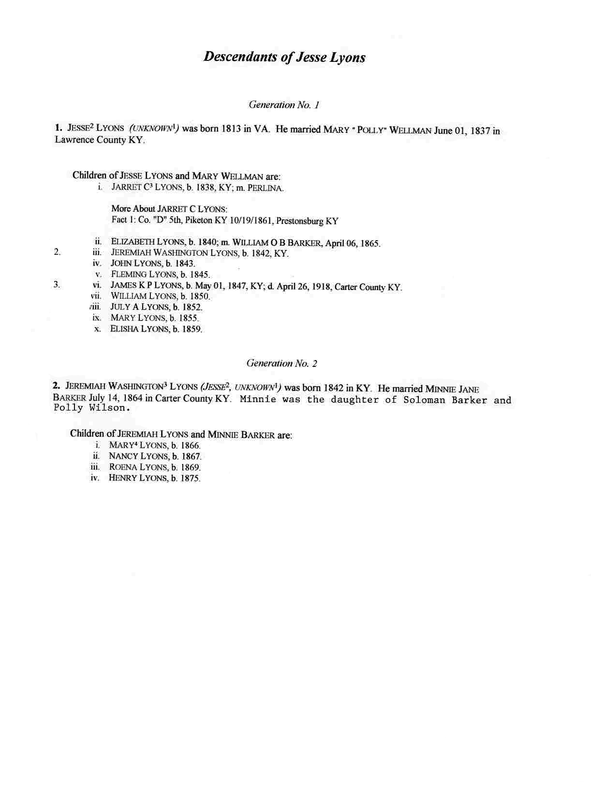
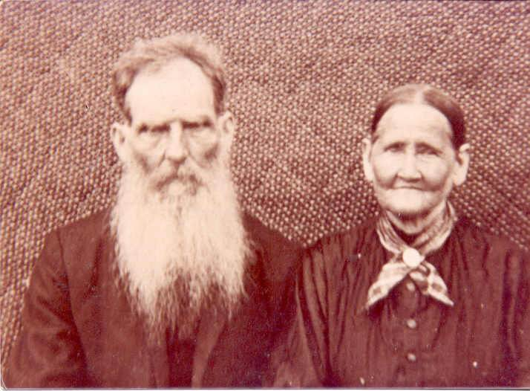
Jeremiah Washington Lyons and Minnie Jane Barker Lyons
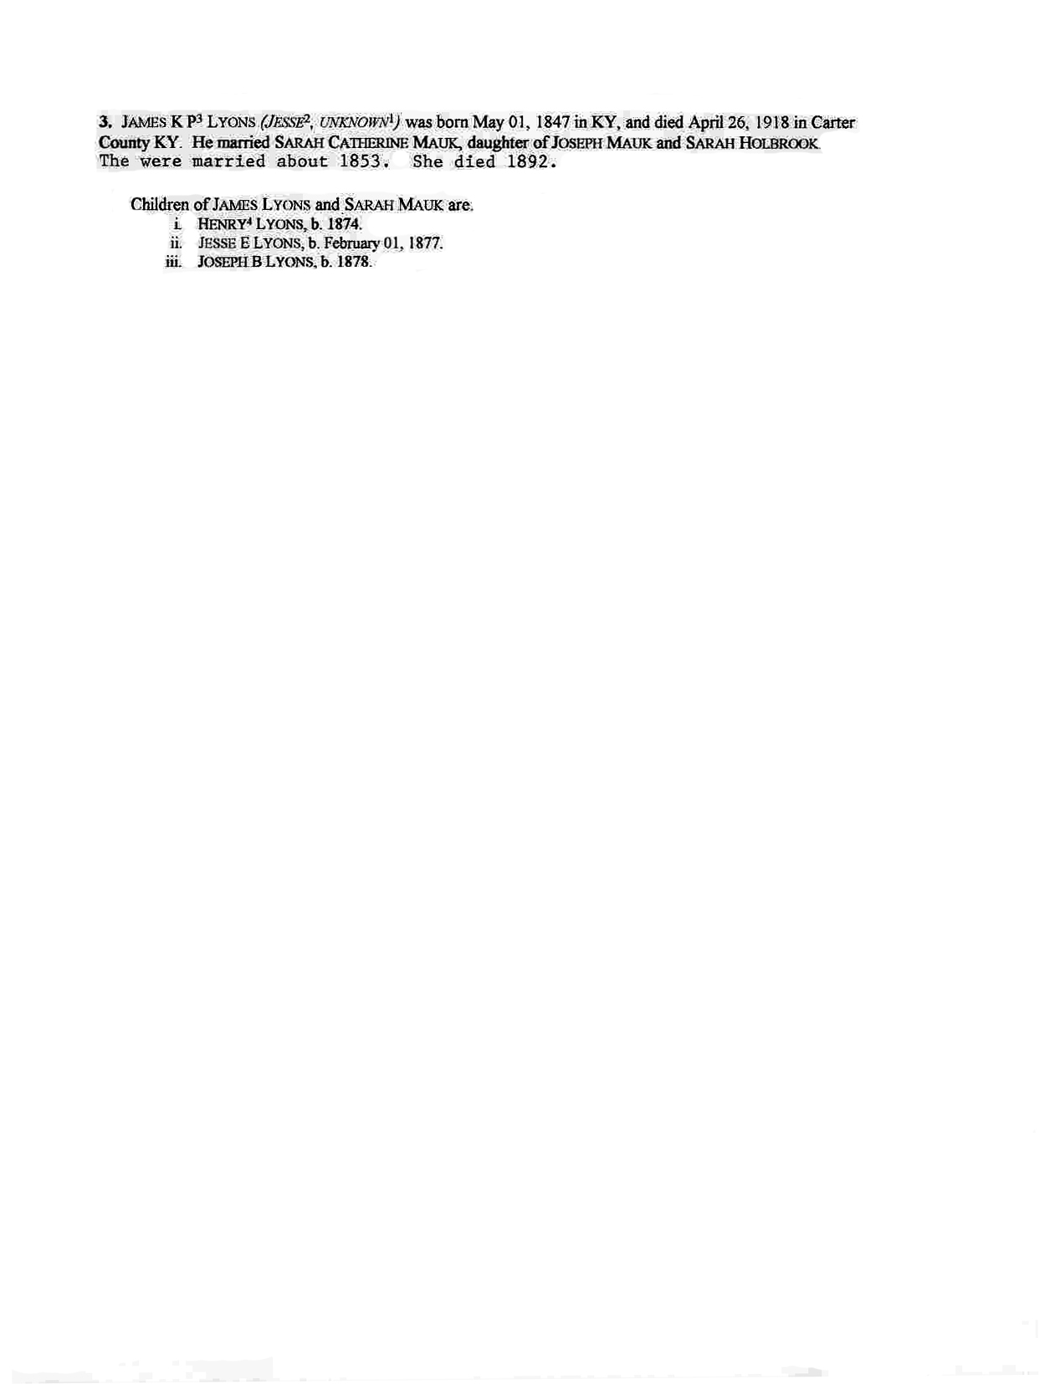
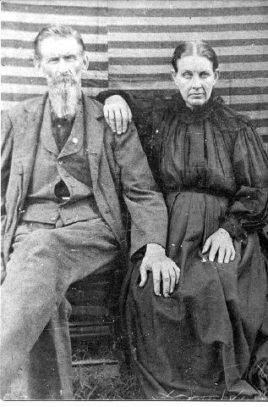
James Knox Polk Lyons and Sarah Catherine Mauk

