An Ancient Medicine Lodge in the Richland Complex

[](https://illinois.academia.edu/TimothyPauketat)

[Timothy Pauketat](https://illinois.academia.edu/TimothyPauketat)

[](https://illinois.academia.edu/JeffKruchten)

[Jeff Kruchten](https://illinois.academia.edu/JeffKruchten)



Melissa Baltus

Timothy R. Pauketat, Dept. of Anthropology, 607 Matthews, University of Illinois, Urbana, IL 61801,  pauketat@illinois.edu Jeffery D. Kruchten, University of Illinois Department of Anthropology, 109 Davenport Hall, 607 S. Mathews  Ave., Urbana IL, 61801, kruchten@gmail.com Melissa Baltus, Illinois State Archaeological Survey, 6810 Forest Hills Road, Loves Park, IL 61111, mbaltus2@illinois.edu Kathryn E. Parker, Archaeobotany, P. O. Box 156 Indian River, MI 49749, keparker@racc2000.com Elizabeth A. Kassly, 107 Brackett Street, Swansea, IL 62226, arch.eye@hotmail.com

©2012 Illinois Archaeological Survey, Inc., Illinois Archaeology, vol. 24, pp. 159–183

 An Ancient Medicine Lodge in the Richland Complex

Timothy R. Pauketat, Jeffery D. Kruchten, Melissa R. Baltus, Kathryn E. Parker, and Elizabeth Kassly

 In February and March 2008, an unusual Mississippian building was identiﬁed and excavated on an isolated hilltop at the edge of the Richland Complex in the uplands 11 km east-southeast of the well-known Cahokia site. Based on its architectural attributes, mode of abandonment, artifact assemblage, and plant remains, we infer that it was a  special residence, or medicine lodge, connected to a nearby Stirling phase settlement and, ultimately, to Cahokia. This T-shaped building possessed a unique interior alcove that, along with a second rectangular building, was aligned with the winter solstice sunrise. Sometime during the Stirling phase, both buildings were burned and the remains left exposed to the elements until the structural basins silted shut.

On February 25, 2008, archaeologist Elizabeth Kassly recognized a dark patch of feature ﬁll on a recently disturbed hilltop near a large Cahokia-related settlement in an area of the southwestern Illinois uplands dubbed the Richland Complex (Alt 2001:151;  Alt 2002; Pauketat 2003). The larger site had been reported to the Illinois Archaeologi-cal Survey in 1999–2000 as part of the University of Illinois Richland Archaeological Project, but the particular hilltop where the feature ﬁll was observed had not previ-ously produced signiﬁcant concentrations of pre-Columbian artifacts, as indicated by a pedestrian survey in 2003 by SCI Engineering (Warner 2003). In fact, the SCI survey had located only a series of isolated ﬁnds on the landform, including one nondiagnos-tic bifacial thinning ﬂake reported as 11S1588 (Warner 2003:table 1) or the Christy Schwaegel site (Figure 1, top). On that February day, Kassly recognized the feature ﬁll at the Christy Schwaegel site because the upland ridge upon which it was located had been mechanically stripped of

its plow zone to make way for the construction of a new high school. Before that strip-ping, the SCI surveyors had determined that this and the other isolated pre-Columbian sites “lack[ed] the density of cultural material to suggest that long-term habitation may have occurred in these locations” and thus concluded that it was “unlikely that they [the sites] have preserved subsurface integrity due to the nature of an isolated ﬁnd” (Warner 2003:3). Kassly’s discovery, of course, proved that the Phase I methodology that underwrote such a conclusion is problematic, especially in the densely occupied uplands east of Cahokia (Pauketat et al. 2005). Subsequent to being contacted by Kassly, and in consultation with the Illinois Historic Preservation Agency, O’Fallon School District #203, and SCI Engineering, Kruchten and Pauketat visited the site and identiﬁed the dark patch of feature ﬁll as an isolated Mississippian building or buildings that had been serendipitously exposed by construction equipment (Figure 1, bottom). In short order, Kruchten, Pauketat, and Baltus, aided by Don Booth (SCI Engineering) and Steve Boles (Illinois State Archaeo-logical Survey), arranged to salvage what remained of the feature(s) over the course of three days, March 19–21, 2008. Our investigations documented the remains of two burned Stirling phase (A.D. 1100–1200) buildings, the ﬁrst being an unusual T-shaped structure and the second an adjacent rectangular building. The buildings appear to comprise a special “nodal” rural site (Emerson 1997) probably associated with a larger settlement less than .5 km to the south (the Family Schwaegel site, 11S1313). The speciﬁcs of the Christy Schwaegel site’s construction and occupation history cast additional light on the general signiﬁcance of  T-shaped buildings, known to have been built only during the Lohmann and Stirling phases in the greater Cahokia region (A.D. 1050–1200). We argue that this latest ex-ample is similar to historic-era “medicine lodges” known from the Plains and conclude that the site was probably home to a local priest and/or to community religious objects associated with the nearby settlement and, more than likely, Cahokia itself.

 The Excavation

 The excavation was begun on March 19, 2008, when warmer weather thawed the pre- viously frozen upper feature ﬁlls. That morning, shovel scraping revealed the feature and its burned debris to be portions of two buildings, side by side, with a pit later found inside the second smaller one (Figure 2). Following the establishment of two UTM mapping points using a GPS receiver and compass, a plan map of the remnant basins  was made prior to commencing the excavation of the buildings with shovels. The T-shaped building, Feature 1, was sectioned since it possessed a relatively deep basin. The smaller rectangular building, Feature 2, was not sectioned because its basin ﬁll had been mostly scraped away by the construction equipment. Given the emergency conditions, excavated ﬁlls were not screened. Moreover, wall trenches and interior post molds were not cross-sectioned owing to a lack of time. Post molds in wall trenches were observed and mapped as dark, slightly burned circles. Single shovel cuts were made across interior

 Pauketat et al.

 161

 Figure 1. The Christy Schwaegel site location (top) and Feature 1 before excavation (bottom, view to northeast).

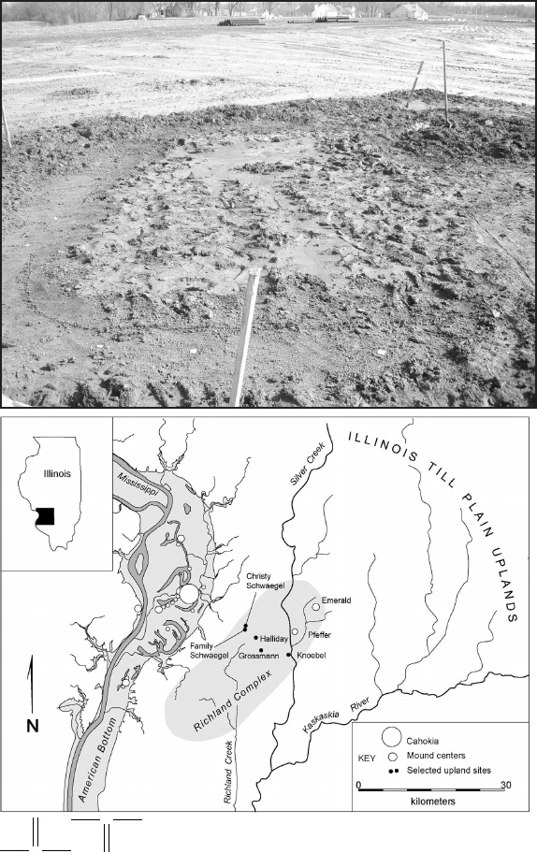

 Illinois Archaeology Vol. 24, 2012

162

 Figure 2. Features 1-3 plan view.

post molds as a means of conﬁrmation. Wall trenches were systematically probed with a steel rod to check for large artifacts.

 Feature 1

Feature 1 is a wall trench building measuring 5.5 m by 3.0 m in plan dimensions (mea-sured from the exterior of the wall trenches, not counting the 1.4 x .8 m T-extension).

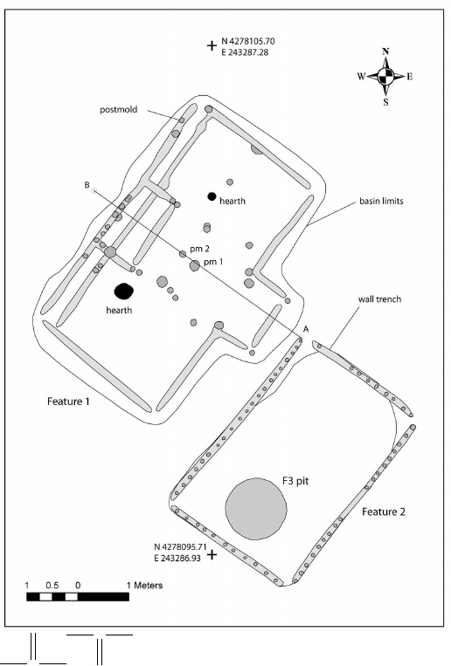

 Pauketat et al.

 163

 Figure 3. Feature 1 proﬁle, view to southwest.

 The basin within which this building was constructed is slightly longer and wider (6.0  x 3.4 m [4.4 m to T-extension edge]) and at least 14 cm deep. Feature 1’s upper basin ﬁll contained few artifacts and was primarily made up of sterile, laminated silts that had been washed into the depression subsequent to its incineration. Near the ﬂoor and around the basin edges, burned sections of wooden poles were common. In fact, the lower basin ﬁll was a mix of laminated silt wash, charred thatch, carbonized timbers, burned clay, and a few burned chert ﬂakes. Only in the southwestern building quadrant  was there evidence of intact wall or roof fall, which consisted of a section of framework made up of ﬁve members and two cross-members each spaced about 15 cm apart, with some elements showing a slight curvature (as in bent-pole construction). Otherwise, the disposition of thatch and wooden pole sections just above the ﬂoor made it clear that, except for the previously mentioned framework section, the remnant charred wall poles and roof parts had at one point ﬂoated atop a water-ﬁlled open basin, probably sometime shortly after the building’s incineration. There was no pattern to the rest of the roof or wall fall that remained, although the free-ﬂoating pieces of charred wood had clearly collected along the inner sides of the basin (and in the southwestern basin quadrant) where the water had ﬁrst ponded and then drained or evaporated.  The heaviest laminated silt was observed in the T-extension and adjacent areas atop the burned ﬂoor, as if this area had been a former doorway that subsequently enabled rain or melt water to wash into the abandoned building basin. Beneath the postincineration laminations at the T-extension was a possible pre-abandonment zone (A1) of laminated silt loam, seemingly afﬁrming the entryway interpretation (Figure 3). Moreover, the interior of the Feature 1 building is unique among all known T-shaped buildings in the greater Cahokia region because of the presence of an interior alcove, a small rect-angular room-like feature (1.9 x 1.0 meters in size) located midway along the interior of the northwestern outer wall trench (Figure 4). This alcove consisted of short wall trenches with individual post molds at its northeastern and southeastern corners. The inner alcove was clearly not a feature of the original northwestern wall, as represented by an inner Feature 1 wall trench. Rather, the alcove superimposed the ﬁrst (inner) wall

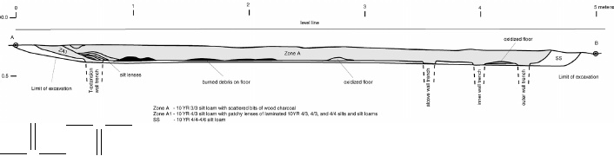

 Illinois Archaeology Vol. 24, 2012

164

 Figure 4. Feature 1 ﬂoor, view to southwest: top, plan mapping by M. Baltus and D. Booth in progress; bottom, interior alcove visible center right.

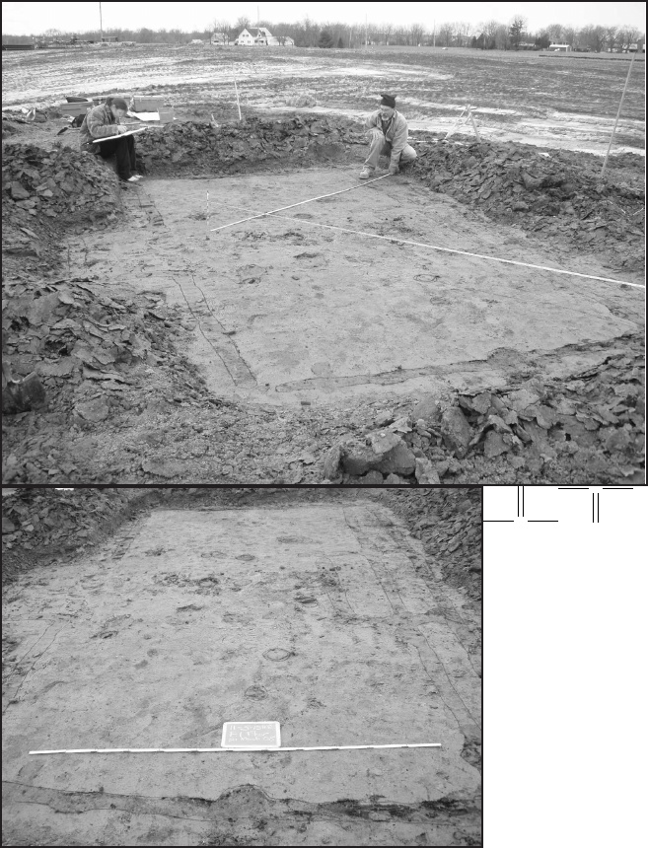

 Pauketat et al.

 165

and was built at the same time as the second (outer) northwestern wall. This alcove, the only one like it known in the region, seems to have been a virtual duplicate of the  T-entrance on the building’s southeastern long wall. Between the T-shaped entrance and the interior alcove are what appear to be a series of post molds and two hearths. Two of the post molds, PM1 and PM2, may have been building center posts. Of these, PM1 was earlier (and central to the initial building) as shown by the burned building debris that fell over it but not over PM2. Thus PM2  was later, and central to the rebuilt F1 ﬂoor space. Other posts probably supported the roof. Notably, a pair of post molds near the inner alcove’s southeastern trench match two others at the interior corners of the T-entrance. The two hearths were evident on either side of this central space. The northeastern hearth was a shallow feature 3 cm deep, evident as an oxidized patch on the ﬂoor. The southwestern hearth was likewise 5 cm deep, with some burned clay and charcoal evident in its ﬁll underlain by an oxidized patch of the Feature 1 ﬂoor. Other than the hearths and the post molds, the ﬂoor of Feature 1 was clean.

 Feature 2 and 3

 Just 60 cm to the southeast of Feature 1’s T-entrance was Feature 2, a smaller wall trench building 4.2 m in length and 3.0 m in width (from exterior wall trench to exterior wall trench). This building had been more severely damaged by the recent earthmoving activity, but a few centimeters of the building’s basin remained, along with scattered chunks or segments of burned wall and roof timbers. The charred post uprights had burned into the wall trenches, making visible most of the post molds, which were found to have diameters of 4 to 8 cm spaced 15 to 20 cm apart. No interior post molds were observed on the ﬂoor of Feature 2. Weathered and deteriorated bits of a small ceramic vessel were found near the midpoint of Feature 2’s long southeastern wall, presumably on the ﬂoor of the burned building. These were possibly portions of a vessel that was also found in a pit in the southern end of the building’s ﬂoor. This pit, Feature 3, was a circular bell-shaped feature that measured 116 to 120 cm in diameter and 43 cm deep (Figure 5). It appears to have been ﬁlled with refuse prior to the building’s incineration, evident by the appearance of its upper ﬁll spilling out onto the ﬂoor around the pit (as observed during shovel scraping of the Feature 2 ﬂoor). This upper ﬁll was labeled Zone A (3/3.5 silt loam) and was underlain by a lower zone, labeled Zone A2 (10YR 3/3 loamy silt containing ash and scattered bits of wood charcoal). Between the two zones was an intermediate and largely sterile loam, labeled Zone A1 (10 YR 4/4). Most artifacts were found at the base of Zone A immediately atop Zone A1.

 I   l   l   i  n o  i   s  A r  c  h  a e  o  l   o   g  y  V  o  l   .2 4  ,2  0  1 2

1   6   6

 Figure 5. Feature 3 proﬁle, view to southwest.

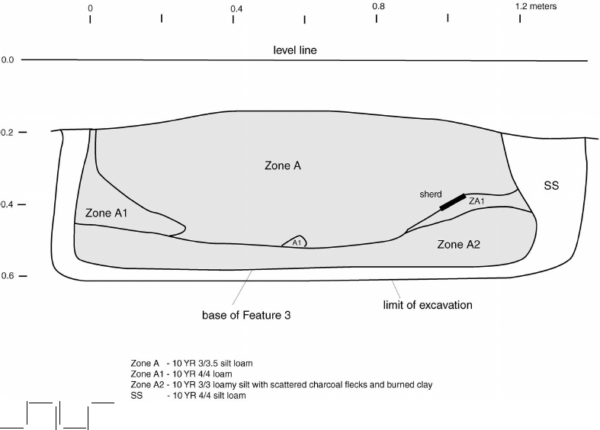

 Pauketat et al.

 167

FeatureSherdsChert itemsOther lithic detritiusOther non-lithicTotalNWt (g)NWt (g)NWt (g)NWt (g)NWt (g)11432.871129.531333.41233.9128529.622526.3843.70010.73470.73177862.44711518393.61388.42551459.4total216921.5126288.249727261234172059.7

Table 1. Artifact Inventory.

 Artifacts

Few artifacts were associated with the two buildings and single pit at the Christy Schwaegel site, consistent with the lack of surface indications. Those materials that  were recovered derive from three sorts of contexts. First, there were burned chert ﬂakes on or near the ﬂoor of Feature 1, and burned and deteriorated portions of a single ves-sel section on the ﬂoor of Feature 2 (much of which was observed but not collected). Second, there were scattered pottery and lithic artifacts in the house basins, possibly  washed into the features after the buildings had burned. Third, there were artifacts deposited prior to the incineration event inside the Feature 3 pit. A total of 417 artifacts weighing approximately 2,060 grams were recovered from the buildings and pit at the Christy Schwaegel site (Table 1). Over half of these were pieces of earthenware vessels. A minimum of six vessels may be enumerated using rim and neck sherds (Tables 2 and 3). These include one large jar, a small jar, a large bowl, a ﬁneware beaker, a bottle or jug, and a funnel. All of these were tempered with crushed mussel shell except the beaker, and most were characterized by dark slipped surfaces.  Along with the prevalence of dark slips, the vessel forms and rim shapes of these vessels indicate a Stirling phase afﬁliation, probably from the ﬁrst few decades of the period  A.D. 1100–1200 (Figure 6). The vessel forms also seem to indicate a domestic assem-blage, in that the diversity of vessel sizes and shapes cover the range of those typically known from domestic contexts at Cahokia and related sites (Holley 1989; Pauketat 1998). Three sherds from two shell-tempered jars had ground edges, pieces of reshaped and recycled vessel sections.Other artifacts in the 11S1588 refuse assemblage include lithic tools, manufactur-ing debris, and burned earth and organic residues. Most of this is chert debitage (Table 4), of which 112 (of 126) items were unutilized Burlington ﬂakes. Two were exhausted Burlington chert cores, and two were unidentiﬁed and unutilized ﬂakes. There were also six utilized and two retouched Burlington ﬂakes, one of which was a battered ﬂake used as a wedge and another of which was a perforater, a single projectile point fragment made from an unidentiﬁed (burned) chert; another was a Mill Creek chert hoe-blade resharpening ﬂake. The non-chert lithics included an assortment of 49 sandstone, silt-

 Illinois Archaeology Vol. 24, 2012

168

Shell tempered Total Additional NotesPlain/eroded ext.Dark slipped ext.FeatureNWt (g)NWt (g)NWt (g)–1716.256.11222.3–21141422.32526.3–365297.21634.481331.6–3––4123.54123.5sherds from a small dark slipped int./ext. vessel (possibly vessel 3-2)3––39235.239235.2sherds from at least two dark slipped int./ext.  vesselstotal83317.4115321.5198638.9–

Table 2. Pottery Body Sherds.Table 3. Pottery Rim Sherds and Vessels.

Feature-vessel number Vessel typeTemperSurface exteriorInteriorOriﬁce diameter (cm)1-1beakerﬁne grogred-brown slipred-brown slip81-2bowlshelldark slipdark slip353-1jarshellplainplain463-2jarshelldark slipplain163-3bottleshelldark slipplain133-4funnelshellplainplain73-NVscoops?shelldark slipplainN/A total–––––

stone, igneous rock, and hematite artifacts, two of the former being abraders and the single latter object presumably a paint stone (Table 5). Finally, there were 26 pieces of burned earth, bone, and mussel shell (Table 6).

 Pauketat et al.

 169

Feature-vessel numberOrifice diameter(cm)+/-% of OriﬁceN of sherdsWt (g)Additional notes1-18–813.8–1-2355316.7–3-146–156114.4red slipped lip3-216–1548.9possibly rim of pot with 41 sherds3-313–713.9represented by neck 3-47–25257.9whitish ash residue exterior3-NVN/A–N/A387sherds from two recycled vessel frag-ments with ground edgestotal–––18282.6–

Table 3. Pottery Rim Sherds and Vessels, Continued. Figure 6. Ceramic vessels: top, vessel proﬁles; bottom, V3-1 rim sherd.

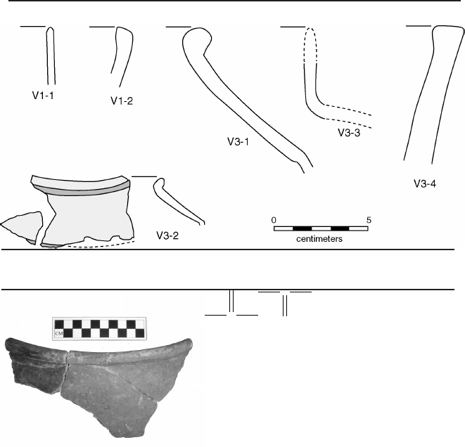

 Illinois Archaeology Vol. 24, 2012

170

Table 4. Chert Artifacts, Continued.

 Mill CreekUnidentiﬁedunburnedunutilizedburnedTotalﬂakesﬂakesprojectilepointAdditional NotesFeatureNWt (g)NWt (g)NWt (g)NWt (g)1––––––71129.51 burned perforator, 1 battered wedge2––29––843.7unidentiﬁed ﬂakes  were burned310.9––10.746114.3proximal end (16.8 mm wide) of a  Madison projectile point total10.92910.7126288.2–Feature, zoneSandstoneSandstone abraderIgneous rock NWt (g)NWt (g)NWt (g)1, basin3040.4––––1, NW outer wall trench1293––––2, basin/ﬂoor––––––3, all zones1156.9293.61244.3total42390.3293.61244.3

Table 5. Non-Chert Lithic Artifacts.

Burlington chert unburnedburnedunburnedretouchedunutilizedunutilizedutilized ﬂake toolsunutilizedﬂakesﬂakesﬂakescoresFeatureNWt (g)NWt (g)NWt (g)NWt (g)NWt (g)12034.24663.1426.415.8––233.9––229.411.4––33239.11134.4––––239.9total5577.25797.5655.827.2239.9

Table 4. Chert Artifacts.

 Pauketat et al.

 171

Feature, zoneSiltstone HematiteTotalAdditional NotesNWt (g)NWt (g)NWt (g)1, basin3040.41, NW outer  wall trench12932, basin/ﬂoor003, all zones31.410.418396.6one abrader has single slot, other is frag-ment of a palette (20 mm thick)total31.410.449730

Table 5. Non-Chert Lithic Artifacts, Continued.

Feature,Burned clayBoneMussel shellTotalAdditional NoteszoneNWt (g)NWt (g)NWt (g)NWt (g)1, basin1233.91233.92, basin and ﬂoor10.710.73, all zones417.440.9570.11388.4mussel shell includes one valvetotal175240.9570.126123

Table 6. Other Artifacts.

Plant Remains

 Two hand-collected and six ﬂotation samples were taken from the ﬂoor of Feature 1 and the ﬁll of Feature 3.

1

 The ﬂotation samples included 44 liters of sediment from Features 1 and 3 (Table 7). Wood, much of it presumably burned structural debris, was ubiquitous, and was by far the dominant class of remains. Seeds, maize, nutshell, and miscellaneous plant residues were each recovered at much lower frequency and ubiquity than wood. Mean botanical density (based on wood and nutshell fragments >2 mm in size/liter of ﬁll) for the assemblage was 37.5 fragments/liter, or by weight .42 g/liter,  with wood comprising about 95 percent of these totals. Most wood was recovered from the two Feature 1 ﬂoor samples, while most remains of edible plant resources—nutshell, cultivated seeds, maize, and cucurbit rind—were associated with Feature 3. Flattened monocot stems from two different species of grass (based on differing diameters) made up most of the two hand-collected sediment samples. Wood in the two bulk samples included 2,234 very small fragments (not listed in Table 7). Of these, 53 were identiﬁed to genus: 35 were hickory (

Carya

 sp.), 6 were elm (Ulmaceae fam-ily), and 4 were oak (

Quercus

 sp.), the rest being unidentiﬁable (Leighann Calentine, personal communication 2011). Another single 6 liter ﬂotation sample from the central ﬂoor area of Feature 1 contained 10.95 g of wood, which represented over 60 percent

 Illinois Archaeology Vol. 24, 2012

172

of all wood recovered through ﬂotation sampling. Hickory (

Carya

 sp.) was the primary taxon, followed by oak (

Quercus

 sp.)—especially the red subgroup (

Q

. sp., subgenus

 Erythrobalanus

)—and one fragment from the elm family (Ulmaceae). Of the remains of edible plants, a total of 90 very small nutshell fragments (.98 g)  were recovered, most in Feature 3; all were hickory (

Carya

 sp.) except for a trace (one fragment) of hazelnut (

Corylus americana

). Likewise, all but two of 292 seeds found  were from this same pit. Among them, three native Eastern Complex (EC) starchy cultigens—chenopod (

Chenopodium berlandieri

), maygrass (

 Phalaris caroliniana

), and erect knotweed (

 Polygonum erectum

)—together comprised 91 percent of the 239 seeds identiﬁed. The frequency of starchy cultivated grains in Feature 3 is typical of observed patterns for all but the latest Mississippian assemblages in southwest Illinois, marked by abandonment of traditional EC small-seeded cultigens. At the time of the Christy Schwaegel occupation, maygrass, chenopod, and erect knotweed were still dietary staples universally grown, albeit combined with an ever-increasing emphasis on maize production. Maygrass, the primary early season starchy grain, was balanced by harvests of chenopod and erect knotweed in the late summer and fall; all three resources were storable for use throughout the year. Well-preserved Feature 3 chenopod fruits included a mix of morphological forms, some with the truncate proﬁles and thin smooth testae of domesticated

C. berlandieri

ssp.

 jonesianum

, while others exhibited the thick, punctate testae and rounded proﬁles characteristic of wild chenopod. Such a mixture of morphological forms typiﬁes late prehistoric chenopod assemblages, reﬂecting crops that could not be completely isolated from wild chenopod stands in the same vicinity. Erect knotweed seeds were primarily naked kernels lacking distinctive pericarps. Three intact achenes were the distinctive slender, elongate morph having a paper-thin, smooth pericarp. The second recognized morph, characterized by a squat terete proﬁle and thick punctate pericarp, was not pres-ent. In this region, naked kernels often predominate in late prehistoric erect knotweed assemblages, accompanied by varying percentages of the two different achene types. Both types can occur on the same plant, but the proportion of slender, elongate achenes increases as the season progresses.Five tiny (<5.0 mm in length) sunﬂower (

 Helianthus

sp.) kernels, accompanied by loose pericarp fragments were among taxonomically di- verse seeds from Feature 3. All ﬁve are smaller than the predicted size range for late prehistoric domesticated

 H. annuus

 var.

macrocarpus

 (Asch and Asch 1985; Yarnell 1981).  These specimens could represent a small-seeded cultivar of domesticated sunﬂower, plants grown under less than optimal conditions, feral

 H. annuus

plants, or a completely  wild sunﬂower. Association of sunﬂower seeds with EC starchy cultigens in Feature 3 could be interpreted as evidence that all were harvested products. In support, there is a signiﬁcant body of data (including data from the Richland Complex sites) demonstrating that

 H. annuus

dimensions in this region tend to be smaller than the predicted means for domesticates from other areas of the Midwest (Lopinot 1991; Parker 2002; Parker 2003; Parker 2007; Powell 2000; Simon and Parker 2006). Attributes such as oil content, taste, or ease of harvest and processing may have inﬂuenced selection for an

 H. annuus

 variant, one that was polycephalic rather than the emblematic monocephalic type.

 P  a u k  e  t  a t  e  t  a l   .

1  7   3

Feature Number1, E1/21, inner alcove ﬂoor1, center ﬂoor1, T-entryway ﬂoor3, zone A23, zone A2TotalsFeature Type or Function'T'-shaped  wall trench structure belled pit inside F. 2Sample Number1-51-81-91-103-23-3–Sample Volume (liters)10.03.06.05.010.010.044.0 Total Wood (N)23212990105195281562 Total Wood Wt. (g)2.470.0610.951.661.950.5317.62Breakdown by taxon (N)–––––––Carya sp. (hickory)106515131564Quercus sp. (oak)4––––15Q. spp., subgenus Erythrobalanus (red oak subgroup)4–13–1–18Ulmaceae (elm family)–––1––1Bark–1223412Ring porous1–––3–4Unidentiﬁable15–2––8 Total Nutshell (N)1010781090 Total Nutshell Wt. (g)0.03–0.02–0.820.110.98Breakdown by taxon (N and Wt.)–––––––Carya sp.––1–781089 (hickory)––0.02–0.820.110.95Corylus americana1–––––1 (hazelnut)0.03–––––0.03 Total Seeds (N)02002819292Breakdown by taxon (N)––––––– Amaranthus sp. (pigweed)––––5–5Chenopodium berlandieri (chenopod) ––––63164

Table 7. Plant Remains from Flotation Samples.